DIABEATIS360: AN AI-INTEGRATED MOBILE APPLICATION FOR DIABETES SELF-MANAGEMENT AND TELEHEALTH CONSULTATION IN THE PHILIPPINES

A Proposal
Presented to the Faculty of the
College of Computer Studies

University of Cebu
Cebu City

In Partial Fulfillment of the
Requirements for the Degree

Bachelor of Science in Information Technology

Catubay, Karylle C.
Gillera, Russell Ray
Gulay, Niño Dave M.

Mr. Joaquin Patiño
Adviser

July 2026

APPROVAL SHEET

ACKNOWLEDGMENT

We sincerely thank everyone who has guided and supported us throughout this project.
We would like to express our sincere gratitude to our research adviser, Mr. Joaquín Patiño, for his invaluable guidance, constructive feedback, and constant support throughout this study. His expertise and dedication have been essential in the completion of this project.
We also wish to express our gratitude to Mr. Neil A. Basabe, MIT, Dean of the College of Computer Studies, whose confidence in our abilities pushed us to work harder and aim higher than we thought we could.
We would like to extend our sincere gratitude to the healthcare professionals and patients who took out their valuable time for the consultation process and survey validation. Your personal experiences have really helped us take this project forward.
We also thank our families and friends for their unwavering support, patience, and encouragement throughout this process. This project would not have been possible without you. We hope to make you proud in all that follows.

The Researchers

DEDICATION

First and foremost, the researchers dedicate this work to Almighty God for the strength, wisdom, and guidance granted to us throughout this undertaking. It is through His constant presence that we have been able to bring this work this far.
We dedicate this study to the Filipino people living with diabetes, whose perseverance inspires us. We hope Diabeatis360 serves as a trusted resource for their families and supports greater confidence and peace of mind in their health journey.
To our families, friends, and colleagues, your unwavering support and encouragement have been essential to our journey. Your presence during challenging times has been invaluable.
To healthcare workers, medical practitioners, and community health advocates, in the hope that this system may support their efforts more efficiently by providing them with better tools and up-to-the-minute patient information.
We dedicate this work as well to those who have suffered the complications of diabetes, the families who have cared for a loved one through this illness, and the communities affected by its burden, for it is their experience that strengthens our resolve to pursue solutions through this research.
Finally, we dedicate this study to our school and academic mentors, whose support helps us understand that knowledge is meant to solve real problems and to create something with a lasting positive impact.

TABLE OF CONTENTS
APPROVAL SHEET 2
ACKNOWLEDGMENT 3
DEDICATION 4
TABLE OF CONTENTS 5
LIST OF TABLES 8
LIST OF FIGURES 10
CHAPTER I 1
INTRODUCTION 1
Rationale of the Study 1
Objectives of the Study 4
Scope and Limitations 6
Significance of the Study 8
Definition of Terms 9
CHAPTER II 12
REVIEW OF RELATED LITERATURE AND STUDIES 12
​Related Literature 12
Related Studies 21
Comparative Matrix/Competitors' Analysis 24
CHAPTER III 29
DESIGN AND METHODOLOGY 29
Research Design 29
Flow of the Study 30
Research Environment 32
Respondents 33
Research Instruments 34
Research Procedure 35
Data Gathering 36
Treatment of Data 36
Ethical Considerations 37
Software Engineering Methodology 39
Planning or Conception-Initiation Phase 40
Business Model Canvas 40
Program Workflow 43
Validation Board (Stages 1 and 2) 47
Business Roadmap 50
Gantt Chart 54
Analysis-Design Phase 57
Use Case Diagrams 57
Storyboard 62
Database Design 86
Entity-Relationship Diagram 87
Data Dictionary 88
Network Design 101
Network Model 102
Development/Construction/Build Phase 106
Technology Stack 106
Software Specification 107
Hardware Specification 108
Program Specification 109
List of Modules 109
Testing Plan 113
Unit Testing 113
Integration Testing 122
Alpha Testing 125
Acceptance Testing 127
REFERENCES 135
CURRICULUM VITAE 139
APPENDICES 142
Appendix A: Oath of Confirmation 142
Appendix AA: Standard Form for the Grammar and Plagiarism Tests 144
Appendix AA: Grammar and Plagiarism Form and Result 144
Appendix B: Capstone Project Team Composition Form 146
Appendix BB: Standard Form for the Research Topic Endorsement 147
Appendix E: Capstone Project Working Title Form 148
Appendix G: Consultation Logs 149
Appendix H: Transmittal Letter 151
Appendix I: Diabetic Adults – Survey Questionnaire 155
Appendix J: Doctor – Survey Questionnaire 160
Appendix K: Capstone Project Minutes of the Proceedings 165
Appendix L: Capstone Project Hearing Notice 167
Appendix R: Capstone Project Panel Honoraria (Form 10) 168
Appendix W: Standard Form for Proposal Hearing Endorsement 169

LIST OF TABLES

Tables | Title | Page
1 | Comparative Matrix | 24
2 | Competitor's Analysis | 27
3 | Stage 1 Validation Board | 47
4 | Stage 2 Validation Board | 48
5 | Gantt Chart | 54
6 | Users | 89
7 | Guardian_Verifications | 90
8 | Providers | 91
9 | Admins | 92
10 | Glucose_Logs | 92
11 | Food_Database | 93
12 | AI_Suggestions | 94
13 | AI_Suggestions_Foods | 94
14 | Nutrition_Scans | 95
15 | Bookings | 96
16 | Gamification | 96
17 | Badges | 97
18 | User_Badges | 98
19 | Notifications | 98
20 | Subscription_Plans | 99
21 | Subscriptions | 100
22 | Software Specifications | 107
23 | Hardware Specifications | 108
24 | List of Modules | 109
25 | Unit Testing for Mobile | 113
26 | Unit Testing for Web | 119
27 | Integration Testing | 122
28 | Alpha Testing | 125
29 | Acceptance Testing Diabetic User | 127
30 | Acceptance Testing Doctor | 129
31 | Acceptance Testing Admin | 132

LIST OF FIGURES
Figures | Title | Page
1 | mySugr | 21
2 | Yuka | 22
3 | KonsultaMD | 22
4 | The Filipino Doctor (TFD) | 23
5 | Glucose Buddy | 24
6 | Flow of the Study | 32
7 | Iterative Research Methodology | 39
8 | Business Model Canvas | 41
9 | Diabetic User Workflow | 43
10 | Doctor Workflow | 45
11 | Admin Workflow | 46
12 | Business Roadmap | 50
13 | Functional Decomposition Diagram | 52
14 | Diabetic User Use Case Diagram | 58
15 | Doctor Use Case Diagram | 59
16 | Admin Use Case Diagram | 60
17 | Diabetic User-Doctor Interaction Use Case Diagram | 61
18 | Welcome Page – User | 62
19 | Login Page – Diabetic User | 63
20 | Account Registration | 63
21 | Language Preference | 64
22 | Role Selection | 65
23 | Birthdate Selection | 65
24 | Dietary Profile Setup | 66
25 | Medical Condition Profiling | 66
26 | Activity Level Assessment | 67
27 | Nutritional Preference Selection | 67
28 | Notification Setup | 68
29 | User Health Dashboard | 69
30 | Smart Nutrition Scanner | 70
31 | Scan Analysis and Evaluation | 70
32 | Glucose Logging History | 71
33 | Manual Glucose Entry | 71
34 | Healthcare Provider Directory | 72
35 | Telehealth Consultation | 72
36 | User Settings and Profile Management | 73
37 | Login Page – Doctor | 74

38 | Role Configuration | 74
39 | Professional Verification Portal | 75
40 | Clinical Overview Dashboard | 76
41 | Queue Management | 77
42 | Clinical Monitoring & Consultation | 78
43 | Consultation History | 79
44 | Doctor Settings | 80
45 | Admin Login Page | 81
46 | Administrator Dashboard | 81
47 | User Management | 82
48 | Provider Directory and Verification | 83
49 | Content and Announcement Management | 83
50 | Platform Analytics | 84
51 | Reports | 84
52 | Admin Settings | 85
53 | Entity-Relationship Diagram | 87
54 | Diabeatis360 Network Model | 102
55 | Diabeatis360 Network Topology | 105
56 | Diabetes360 Technology Stack | 106

CHAPTER I

INTRODUCTION

Rationale of the Study
Diabetes mellitus is a serious health problem because it has a significant impact on the quality of life of individuals and the incidence of diabetes is increasing throughout the world. (The World Health Organization, 2024) states that in 2022, diabetes impacted more than 830 million people globally, highlighting the increasing demand for effective approaches to manage the disease. Other projects the global number of people with diabetes could reach 1.3 billion by 2050 if current trends continue, stressing the need for scalable and accessible interventions (International Diabetes Federation, 2024).
In the Philippines, the situation is particularly concerning. The International Diabetes Federation currently reports that 4.7 million Filipino adults live with diabetes, up from 4 million in 2019, and an estimated 2.8 million more live with diabetes but remain undiagnosed (International Diabetes Federation, 2024). (Philippine Statistics Authority, 2024) recorded 43,944 deaths due to diabetes in 2024 alone, maintaining its spot as one of the top five causes of death in the country. (Cando et al., 2024) Noted that the number of Filipinos with diabetes is expected to rise from 1.2 million in 2000 to 7.5 million by 2045, placing the Philippines among the top 10 countries with the highest projected diabetes burden. This increasing phenomenon is exacerbated by financial difficulties, where Filipino diabetics have to bear the burden of huge expenses for drugs and consultations due to a lack of health insurance for their diseases (Cando et al., 2024; Parshley, 2023).
The problem of diabetes is a condition that involves the consistent monitoring of the blood sugar level of the body, proper compliance to drugs and changing one’s dietary habits and lifestyle to avoid further health complications (Stevens et al., 2022). Management of diabetes in the Philippines is challenging enough. The typical Filipino diet is carbohydrate-heavy, with rice as a staple food, which significantly affects the glycemic index and blood sugar control. The Food and Nutrition Research Institute (FNRI), under the Department of Science and Technology (DOST), studied the glycemic index of common Filipino foods. The study found that the rice and rice products have medium to high GI depending on the structure of starch and dietary fiber (FNRI-DOST, 2021). DOST-FNRI promotes brown rice, which has a lower glycemic index for its benefits in improving overall nutrition, and helping prevent sudden spikes in blood-sugar levels (FNRI-DOST, 2022). Moreover, the DOST-PCAARRD has also funded research for the development of low glycemic index rice through the process of induced mutations and marker-assisted selection (DOST-PCAARRD, 2022).
The DOST-PCAARRD has also supported research on the development of low-glycemic-index rice varieties through induced mutation and marker-assisted selection, highlighting the national commitment to address diet-related health challenges (DOST-PCAARRD, 2022). Paluyo et al. (2023) developed the "Padayon" digital health model for diabetes and hypertension in rural Philippines, proving that an "offline-first" mobile application is able to break down connectivity issues in low resource environments. Nevertheless, although there are certain advantages, many diabetes-related apps currently available concentrate only on several key features and fail to provide a complete personal service for people with diabetes (Alaslawi et al., 2022; Geirhos et al., 2022).
DOST-PCHRD has been continually backing the development of AI technology in the health sector in the Philippines like the Artificial Intelligence Nutrition Assistant (AINA) which is an AI technology developed by DOST-FNRI and is based on image recognition of Filipino food items (DOST-PCHRD, 2025). The DFTH program has been able to fund research efforts on AI applications within the University of Santo Tomas, University of the Philippines Manila, and National University of Manila, illustrating the increasing capability of Filipino researchers to incorporate AI technology in health solutions that will cater to the requirements of public health (DOST-PCHRD, 2024). Moreover, Advisory 2024-04 has been released by the National Privacy Commission, which gives advice concerning the application of the Data Privacy Act (RA 10173) to the use of artificial intelligence (AI) technology that processes personal data in relation to transparency, accountability, and fairness (National Privacy Commission, 2024). The DOST AI Roadmap (2021) provides the framework of the Philippines' strategy in the development and regulation of AI according to the ethical and regulatory requirements of health applications based on AI.
In order to bridge the gap between existing generic health apps and the unique requirements of Filipino diabetic patients, the proposed Diabeatis360 app will provide a one-stop platform for diabetes management. Integration of functions like blood glucose tracking, Filipino food suggestions based on their diet preferences and glycemic index values, health information, AI support, and health care connection within a single mobile app will help achieve the objectives of the study. It is hoped that such a combination will allow diabetic patients to access these helpful tools in an easy and effective manner while following the data privacy laws and ethical standards of AI.

Objectives of the Study
The goal of this project is to analyze, design, develop, and assess Diabeatis360, a telehealth and mobile wellness application for diabetic patients.
Specifically, it aims to:
- Identify the current methods and tools used by Filipino diabetic patients for self-management in terms of:
  - Existing mobile health applications and their limitations; and
  - Problems encountered in tracking blood sugar, following meal plans, and maintaining consistent health habits.
- Determine the proper mechanism for each of the following:
  - Secure user registration and profile building, including country, birthdate, activity level, dietary preferences, food allergies, and language preference;
  - Monitoring blood sugar levels, interpreting each reading as low, normal, high, or critical with corresponding real-time meal and exercise feedback, tracking reading patterns over time, and setting up health reminders;
  - An AI-assisted recommendation engine for generating localized meal and exercise suggestions based on the user's health profile, including consideration of food allergies and dietary restrictions;
  - AI-based scanning and analysis of nutrition facts labels captured through the device camera, which evaluates the nutritional content against the user’s health profile and suggests healthier alternative food options; and
  - A doctor chat and appointment module for remote consultations with endocrinologists and other licensed healthcare providers.
- Define the best features of the proposed Diabeatis360 system, which include the following:
  - A system for alerting about blood sugar testing, meals, exercise, water intake, and medications;
  - A health progress dashboard that summarises trends in overall wellness, physical activity, calorie intake, and blood sugar;
  - Generates AI-based predictions on potential health risks based on the user's logged data reflecting risk of progressing to full diabetes for prediabetic users, and risk of poor glycemic control or complications for users already diagnosed with Type 1 or Type 2 with corresponding recommendations for prevention, correction, and maintenance.
  - Components of gamification, like milestone rewards, achievement badges, and wellness streaks.
- Establish the acceptability of the proposed Diabeatis360 system among individuals with diabetes in the Philippines. While the application will support both adult users and pediatric users under parental or guardian supervision, system evaluation will primarily focus on adult respondents.

Scope and Limitations
The purpose of this research is to help diabetic Filipinos manage their conditions on their own. Users will be capable of scanning food labels, obtaining meal and exercise recommendations in their local language, managing blood glucose levels, and consulting healthcare professionals virtually. The progress of wellness programs will be monitored, personalized wellness information will be generated, and gamification components will encourage healthy behavior development.
The scopes of the study are the following:
- The study will focus on designing and developing Diabeatis360, a mobile-based application for managing diabetes.
- The system will integrate an AI-assisted recommendations engine to generate localized meal and exercise recommendations based on the user’s health profile.
- The application will include blood sugar logging with trend visualization and reminder scheduling for blood sugar checks, meals, medications, and exercise.
- The application will include a blood sugar interpretation feature that classifies each logged reading as low, normal, high, or critical and immediately provides the user with appropriate real-time meal and exercise feedback based on the result.
- The platform will incorporate an AI-based nutrition label that scans the food products against the user's health profile and suggests healthier alternatives.
- The system will incorporate an AI diabetes risk prediction module that evaluates the user's profile, logged health data, dietary habits, and activity level to generate a personalized risk classification reflecting the risk of progressing to full diabetes for prediabetic users and the risk of poor glycemic control or complications for users already diagnosed with Type 1 or Type 2, with corresponding recommendations for prevention, correction, and maintenance.
- The system will feature a doctor chat and appointment module for remote consultations with endocrinologists and other healthcare professionals specializing in diabetes care.
- The application will include a health progress dashboard, gamification elements such as wellness streaks and achievement badges, and a conceptual community support module for future development.

The limitations of the study are the following:
- The application is eligible only for individuals diagnosed with Type 1 or Type 2 diabetes or prediabetes.
- Pediatric users may access the application only under parental or guardian supervision.
- AI-generated suggestions on meals, exercise, and nutrition are for guidance purposes only and cannot be considered a substitute for personal advice provided by licensed healthcare practitioners.
- The nutrition label scanning feature may produce inaccurate results when labels are poorly printed, damaged, or captured in low light.
- The allergy detection feature relies solely on user-declared food allergies entered during profile setup and does not account for undisclosed or undiagnosed allergies.
- Network-dependent features such as the doctor chat module and AI recommendations require a stable internet connection to function properly.
- The evaluation of system acceptability will be limited to a select group of adult respondents with diabetes in the Philippines.

Significance of the Study
This study on Diabeatis360 will make a meaningful contribution and hold value for various groups and individuals who are either directly or indirectly impacted by diabetes management in the Philippines. The findings of this study are expected to benefit various sectors, including the following:
Adult Diabetic Patients. As the primary users of the application, Filipino adults will benefit most from Diabeatis360. This application will provide a tool for tracking blood sugar levels, offer localized meals suited to the Filipino lifestyle, provide exercise recommendations, and send reminders. The application will help diabetic adults stay consistent and manage their lifestyle effectively.
Family Members and Caretakers. For many Filipinos with diabetes, the main sources of support will be their families and caretakers. They will benefit from this study because it will provide a tool that simplifies health tracking, making it easier for them to stay informed about their loved one's condition and needs.
Healthcare Providers and Doctors. With the built-in doctor chat and appointment features, healthcare professionals can conveniently manage care for adult patients with diabetes. This study will encourage a consistent and easily accessible patient-doctor relationship, especially for individuals living in areas where in-person visits are challenging.
The Department of Health (DOH). The findings of this study will help DOH in its goal of promoting digital health tools and improving chronic disease management nationwide. Diabeatis360 will work with national health programs to address diabetes as a major public health problem in the Philippines.
The Philippine Health Sector. By addressing the gap in locally adapted diabetes management tools, Diabeatis360 will contribute to the broader goal of improving digital health literacy and health outcomes among Filipinos. This study will support the national effort to reduce the impact of diabetes as one of the leading chronic diseases in the country.
Researchers. The study will contribute to the expanding body of knowledge on mobile health applications, AI-assisted wellness tools, and localized digital health solutions. Future researchers and application developers will be able to use the findings of this study as a reference for designing similar culturally responsive health technologies for Filipino users or other underserved populations.
Future Researchers. This study will be useful to future researchers interested in related topics, such as mobile health applications, AI-assisted wellness tools, diabetes self-management, and locally culture-based digital health solutions.

Definition of Terms
The definitions of the following terms help to clarify the main ideas used in this study:
Artificial intelligence (AI) – a technology that enables computers to perform tasks that typically require human intelligence, such as making decisions or providing recommendations.
Blood Sugar Logging – To track and manage diabetes over time, blood glucose levels are routinely recorded.
Diabetes Self-Management – The ongoing effort by a person with diabetes to manage their condition through regular health monitoring, medication adherence, and healthy habits.
Diabetes-Related Complications – These are health problems that occur due to poor management of diabetes and include cases of hypoglycemia, hyperglycemia, and even prediabetes advancing to Type 2 diabetes, which is where the risk prediction module comes into play.
Endocrinologist – A medical doctor who specializes in diagnosing and treating conditions related to hormones and metabolism, including diabetes mellitus.
Gamification – The use of game-like elements, such as streaks, badges, and rewards, in non-game settings to motivate users and encourage consistent behavior.
Localized Meal Recommendations – Food suggestions tailored to the dietary habits, ingredients, and food culture of a specific population.
Mobile Health Application – A smartphone-based software designed to help users track, manage, or improve their health.
Nutrition Label Scanning – The use of a camera on a device to capture and evaluate the nutritional information printed on food packaging.
Telehealth – Getting healthcare services through digital platforms so patients and providers can connect without being in the same place.
Type 1 Diabetes – A chronic condition in which the pancreas produces little or no insulin, requiring individuals to take insulin injections daily to manage their blood sugar levels. It is often diagnosed in children and young adults.
Type 2 Diabetes – A chronic condition in which the body becomes resistant to insulin or does not produce enough insulin to maintain normal blood sugar levels. It is often associated with lifestyle factors and is more common in adults.
Trend Visualization – The presentation of health statistics on a graph to assist in pattern recognition and tracking of performance.
User Profile – The personal information a user enters during registration, such as age, activity level, and dietary preferences, is used to personalize app recommendations.

CHAPTER II

REVIEW OF RELATED LITERATURE AND STUDIES
This chapter presents the literature and studies that helped shape the development of Diabeatis360. It looks at topics such as diabetes self-management, mobile health apps, AI-assisted health tools, gamification in health apps, telehealth, and the role of cultural localization in digital health solutions.

​Related Literature
Diabetes as a Growing Public Health Concern in the Philippines. Diabetes is not a new problem in the Philippines, but the numbers keep getting worse. The International Diabetes Federation reported that 4.7 million Filipino adults are currently living with diabetes, up from 4 million in 2019, and around 2.8 million more have the condition without even knowing it (International Diabetes Federation, 2024). The World Bank reports a prevalence rate of 7.5 percent among Filipinos aged 20 to 79 as of 2024. In 2024 alone, the Philippine Statistics Authority recorded 43,944 deaths caused by diabetes, which keeps it firmly in the top five causes of death in the country (Philippine Statistics Authority, 2024).
What makes this even more concerning is the direction things are heading. (Cando et al., 2024) Noted that back in 2000, only about 1.2 million Filipinos had diabetes. By 2045, that number is expected to hit 7.5 million. The same study pointed out that many Filipinos do not end up with serious complications because they ignore their diagnosis. A lot of them simply do not have access to tools that actually fit how they live. The food databases in most apps do not match what Filipinos eat, and the general advice does not account for local habits or resources. That disconnect between what is available and what is actually useful is a big part of what pushed this study forward.
Mobile Health Applications and Diabetes Self-Management. There are already many people using their phones to help manage their diabetes, and even more who want to. A systematic review in Frontiers in Endocrinology examined 13 studies and found that about 35 percent of patients with diabetes were already using a mobile health app to manage their condition (Birhanu et al., 2024). More telling was the 57 percent who said they would want to use one in the future. The barriers that kept people from consistently using these apps included distrust of the technology, low health literacy, and a lack of relevance to their lives.
That last point came up again in a 2022 systematic review by Alaslawi et al. in JMIR Diabetes. They looked at what actually drives patients and doctors to adopt and continue using diabetes apps, and personalization kept coming up as one of the biggest factors. When an app felt like it understood a person's actual food habits, daily routine, and language, they were much more likely to stick with it. That finding is one of the main reasons Diabeatis360 was built around a user profile system where the recommendations adjust based on who the person is and where they live.
That more functions lead to better apps than single functions was yet another aspect to this (Corsica et al., 2025). People managing diabetes have to track their blood sugar, watch what they eat, stay active, and remember to take their medication. If they require three separate apps to handle everything, the mere act of switching becomes tiresome, and they eventually give up. Combining all of these into one platform, as Diabeatis360 does, is not just a convenience decision. The research says it actually leads to better health outcomes.
Artificial Intelligence in Diabetes Care and Personalized Health Recommendations. The application of AI in diabetes treatment is much more advanced than people believe. As indicated in the study that appeared in Cell Reports Medicine in 2023, AI-powered algorithms are superior to conventional algorithms in predicting the level of blood glucose, recommending meals, and finding patients who are prone to complications (Guan et al., 2023) The main benefit lies in the fact that machine learning algorithms can consider a patient's medical history and find patterns which cannot be found with the help of conventional recommendations, such as the influence of the same food portions on different people's blood glucose levels..
The Lancet Diabetes and Endocrinology published a 2024 review examining where AI fits across the entire spectrum of diabetes care. The authors were clear that the most practical near-term use of AI is in giving people real-time, personalized guidance based on their own data, which is exactly the role the recommendation engine in Diabeatis360 is meant to play. They also raised a valid concern about bias. If an AI system is trained mostly on data from Western populations, its suggestions will reflect that population's diet and lifestyle, not a Filipino's. That is why the recommendation engine in Diabeatis360 is being built around locally relevant nutritional and lifestyle data from the start.
(Xin et al., 2026) Tested this out in practice. In a study published in Frontiers in Public Health, researchers analyzed the results of the comparison of patients who used AI-based mobile application for diabetes treatment and those who got standard nursing treatment. Six months later, patients from the first group had better glucose control. The application offered personalized nutrition plans, workouts, and schedules of monitoring based on individual patient’s data, and this personalized approach helped significantly. This is a strong example that an application like Diabeatis360 based on this approach can help people improve their health.
Gamification as a Strategy for Improving Patient Engagement in Health Applications. One of the hardest things about managing a chronic illness is that it never stops. There is no finish line, which means motivation tends to drop off after the initial effort. A lot of people download a health app, use it for two weeks, and then stop. Gamification is one of the more researched approaches to solving that problem. By adding features like streaks, badges, and rewards to an app, developers aim to make daily health behaviors feel more like something worth doing rather than just another task.
A scoping review on the use of gamification for chronic disease management and its effects on patient outcomes, such as in cases of diabetes, in JMIR Serious Games (Huang et al., 2023), had 70 studies. According to this research, the best gamified interventions provided rewards for continuous daily performance, allowed seeing tangible results, and included personalized rather than generalized objectives. Various chronic conditions were considered, such as diabetes, but the highest influence on real behaviors was achieved through gamification, namely meal tracking and physical activity.
There is a recent 2024 study published in The Lancet's eClinicalMedicine that does a meta-analysis of health applications both gamified and non-gamified through randomized control trials. Gamification proved superior when it came to increased physical activity; however, it also helped in improving levels of glucose in the blood and weight of the participants. It can be concluded from this information that the gamification elements present in Diabeatis360 application are no mere decorative touches. There is scientific proof that they help and are necessary.
Telehealth and Remote Consultation in Diabetes Management. Managing diabetes properly usually means staying in regular contact with a doctor, but for many Filipinos, that is easier said than done. Travel time, clinic fees, and limited specialist availability, especially outside Metro Manila, make regular checkups impractical for many patients. Telehealth has become one of the more realistic solutions to that gap, allowing patients to connect with health professionals via their phones without leaving home.
The use of telehealth in diabetes care was examined in a paper published in Frontiers in Endocrinology (Middelbeek et al., 2023). Patient satisfaction has been reported, especially in regard to monitoring glucose levels, making adjustments in medication, and obtaining dietary guidance regularly. One of their significant findings has been that the adoption of telehealth services which started during the pandemic period continued despite its end. Those people who would not have opted for a virtual consultation prior to the pandemic were forced to do so but found it so useful that they continued using it.
(Elvira Arcellana & Jimeno, 2020) Documented the use of telemedicine in the Philippines during the pandemic to keep diabetic patients in touch with their doctors when in-person visits were impossible. Physicians reviewed blood sugar logs, adjusted medications, and gave dietary guidance remotely. It called for such a setup to be maintained as a permanent feature of diabetes care in the country, not just an emergency measure. Since then, that argument has only grown.
In a pilot project published in Telehealth and Medicine Today in 2024, a large-scale digital health clinic for urban and rural communities was run in the Philippines. It served 322 patients in just three days. In a shocking discovery, nearly 40 percent of those patients hadn’t seen a doctor in over a year. That number says a lot about the access gap a tool like Diabeatis360’s doctor chat feature is trying to bridge. From a policy standpoint, PhilHealth Circular 2021-0013 has formally recognized teleconsultation as a reimbursable service. This means that remote consultations are now a covered health benefit for Filipinos. Hence, integrating a consultation feature into Diabeatis360 is not only technically feasible but also timely.
Local Literature on the Filipino Diet. Rice remains the dominant staple in the Filipino diet, and recent local research continues to raise concern over its glycemic impact. In an investigation reported in Scientific Reports in 2026, rice types that are commercially grown in the Philippines both colored and not were analyzed and found to be in line with current fears regarding a correlation between the consumption of carbohydrate-filled and high glycemic index foods and the development of chronic conditions such as Type 2 diabetes (Bayaga et al., 2026). Since rice is considered the primary source of carbohydrates for the majority of Filipinos, this glycemic impact is a critical consideration in local dietary planning. These results support the significance of having the Diabeatis360 food suggestion function customized in such a way that it takes into consideration the carbohydrate content and effect on blood glucose levels of the traditional Philippine diet instead of general dietary recommendations from other countries.
Local Studies on Mobile Health (mHealth) Acceptance in the Philippines. Local research supports the feasibility of mobile and telehealth adoption among Filipinos. A study applying the Unified Theory of Acceptance and Use of Technology (UTAUT2) model to 533 Filipino respondents found that usage behavior and behavioral intention were the strongest predictors of telemedicine adoption in the country, with performance expectancy, effort expectancy, hedonic motivation, and social influence also found to significantly affect how Filipinos accept and continue using telehealth technologies (Ong et al., 2022). This is one of the first studies to specifically examine Filipino behavioral perception toward telemedicine, and its findings are directly relevant to the feasibility of Diabeatis360's doctor consultation feature.
Complementing this, a Manila-based study applying the Technology Acceptance Model (TAM) surveyed 405 Filipino respondents aged 18 to 50 regarding their perception of mobile health applications. The study found that the majority of respondents responded positively toward the use of mHealth apps, with perceived usefulness and perceived ease of use identified as the primary drivers of acceptance, and no significant difference in perception across gender, occupation, or age group. These findings support the assumption that Filipino users, regardless of demographic background, are generally receptive to health apps provided the tools are easy to use and clearly demonstrate value from the outset.
AI Adoption and Trust in Philippine Healthcare. There are unique obstacles to the adoption of AI in healthcare for the Philippines. According to an article in npj Digital Medicine, while there is great potential, the adoption of AI in healthcare in the Philippines is constrained by the issues of ethics and privacy, lack of awareness among people, unreliability of technology, and professional liability (Sarmiento et al., 2025).
Learning from other countries in Southeast Asia, Europe, and America, the study suggests that the Philippines must create a well-thought-out national policy that ensures the proper use of AI technology to help patients without losing their trust and encouraging innovation. The significance of considering Diabeatis360's AI-powered functionalities, such as its recommendation engine and risk prediction for diabetes tool, as advisory in nature, without substituting the decisions of health professionals, cannot be overemphasized.
Philippine Data Privacy Act and AI Governance. Aside from the basic provisions laid down by the Data Privacy Act of 2012 (Republic Act No. 10173), the National Privacy Commission came out with Advisory No. 2024-04, which expressly applies the fundamental data protection concepts embodied in the Act throughout the full artificial intelligence lifecycle—from development, training, testing, deployment, and usage (National Privacy Commission, 2024). The advisory also makes it mandatory for personal information controllers utilizing AI systems to inform the data subjects about the nature of the processing, prevent algorithmic bias, and keep accurate personal data. This is directly relevant to Diabeatis360, since its AI-powered features, including the recommendation engine and diabetes risk prediction module, process sensitive personal health data at every stage of operation. This advisory further emphasizes the dedication of the study to ensure that the health information of the users is properly managed while developing and operating the system, in accordance with the nation's effort in regulating AI usage in the country.
Synthesis and Research Gap
All of the above-mentioned literature highlights not only the necessity but also the possibility of developing a solution similar to Diabeatis360. First of all, diabetes is still one of the critical health issues in the Philippines, which becomes even more challenging because of the widespread usage of food with a high glycemic index (such as rice), which the current solutions in the sphere of digital health care cannot take into consideration (Bayaga et al., 2026). At the same time, local studies on mobile health and telemedicine acceptance confirm that Filipino users are generally receptive to digital health solutions, provided the tools are perceived as useful, easy to use, and personalized to their actual habits and language (Ong et al., 2022).
According to global and regional research findings, artificial intelligence can effectively enhance diabetes self-management outcomes, but this will be contingent upon training on relevant data in the locality rather than Western data. The use of AI technology for managing diabetes in the Philippines will call for particular concern for trust, transparency, and compliance with data privacy laws, like the Data Privacy Act and its expansion to AI in NPC Advisory No. 2024-04 (National Privacy Commission, 2024; Sarmiento et al., 2025)
Although there has been an increasing amount of studies on this issue, one obvious gap is still present – there is no current platform, either globally or locally, which offers Filipino diet-based information, live glucose analysis, AI risk assessment, gaming for motivation, and physician consultation all combined in one culturally relevant application. The current global applications do not provide Filipino diet localization, while the current Philippine health apps limit themselves either to general teleconsultation or specific tracking without incorporating AI and diabetes management. This project, Diabeatis360, was created in order to bridge this gap based on the evidence from the local diabetes and dietary statistics as well as mHealth and AI acceptability research in the Philippines.

Related Studies
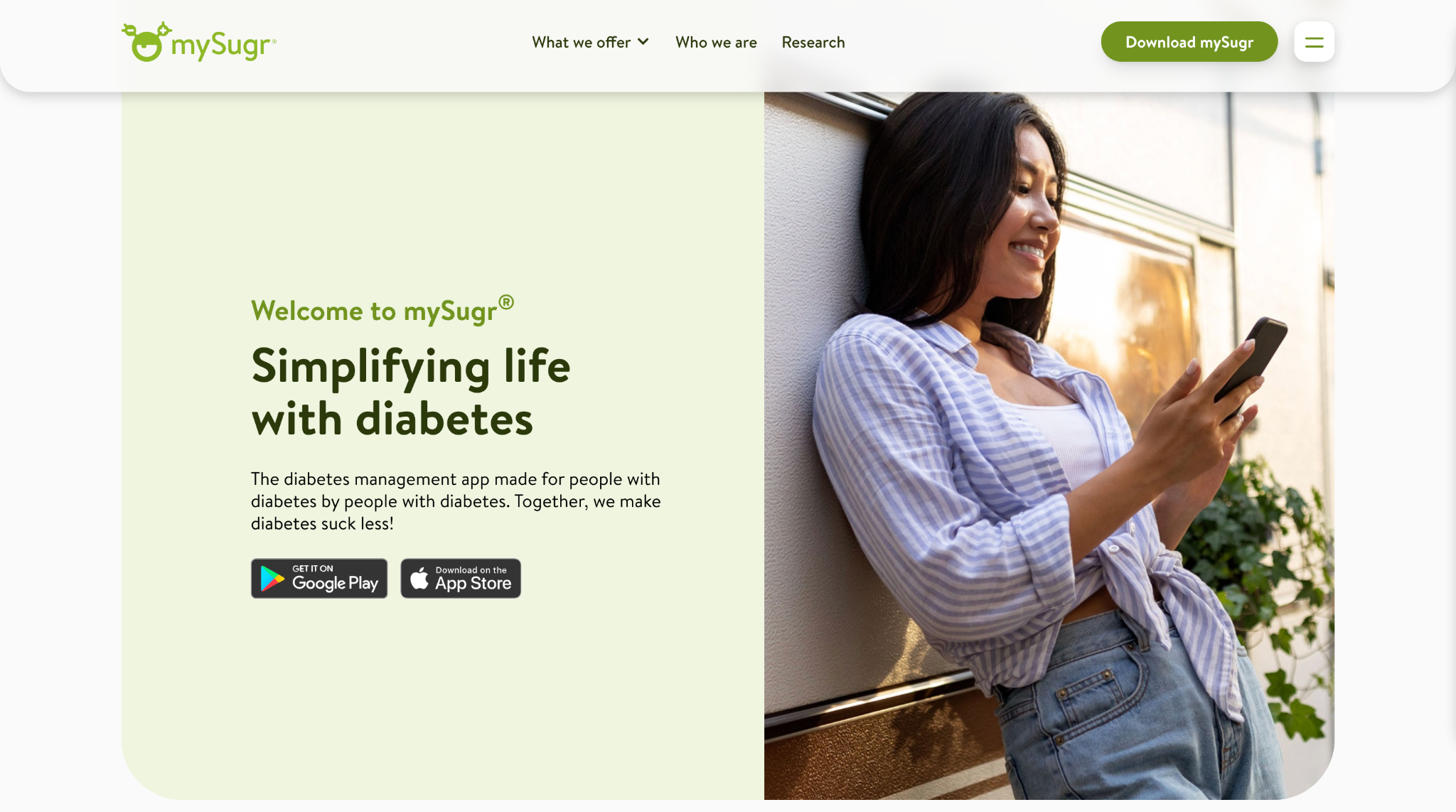
Figure 1: mySugr
mySugr is a mobile diabetes management app that lets users log blood sugar, meals, insulin, and medication in one dashboard, with an estimated HbA1c calculated from regular logging. It also has tough challenges and missions to keep users engaged. The tracking and gamification in mySugr are similar to the core features envisioned in Diabeatis360, but there is no localization for Filipino food culture
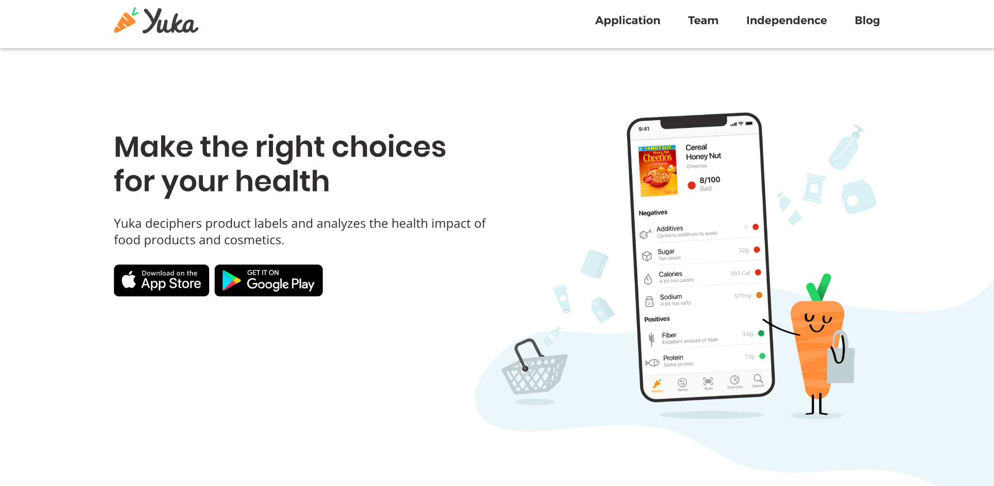
Figure 2: Yuka
Yuka is a mobile app that lets users scan food or cosmetic barcodes and instantly rate a product's healthiness from 0 to 100 based on its nutritional value, additives, and organic status. If a product gets a low score, Yuka suggests better alternatives. This scanning and scoring system is very similar to the AI-based nutrition label feature proposed for Diabeatis360.

Figure 3: KonsultaMD
KonsultaMD is a Philippine telehealth app where users can talk to licensed doctors anytime, through video calls, phone calls, or chat. It also lets people order prescriptions and get reminded about their health needs. It shows the kind of doctor chat, appointment booking, and notification features that Diabeatis360 wants to include. However, KonsultaMD is made for general health concerns, not specifically for managing diabetes.

Figure 4: The Filipino Doctor (TFD)
The Filipino Doctor is a Philippine telemedicine app that links patients with local doctors for remote consultations and prescriptions, with a secure payment system and digital prescription vault. Medicines can also be delivered to users. Secure doctor-patient communication is already being done locally, said TFD, lending credence to the feasibility of the doctor chat module in Diabeatis360.

Figure 5: Glucose Buddy
Glucose Buddy is an application for diabetics that enables monitoring of blood glucose levels, provides weekly reports and workout routines, and allows users to get in touch with certified diabetes coaches remotely on demand. The features provided by Glucose Buddy include the blood sugar tracking and remote coaching features of Diabeatis360 but lack a culture fit for Filipinos.

Comparative Matrix/Competitors' Analysis
Diabeatis360 and comparable diabetic self-management apps are compared in the comparative matrix. Based on key features such as blood sugar monitoring, nutrition scanning, AI-assisted recommendations, and doctor consultations, the comparative matrix compares Diabeatis360's features with those of other diabetes self-management apps.
Table 1
Comparative Matrix
Features | mySugr | Yuka | KonsultaMD | The Filipino Doctor | Glucose Buddy | Diabeatis360 | Total
Blood Sugar Logging | ✓ |  |  |  | ✓ | ✓ | 50.00%
Blood Sugar Interpretation (Low/Normal/High/Critical) with Real-Time Feedback |  |  |  |  |  | ✓ | 16.67%
Trend Visualization | ✓ |  |  |  | ✓ | ✓ | 50.00%
Reminder/Notification System | ✓ |  | ✓ |  |  | ✓ | 50.00%
Nutrition Label Scanning |  | ✓ |  |  |  | ✓ | 33.33%
Localized Meal & Exercise Recommendations |  |  |  |  |  | ✓ | 16.67%
AI-Assisted Recommendations |  | ✓ |  |  |  | ✓ | 33.33%
AI Diabetes Risk Prediction |  |  |  |  |  | ✓ | 16.67%
Doctor Chat/Consultation |  |  | ✓ | ✓ |  | ✓ | 50.00%
Appointment Scheduling |  |  | ✓ | ✓ |  | ✓ | 50.00%
Health Progress Dashboard | ✓ |  |  |  | ✓ | ✓ | 50.00%
Gamification | ✓ |  |  |  |  | ✓ | 33.33%
Total | 41.67% | 16.67% | 25% | 16.67% | 25% | 100%
Table 1 highlights that Diabeatis360 is the only service among those compared that covers all 12 features, including the unique Localized Meal Recommendations, Blood Sugar Interpretation with real-time meal and exercise feedback, AI Diabetes Risk Prediction that reflects risk of progression for prediabetic users and risk of poor glycemic control or complications for diagnosed users, and the combined Doctor Chat and Appointment Scheduling module, which are often absent from competing platforms.A comparative analysis reveals that Diabeatis360 is the most effective application for meeting the unique requirements related to diet, monitoring, and consultations among Filipino adult patients with diabetes by incorporating functions such as blood glucose logging, blood glucose interpretation, AI-based advice, AI diabetes prediction, nutritional label scanning, and gamification in one app.
Competitor’s Analysis
Table 2
Competitor’s Analysis
Competitor | Features | Limitations | Platform Details | Support
mySugr  URL: www.mysugr.com  Proponents: Fredrik Debong | -Blood sugar logging  -Estimated HbA1c calculation  -Gamified challenges and missions  -Meal photo logging | - No Filipino food database  -Some features are locked behind a Pro subscription  -Bolus calculator unavailable in some countries | -Mobile App (Android/iOS) | • Email  • In-app support  • Facebook  • Instagram
Yuka  URL: yuka.io  Proponents: Julie Chapon; Benoît Martin; François Martin | -Barcode scanning for food and cosmetic products  -Health rating from 0–100  -Healthier alternative suggestions  -Breakdown of ingredients and additives | -Limited to packaged products with barcodes  -Search feature requires a subscription  -No blood sugar or diabetes-specific tracking | -Mobile App (Android/iOS) | • Email  • Instagram  • In-app help center
KonsultaMD  URL: www.konsulta.md  Proponents: Maridol Ylanan (Global Telehealth, Inc.) | -24/7 doctor consultations  -Video, phone, and chat access  -e-Prescription and e-laboratory requests  -Health reminders and monitoring | -General teleconsultation, not diabetes-specific  -Subscription fees required  -No blood sugar or meal tracking | -Mobile App (Android/iOS)  -Web | • Phone hotline  • Email  • Facebook
The Filipino Doctor (TFD)  URL: thefilipinodoctor.com  Proponents: Medicomm Pacific, Inc. | -Doctor Finder by specialty  -Chat and video call consultations  -Digital prescriptions and medical certificates  -Medicine delivery | -No blood sugar or diet tracking  -Doctor availability varies by specialty.  -Medicine delivery limited to Metro Manila | -Mobile App (Android/iOS)  -Web | • Email  • In-app help center
Glucose Buddy  URL: www.glucosebuddy.com  Proponents: Tom Xu | -Blood sugar, insulin, and meal logging  -Trend graphs and reports  -Access to licensed diabetes coaches  -Wearable technology | -No Filipino food database  -Coaching requires a paid subscription  -No nutrition label scanning | -Mobile App (Android/iOS) | • Email  • In-app support

CHAPTER III

DESIGN AND METHODOLOGY

Research Design
The Diabeatis360 project adopts a developmental and iterative research design to guide the creation of a mobile-based diabetes management and telehealth consultation application intended for diabetic patients and healthcare providers in the Philippines. This approach emphasizes the planning, analysis, design, and development of a system that addresses common challenges in diabetes self-management by integrating features such as blood sugar monitoring, AI-powered meal and exercise recommendations, AI chatbot assistance, nutrition label scanning, doctor chat and appointment consultation, gamification, and a health progress dashboard.
The most suitable design for this study is a developmental research, as Diabeatis360 is a system that needs to be built, tested and evaluated, and not just observed and measured. Experimental research is not considered as it requires controlled conditions and manipulation of variables which is not applicable to system development. Descriptive research is also not appropriate as its aim is only to describe the existing condition and it does not produce any functional output.
However, developmental research is uniquely suited for research whose end product is a system, tool, or intervention that previously did not exist. It provides a structured progression from problem identification, requirements gathering, design, iterative building and evaluation, each stage feeding into the next. This iterative structure is critical to Diabeatis360 because the core features of the system such as the AI recommendation engine and blood sugar interpretation logic need to be improved through development cycles based on ongoing feedback from diabetic patients and healthcare professionals instead of being designed in a single iteration. This makes developmental research not a matter of preference but a methodological necessity for a study whose deliverable is a working, user-validated software system.
Method
The application of Diabeatis360 is proposed, designed and quantitatively evaluated by the researchers. This method is used to gather and analyze quantitative data to assess system performance and user experience. The system, Diabeatis360, is a mobile-based application developed to support diabetes self-management among individuals with diabetes in the Philippines, including adult and pediatric users under parental or guardian supervision, while also providing healthcare professionals with a telehealth consultation platform through the doctor chat and appointment module. Structured survey questionnaires will be administered in two phases to get measurable data on usability, relevance and system acceptability. The quantitative data collected will allow a statistical evaluation of the relevance and effectiveness of the system and will point out the potential of the system to improve the self-management of diabetes and promote healthier behaviors among the system targeted users.

Flow of the Study
The project began with problem identification, in which the researchers observed the gap between the rising burden of diabetes in the Philippines and the limited cultural relevance of existing self-management applications. This initial observation was tested against the review of related literature and studies, which examined existing research on diabetes self-management, mobile health applications, AI-assisted care, gamification, and telehealth to confirm that the identified problem was both real and insufficiently addressed by current tools. Findings from this review directly shaped the Stage 1 validation survey, which gathered evidence from Filipino diabetic patients and medical professionals to confirm the problem before any design work began.
Once the problem was validated, the researchers proceeded to requirements gathering, drawing from the Stage 1 survey results, the comparative matrix of competitor applications, and consultations with the project adviser to determine what the system needed to do. These requirements were then separated into functional and non-functional categories. An in-depth analysis was made of the data processing flow, UI/UX design, data security and privacy, data storage, reporting tools, and user documentation. All this knowledge was transferred to the design phase, where data modeling, prototypes, a security framework, system architecture, a reporting dashboard, and a user manual were created.
After the design, the system underwent a thorough testing stage consisting of system testing following the ISO 25010 standard covering usability, functionality, reliability, and portability, and user testing conducted with users and doctors or healthcare practitioners. The end product was Diabeatis360: An AI-Integrated Mobile Application for Diabetes Self-Management and Telehealth Consultation in the Philippines. The final step was the review phase, in which user satisfaction, AI recommendation accuracy, engagement metrics, and overall system performance were examined as key evaluation metrics.
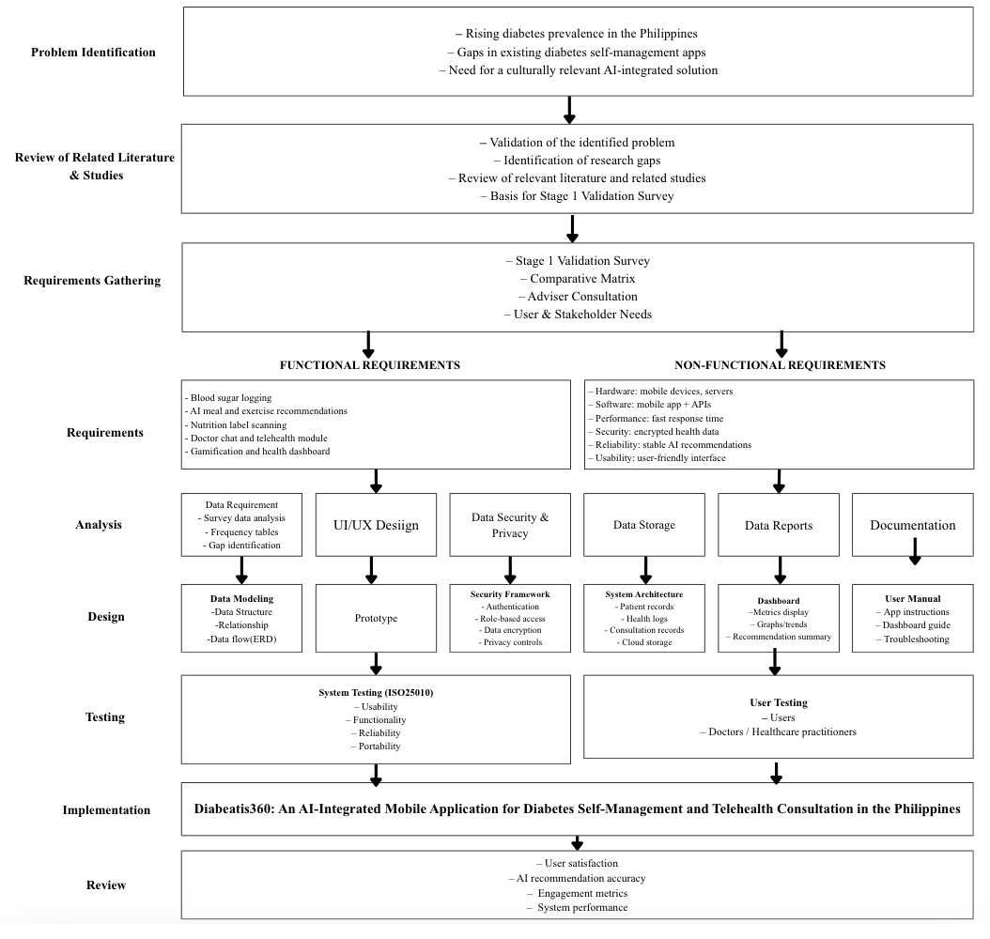
Figure 6: Flow of the Study

Research Environment
The study will be conducted online and will involve two groups of respondents: Filipino adults with Type 1 or Type 2 diabetes and licensed medical professionals involved in the management of diabetic patients. Although respondents from all over the Philippines are welcome to participate in the study, residents of Cebu City and the surrounding areas were given special attention because they are the application's immediate target community. They were instructed to fill out structured Google Forms. The participants will fill out the questionnaire individually on their own devices since the whole process of collecting data was done through digital means. Further, the patient survey form was provided in the Cebuano language as well.

Respondents
The respondents in this study are divided into two groups that represent the primary market segments of the Diabeatis360 application.
The first group includes Filipino adults suffering from either Type 1 or Type 2 diabetes that use the Diabeatis360 mobile application as their main point of access for the application. They are the ones that would benefit the most from the self-management functionalities provided by the system such as blood sugar monitoring, AI-driven suggestions for food intake and physical activity, scanning of nutrition labels, gamification, and health dashboard. The reason why they were chosen as the potential participants of the survey is that they directly have to deal with the issues related to diabetes management, which makes them the most suitable people to confirm the problems and the solution offered.
Licensed medical professionals who manage patients with diabetes, such as endocrinologists, nurses, dietitians, and other healthcare providers, make up the second group. This group represents the healthcare provider side of the Diabeatis360 telehealth platform, specifically the doctor chat and appointment module through which remote consultations with diabetic patients will be conducted. The system must be selected from a clinical system for the clinical system.
Sampling Method
The study uses purposive sampling for both respondent groups, selecting only participants with characteristics directly relevant to the study's objectives. For the diabetic patient group, purposive sampling was applied to include only Filipino adults who have been formally diagnosed with either Type 1 or Type 2 diabetes and who are potential users of the Diabeatis360 mobile application. The sample selected for the medical professionals was done using purposive sampling where only registered healthcare practitioners who manage diabetes patients were selected. Purposive sampling is a method which works well in conducting research about system assessment and users' views of the health applications being developed. This form of sampling involves selecting participants based on their suitability to the research questions at hand (Andrade, 2021).

Research Instruments
The research design was based on a quantitative approach with data being collected using two structured questionnaires that were filled through Google Forms. The first questionnaire was sent out to adult Filipino diabetics while the second one was sent to certified medical practitioners. Both started with the informed consent form which gave the purpose of the research and assured anonymity of the respondent’s data.
Questionnaire #1 was divided into four main parts: (1) demographic information (age, gender, barangay, type of diabetes, years diagnosed with diabetes); (2) current practices of self-management (frequency of blood sugar measurement, methods of tracking, dietary practices, exercise routines, medication schedule); (3) problems related to self-management practices, assessed using a four-point Likert scale measuring frequency of monitoring, medication adherence, availability of appropriate Filipino foods, availability of consultations, appropriateness of tools currently used, and ability to afford medications; and (4) technology and app use (previous experience with an app, usefulness of app features, reasons for non-use, desirable features of a diabetes management application). The name of the app Diabeatis360 was not used to avoid response bias.
The medical practitioners’ survey also included four parts as follows: (1) demographic information (age, gender, specialization, period of experience, working environment); (2) methods used in managing patients with diabetes (methods of observation, difficulties that arise, methods of giving advice on diet, ways of following up); (3) attitudes towards telemedicine and digital tools (previous experience, perceived advantages, worries about accuracy, privacy, and patient literacy); and (4) necessity of having a local digital tool, its desirable characteristics, and readiness to use a safe doctor portal for online patient management.
Responses from both groups were used to validate the identified problems and guide the development of Diabeatis360's features.

Research Procedure
In this section, the researchers outline the steps taken to gather, treat, and analyze data relevant to the study.

Data Gathering
A well-documented research schedule was developed for the data collection process. The researchers drafted a letter of transmittal and forwarded it to the respective office in an attempt to get authorization for conducting the study and distribution of survey questionnaires to the selected people. It specifies the purpose of the study and reassures the respondents that the information will be kept confidential and used for academic purposes only. Once the authorization was received, the online survey questionnaires were then distributed to the respondents via Google Forms.
The surveys were centered on diabetic management habits, health problems, the use of existing technology, perception of telemedicine, and the need for an indigenous diabetes management tool using digital technology. A purposive sampling method will be used to select respondents, ensuring that participants have relevant experience and characteristics to validate the identified problems meaningfully. The first group was made up primarily of Filipino adults with Type 1 or Type 2 diabetes who lived in Cebu City and surrounding areas. The second group consisted of licensed medical professionals who manage diabetic patients and were also primarily based in Cebu City. The proponents will be present throughout the process to help participants understand the study's aim and ensure they understand all the questions. All respondents completed the questionnaire electronically, and researchers were available to clarify questions as needed.

Treatment of Data
Quantitative techniques were employed in order to carry out an analysis of the data that was gathered from the two sets of respondents. The data that was collected using Google Forms was analyzed quantitatively in order to determine the challenges associated with self-management of diabetes among the diabetics in the Philippines, as well as the opinions of the medical practitioners about the use of telehealth technology and digital health technology. Demographic information was also supplied by the participants in order to provide insight into the findings.
The raw survey responses were closely examined for incomplete or inconsistent entries to preserve the integrity and accuracy of the data. The cleaned dataset was organized and input into a spreadsheet for structured quantitative analysis. Descriptive statistics that include frequency distribution and percentage distribution have been used to reveal similarities in the experiences, obstacles, and perceptions related to diabetes self-management and Diabeatis360 usage by diabetics and medical practitioners. The analyzed data will be presented using charts, graphs, and tables to illustrate trends and make findings more visually accessible and understandable. A Likert scale will be employed for the purpose of evaluation of the system using the questionnaire in the second stage, and the total score of 3.50 on average from all the dimensions will be taken as the indicator of acceptable performance of the system. Quantitative insights from both respondent groups will inform actionable recommendations to develop the Diabeatis360 application further and ensure its relevance to the diabetes self-management and telehealth consultation needs of its target users in the Philippines.

Ethical Considerations
The researchers will uphold the highest ethical standards in order to safeguard the rights, dignity, privacy, and welfare of all the participants in the course of the research process. The participants will be provided with full details regarding the nature of the research, its methodology, the possible benefits and risks associated with the research, as well as the rights of the participants as part of the research. Participation in the research will be purely voluntary, with all the participants giving their consent before participating in the research. (World Medical Association, 2022).
All information collected during the study, including questionnaire responses and data entered into the Diabeatis360 prototype, will be treated with strict confidentiality. Access to the collected data will be restricted to the authorized members of the research team, and appropriate measures will be taken to ensure secure storage and handling of all research records. Personal identifiers will be removed or anonymized whenever possible to protect participants' identities and prevent unauthorized disclosure of confidential information (Council for International Organizations of Medical Sciences [CIOMS], 2021).
Given that the proposed system will be gathering personal health information, such as glucose levels and dietary practices, as well as health profiles, only those minimum amounts of personal health information required for the realization of the purposes of the study will be collected. The investigators will not ask for medical reports, lab reports, or any other type of very sensitive information that is not absolutely needed in the evaluation of the proposed system. Sufficient technical and administrative controls will be in place to prevent unauthorized access to, modification of, or disclosure of the information collected (National Institute of Standards and Technology, 2020).
The researchers will make sure that all research activities comply with institutional ethics as well as national laws before the collection of data. The researchers will adhere to principles of integrity, accountability, transparency, respect for persons, and responsible data management in order to perform quantitative research with humans in an ethical manner throughout the research process (Philippine Health Research Ethics Board, 2022).

Software Engineering Methodology
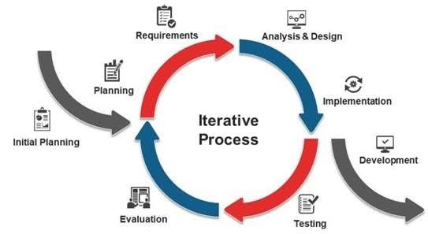
Figure 7: Iterative Research Methodology
The researchers chose the Iterative Research Methodology for the development of Diabeatis360 due to its cyclical, flexible, and improvement-driven nature. This methodology allows the team to gradually build, test, and refine the application's features based on ongoing feedback from diabetic patients and medical professionals. Through this iterative process, the importance of certain core components like blood sugar monitoring, AI-powered diet and workout suggestions, reading nutrition labels, consulting doctors, gamification, and health status tracking was realized in a systematic and efficient manner. This process makes sure that the final product will be user-friendly as well as fast and dependable enough to satisfy the requirements of the target audience for managing diabetes and consulting with a doctor through telehealth.

Planning or Conception-Initiation Phase
In this phase of planning, the course of action for the entire Diabeatis360 project is defined. In the planning phase, the problem statement, which the project seeks to address, is identified along with the user group of the proposed system. Critical system requirements will be determined to ensure the successful development of Diabeatis360 as a comprehensive diabetes self-management and telehealth platform for individuals with diabetes in the Philippines. The Business Model Canvas, Program Workflow Diagram, Validation Board, Functional Decomposition Diagram, and Gantt chart are important planning tools that will guide the development process, clarify user needs, and ensure that personal health data is handled responsibly throughout the project.

Business Model Canvas
The Business Model Canvas created for Diabeatis360 acts as a road map that explains the way in which the application will be able to create, deliver, and capture value for the people using it. This model describes the main elements of the proposed system, such as its value proposition, target users, key partners, resources, channels, customer relationships, cost structure, and revenue streams. With the help of this model, the researchers made sure that the system Diabeatis360 will be not only feasible but also sustainable and will be able to address the needs of Filipino adults with diabetes. The Business Model Canvas provides information about the value proposition, target users, key partners, and required resources for the operation of the application. In addition, it includes the channels and customer relationships used to make the application engaging and accessible for users. Moreover, it provides information about the cost structure and revenue streams that can help ensure the sustainability of the proposed system.
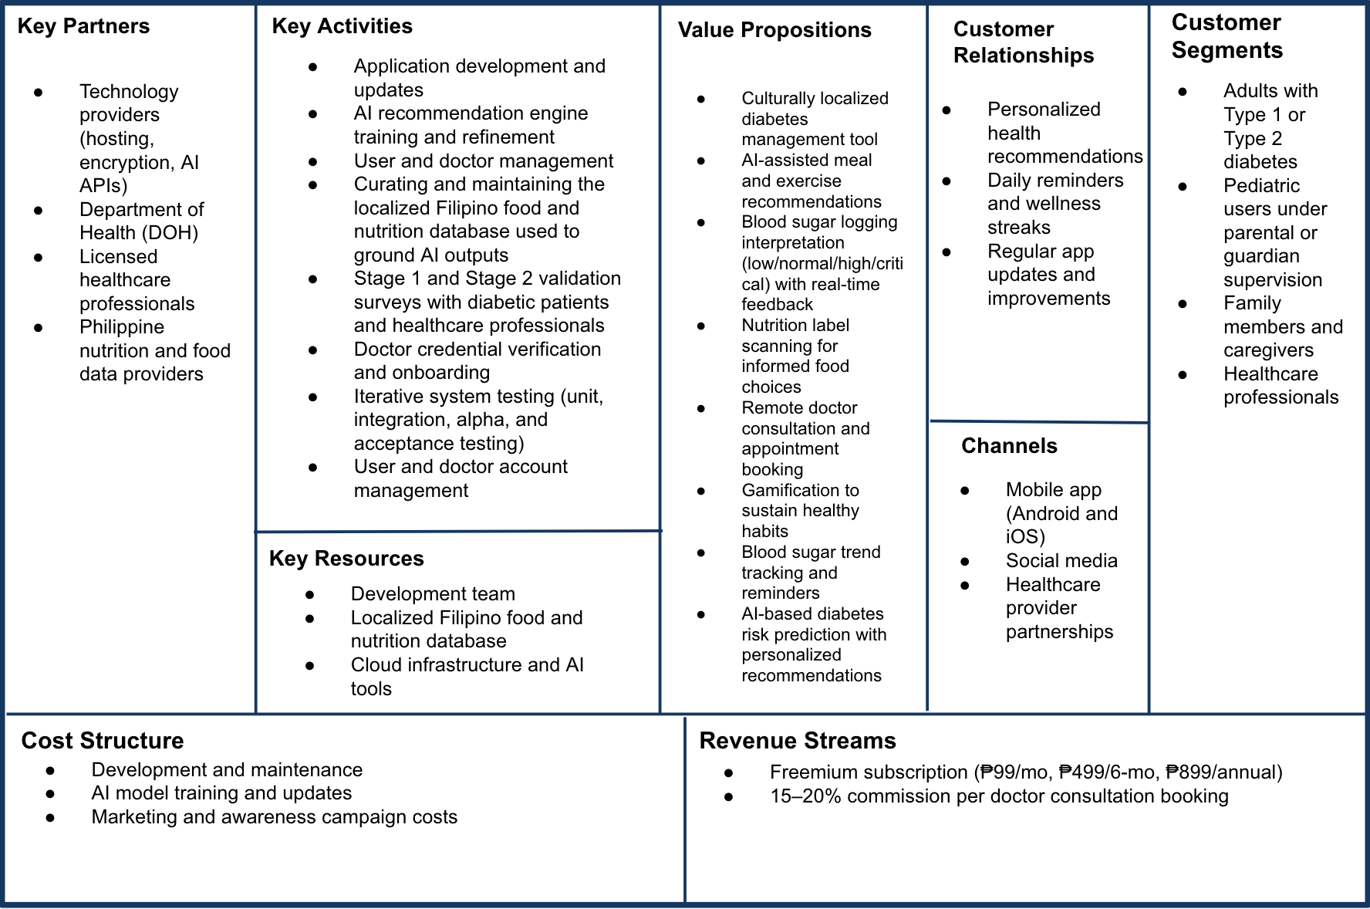

Figure 8: Business Model Canvas

The Revenue Streams for Diabeatis360 combine a freemium subscription model with a commission-based structure for doctor consultations. The Free Plan provides access to core self-management features including blood sugar logging, AI diabetes risk prediction, basic health reminders, the doctor chat and appointment module, and basic gamification, but with daily limits on nutrition label scanning of up to 3 scans per day and AI meal and exercise recommendations of up to 2 generations per day. Users who choose to upgrade to Premium gain full unlimited access to all features including unlimited nutrition label scanning, unlimited AI meal and exercise recommendations, full gamification, priority appointment booking, and advanced AI health reports. Premium users simply choose their billing cycle based on their preference: Monthly at ₱99 for full access, 6-Month at ₱499 for the same full access at better value, or Annual at ₱899 for the same full access at the best value.
In addition to subscriptions, Diabeatis360 earns 15 to 20 percent commission on each completed doctor consultation booking, with doctors retaining the remainder of their set consultation fee. Since the doctor chat and appointment module is accessible even on the Free Plan, every user regardless of subscription status contributes to this revenue stream every time they complete a consultation. Doctors benefit as well since they set their own consultation fees and retain the majority of their earnings, which encourages more healthcare professionals to join and remain active on the platform. Such a two-tiered approach guarantees the financial sustainability of Diabeatis360, making diabetes management tools available and affordable to every Filipino diabetic patient, irrespective of his/her capacity to pay for premium services.

Program Workflow
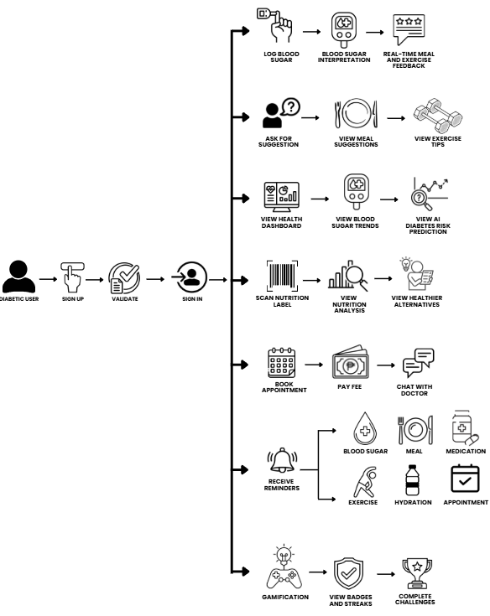

Figure 9: Diabetic User Workflow
This figure shows the entire process flow of Diabetic User in the Diabeatis360 mobile application. To begin with, the user first signs up, validates, and logs into the application to be able to use its features. In health management, the user will log his/her blood sugar level; this automatically initiates the blood sugar interpretation feature, where the level is classified as low, normal, high, or critical and generates meal and exercise suggestions accordingly.
Through the AI assistance feature, the user can ask for personalized suggestions and receive localized meal and exercise recommendations based on their health profile. The nutrition scanning feature allows users to scan food product labels, view nutritional analysis, and receive suggestions for healthier alternatives. The health dashboard gives the user a comprehensive view of their blood sugar trends and their AI diabetes risk prediction, which generates a personalized risk classification reflecting their risk of progressing to full diabetes if prediabetic, or their risk of poor glycemic control or complications if already diagnosed with Type 1 or Type 2, along with corresponding recommendations for prevention, correction, and maintenance.
Under appointment management, the user can book a consultation with an available doctor, which includes paying the consultation fee and, optionally, chatting with the doctor once the appointment is confirmed. The user also receives timely reminders across six health behavior categories: blood sugar checks, meals, medication, exercise, hydration, and appointments to keep them consistent with their self-management routine. Finally, the gamification feature allows users to view their earned badges and streaks and to complete wellness challenges to stay motivated in managing their condition.

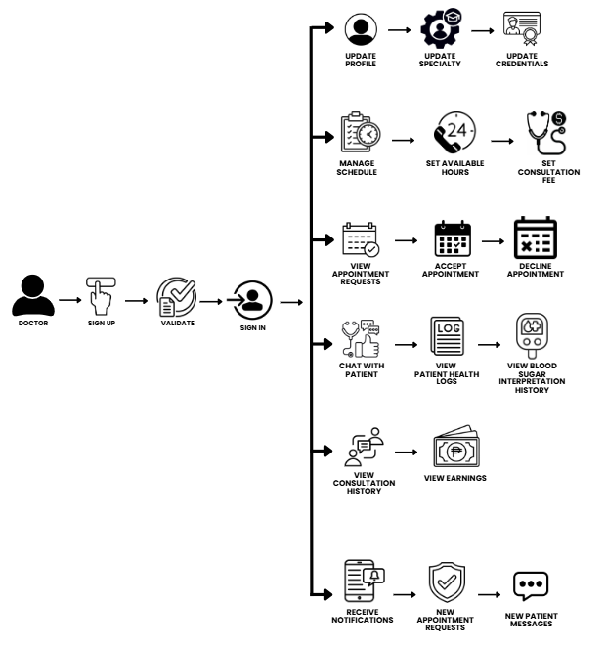
Figure 10: Doctor Workflow
This diagram represents the general workflow of the Doctor in the Diabeatis360 mobile application. The doctor logs in using another doctor account, completes the validation, and is redirected to their personal dashboard. From there, the doctor can update their profile, including their specialty and credentials, and manage their consultation schedule by setting their available hours and consultation fee. The doctor can view the appointment requests and accept or reject them. After making the appointment, the physician will be able to correspond with the patient using the in-app messaging feature, as well as analyze the health log and blood sugar interpretation records of the patient to guide the consultation process. The physician will also be able to check their complete history of consultations and their earning from completed appointments. Moreover, the physician will be notified instantly when an appointment or message comes in.

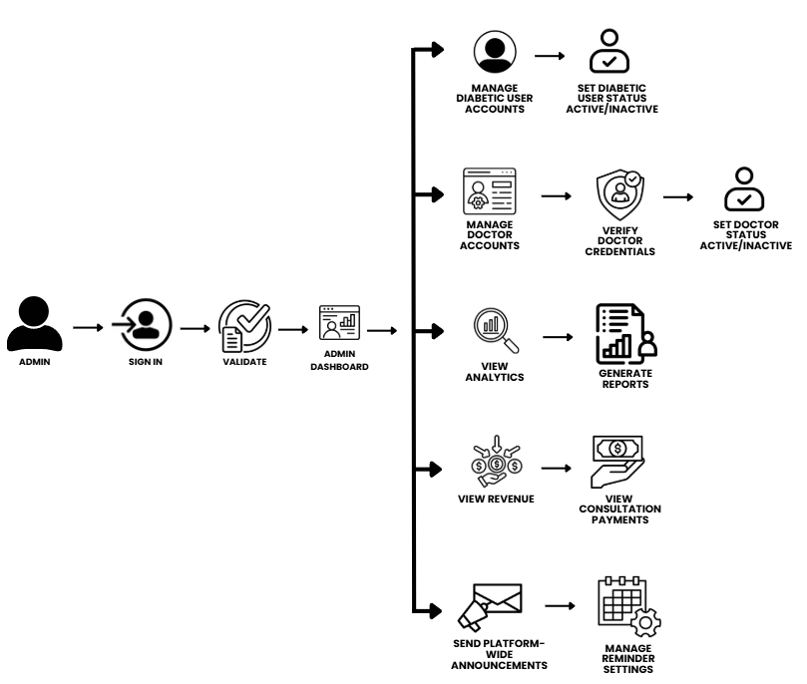
Figure 11: Admin Workflow
This diagram shows the overall workflow for the Admin in the Diabeatis360 system, including the web-based admin panel. The admin logs in through a web browser, validates, and goes to the admin dashboard. From there, the admin can control all registered 'users' accounts and change each account's status to active or inactive as needed. The admin can also verify doctors' credentials, set their status, and manage all doctor accounts. Under community management, the admin can view all community posts and remove any inappropriate content to maintain a safe and respectful platform environment. The admin monitors overall platform activity through the analytics module and can generate system reports based on usage data. Revenue management allows the admin to view all income generated from consultation payments. Finally, the admin can send platform-wide announcements to all users and manage the reminder settings configured across the application.

Validation Board (Stages 1 and 2)
Table 3
Stage 1 Validation Board
STAGE 1
Startup Name | Diabeatis360: An AI-Integrated Mobile Application for Diabetes Self-Management and Telehealth Consultation in the Philippines
Customer Segment | Filipino adults 18 to 60 diagnosed with Type 1 or Type 2 diabetes or prediabetes who own and regularly use a smartphone, residing in Cebu City and surrounding areas. (Note: While the application is designed to support pediatric users under parental supervision, the system evaluation for this study will primarily focus on adult respondents, as stated in the Scope and Limitations.)
Hypothesis | It is very difficult for many diabetic Filipino adults to practice self-management techniques since there are no culturally specific tools to help them do so, they are fragmented, and also because they lack personalization according to local eating and living practices.
Experiment (Method) | A Google Forms survey will be conducted among Filipino adults and licensed medical professionals in Cebu City to validate the presence and extent of diabetes self-management challenges. The survey will explore current self-management practices, difficulties with blood sugar tracking, problems with existing health apps, perceptions of telehealth, and the impact of the lack of a locally adapted digital tool. Questions will be structured, multiple-choice, and will not mention Diabeatis360 to avoid bias and to validate the problem independently.
Success Metric | At least 70% of respondents report finding it difficult to manage their diabetes with currently available tools consistently, or that existing apps do not reflect their local food culture and daily habits.
GET OUT OF THE BOX
Result | To be determined after survey administration.
Action | To be determined based on results.

Table 4
Stage 2 Validation Board
STAGE 2
Startup Name | Diabeatis360: An AI-Integrated Mobile Application for Diabetes Self-Management and Telehealth Consultation in the Philippines
Customer Segment | Filipino adults aged 18 to 60 diagnosed with Type 1 or Type 2 diabetes who own and regularly use a smartphone, residing in Cebu City. (Note: The application under parental supervision supports pediatric users, but the system evaluation for this study will focus on adult respondents to establish system acceptability, as per the study's Scope and Limitations.)
Hypothesis | A mobile application that provides localized meal and exercise recommendations, blood sugar tracking, AI-assisted health suggestions, gamified wellness goals, and access to doctor consultations will help Filipino adults with diabetes manage their condition more consistently and effectively.
Solution | Diabeatis360 — a mobile application built specifically for Filipino diabetic adults that integrates blood sugar logging, blood sugar interpretation that classifies each reading as low, normal, high, or critical with corresponding real-time meal and exercise feedback, AI-powered personalized meal and exercise suggestions based on local food culture, nutrition label scanning, AI diabetes risk prediction that generates a personalized risk classification reflecting risk of progressing to full diabetes for prediabetic users, and risk of poor glycemic control or complications for users already diagnosed with Type 1 or Type 2 with recommendations for prevention, correction, and maintenance, a health progress dashboard, gamification features, and a doctor consultation and appointment module into a single platform.
Experiment (Method) | A second Google Forms survey will be administered to respondents after they are introduced to and interact with the Diabeatis360 prototype. The survey will evaluate the app's perceived usefulness, ease of use, cultural relevance of recommendations, trust in AI-generated suggestions, comfort with the doctor consultation feature, and overall likelihood of continued use.
Success Metrics | At least 80% of respondents agree (or strongly agree) that Diabeatis360 is useful, easy to use, and more relevant to their daily lives as Filipino diabetics than other apps they have tried or are aware of. A composite mean score of 3.50 or higher (out of 4.00) across all key evaluation dimensions will also be considered indicative of acceptable system performance.
GET OUT OF THE BOX
Result | To be determined after survey administration.
Action | To be determined based on results.

Business Roadmap
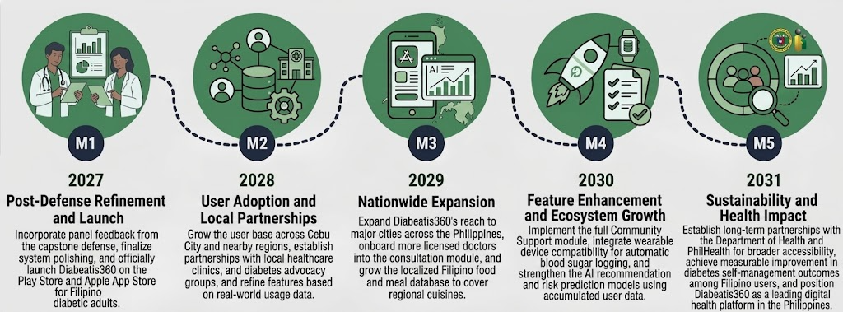

Figure 12: Business Roadmap
The Business Roadmap of Diabeatis360 highlights the major milestones from June 2025 to November 2025, along with the full development cycle of the application, from initial validation to final submission. The primary objective is to validate the problem and the proposed solution through surveys of Filipino diabetic patients and medical professionals in Cebu City in June 2025 to validate the need for a locally adapted diabetes self-management platform. The next step is system design, that is, the definition of the system architecture, database structure, and technical basis of the application Diabeatis360, which will serve as a guide for the development process in July 2025.
August 2025: Core Development Begins. The team develops and tests the app's core features, including the health progress dashboard, AI-generated meal and exercise suggestions, blood sugar interpretation, blood sugar logging, and nutrition label scanning. September 2025: Advanced development and testing phase: Doctor consultation module, gamification features, and AI diabetes risk prediction are developed. Internal alpha testing is conducted to identify and resolve bugs and usability issues before the application is released to respondents. In October 2025, the completed application is given to the intended respondents for testing, and their feedback on the system's functionality, usability, and general applicability is collected and reviewed. All paperwork completed, Diabeatis360 application finalized and capstone project formally submitted in November 2025.
Functional Decomposition Diagram
A functional decomposition diagram represents the essential system components needed to build the Diabeatis360 platform for effective health tracking and administration. This structured breakdown serves as a development roadmap, detailing the core modules from user onboarding to clinical monitoring, data analytics, and backend management necessary to achieve the platform's objectives.
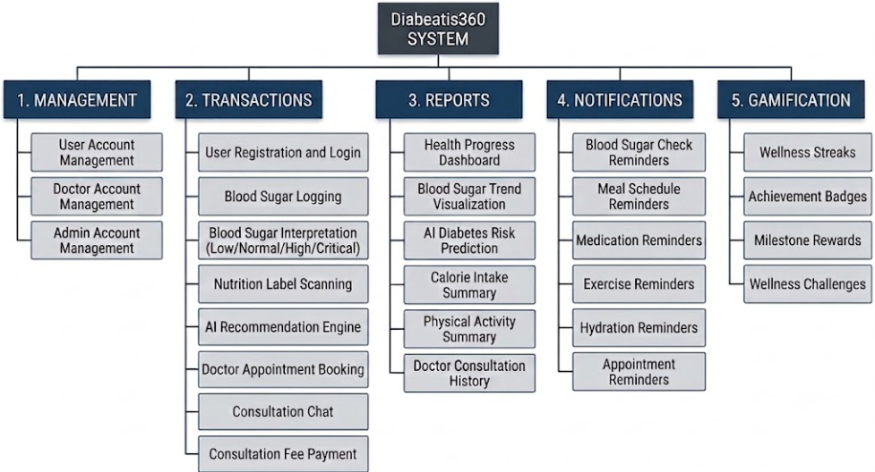

Figure 13: Functional Decomposition Diagram
The main functions and features of Diabeatis360 are broken down hierarchically in the Functional Decomposition Diagram. The Diabeatis360 system, which is separated into five primary categories—Management, Transactions, Reports, Notifications, and Gamification—is at the top of the hierarchy. The specific modules in each category determine the platform's functionality.
Under Management, the system manages user, doctor, and admin accounts, as well as community content, to ensure an organized and secure platform operation. The Transactions module covers the core functional processes of the application, including registration, blood sugar logging, blood sugar interpretation that classifies each reading as low, normal, high, or critical, real-time meal and exercise feedback that is always generated based on the interpretation result, nutrition label scanning, AI-generated recommendations, doctor appointment booking, consultation chat, and payment processing.
Reports include the health progress dashboard, blood sugar trend visualization, AI diabetes risk prediction that evaluates the user's logged health data, dietary habits, and activity level to generate a personalized risk classification reflecting risk of progressing to full diabetes for prediabetic users, and risk of poor glycemic control or complications for users already diagnosed with Type 1 or Type 2 with corresponding recommendations for prevention, correction, and maintenance, calorie and activity summaries, and consultation history, giving users and admins clear visibility into platform data. The Notifications module delivers timely reminders across six health behavior categories: blood sugar checks, meals, medication, exercise, hydration, and appointments, to keep users consistent with their self-management routine. Finally, the Gamification module drives sustained engagement through wellness streaks, achievement badges, milestone rewards, and wellness challenges, reinforcing daily healthy habits over time
The Functional Decomposition Diagram provides a structured representation of how each module contributes to the overall operation of Diabeatis360. By organizing the system into interconnected functional areas, it becomes easier to understand the responsibilities and interactions of every component. This hierarchical structure also supports efficient system development, testing, and future enhancements by clearly defining each module's scope. Overall, the diagram serves as a blueprint that guides the development of Diabeatis360 while ensuring that every function aligns with the system's objectives of improving diabetes monitoring, personalized care, and user engagement.

Gantt Chart
Table 5
Gantt Chart
Task ID | Task Name | Task Lead | Start Date | End Date | June 2026 |  |  |  | July 2026 |  |  |  | August 2026 |  |  |  | September 2026 |  |  |  | October 2026 |  |  |  | November 2026
 |  |  |  |  | 1 | 2 | 3 | 4 | 1 | 2 | 3 | 4 | 1 | 2 | 3 | 4 | 1 | 2 | 3 | 4 | 1 | 2 | 3 | 4 | 1 | 2 | 3 | 4
 | PHASE 1: INITIAL PLANNING
1.1 | Problem Identification and Topic Selection | Gulay | 06/01/2026 | 06/01/2026
1.2 | Definition of Target Users and System Scope | Gillera | 06/01/2026 | 06/08/2026
1.3 | Stage 1 Validation Survey (Problem Validation) | Catubay | 06/08/2026 | 06/15/2026
1.4 | Business Model Canvas | Catubay | 06/08/2026 | 06/15/2026
1.5 | Business Roadmap | Gulay | 06/15/2026 | 06/15/2026
1.6 | Functional Decomposition Diagram | Gulay | 06/15/2026 | 06/22/2026
1.7 | Program Workflow Diagram | Gulay | 06/15/2026 | 06/22/2026
1.8 | Validation Board (Stage 1) | Gulay | 06/22/2026 | 06/22/2026
 | PHASE 2: REQUIREMENTS
2.1 | Stage 2 Validation Survey (Solution Validation) | Gulay | 06/22/2026 | 06/29/2026
2.2 | Validation Board (Stage 2) | Gulay | 06/22/2026 | 06/29/2026
2.3 | Identification of System Requirements | Gillera | 06/22/2026 | 06/29/2026
2.4 | Technology Stack Selection | Gillera | 06/29/2026 | 06/29/2026
2.5 | Hardware and Software Specifications | Gillera | 06/29/2026 | 07/01/2026
 | PHASE 3: ANALYSIS AND DESIGN
3.1 | Use Case Diagrams (User, Doctor, Admin) | Gulay | 07/01/2026 | 07/05/2026
3.2 | Storyboard / UI Wireframes | Catubay | 07/02/2026 | 07/05/2026
3.3 | Entity-Relationship Diagram (ERD) | Gillera | 07/02/2026 | 07/05/2026
3.4 | Data Dictionary | Gillera | 07/03/2026 | 07/05/2026
3.5 | Network Model and Topology | Gillera | 07/03/2026 | 07/05/2026
3.6 | List of Modules | Gillera | 07/03/2026 | 07/05/2026
 | PHASE 4: ITERATION 1 — Core Features
4.1 | User Registration, Login, and Profile Setup | Catubay | 07/20/2026 | 07/27/2026
4.2 | Blood Sugar Logging | Gillera | 07/20/2026 | 08/03/2026
4.3 | Blood Sugar Interpretation (Low/Normal/High/Critical) | Gulay | 07/27/2026 | 08/03/2026
4.4 | Real-Time Meal and Exercise Feedback | Gulay | 07/27/2026 | 08/03/2026
4.5 | Notification and Reminder System | Gulay | 08/03/2026 | 08/10/2026
4.6 | Health Progress Dashboard | Catubay | 08/03/2026 | 08/10/2026
4.7 | Unit Testing — Iteration 1 | Gillera | 08/10/2026 | 08/17/2026
4.8 | Integration Testing — Iteration 1 | Gillera | 08/17/2026 | 08/17/2026
 | PHASE 5: ITERATION 2 — Advanced Features
5.1 | AI Recommendation Engine (Meal and Exercise) | Gillera | 08/17/2026 | 08/24/2026
5.2 | Nutrition Label Scanning | Gulay | 08/17/2026 | 08/31/2026
5.3 | AI Diabetes Risk Prediction | Gulay | 08/24/2026 | 08/31/2026
5.4 | Doctor Chat and Appointment Module | Gillera | 08/31/2026 | 09/09/2026
5.5 | Gamification (Streaks, Badges, Milestones, Challenges) | Gulay | 09/09/2026 | 09/10/2026
5.6 | Consultation Fee Payment | Catubay | 09/10/2026 | 09/11/2026
5.7 | Unit Testing — Iteration 2 | Gulay, Gillera,Catubay | 09/12/2026 | 09/13/2026
5.8 | Integration Testing — Iteration 2 | Gulay, Gillera,Catubay | 09/14/2026 | 09/14/2026
 | PHASE 6: ALPHA TESTING
6.1 | Internal Alpha Testing (Full System) | Gulay, Gillera,Catubay | 09/14/2026 | 09/21/2026
6.2 | Bug Fixing and Refinement | Gulay, Gillera,Catubay | 09/21/2026 | 09/28/2026
6.3 | Performance and Security Review | Gulay, Gillera,Catubay | 09/21/2026 | 09/28/2026
 | PHASE 7: EVALUATION — ACCEPTANCE TESTING
7.1 | Presentation of System to 30 Respondents | Gulay, Gillera,Catubay | 09/28/2026 | 09/28/2026
7.2 | Acceptance Testing — User | Catubay | 09/28/2026 | 10/05/2026
7.3 | Acceptance Testing — Doctor | Gulay | 09/28/2026 | 10/05/2026
7.4 | Acceptance Testing — Admin | Gillera | 09/28/2026 | 10/05/2026
7.5 | Survey Administration and Data Collection | Gulay, Gillera,Catubay | 10/05/2026 | 10/12/2026
7.6 | Data Analysis and Interpretation of Results | Gulay, Gillera,Catubay | 10/05/2026 | 10/12/2026
 | PHASE 8: FINAL DOCUMENTATION AND SUBMISSION
8.1 | Summary, Conclusions, and Recommendations | Gulay, Gillera,Catubay | 10/12/2026 | 10/19/2026
8.2 | Final Formatting and Proofreading | Gulay, Gillera,Catubay | 10/19/2026 | 10/26/2026
8.3 | Submission of Complete Capstone Document | Gulay, Gillera,Catubay | 10/26/2026 | 11/02/2026
8.4 | Panel Presentation and Defense | Gulay, Gillera,Catubay | 11/02/2026 | 11/09/2026

Table 5 presents the comprehensive Gantt chart for the Diabeatis360 capstone project, covering the full development lifecycle from June to November 2026. The chart is organized according to the Iterative Research Methodology. It outlines eight distinct phases: Initial Planning; Requirements; Analysis and Design; Iteration 1, covering core features; Iteration 2, covering advanced features; Alpha Testing; Evaluation through Acceptance Testing; and Final Documentation and Submission. Key milestones such as consultation dates, system design deliverables, alpha testing, user acceptance testing, and the final panel presentation and defense are mapped across the six-month timeline to ensure that all major activities are completed by November 2026. This structure aligns with the project's software engineering approach and demonstrates a clear progression from problem validation through system development, user acceptance, and final submission.

Analysis-Design Phase
During the analysis-design phase, the researchers used the use case diagram, created the storyboard, and designed the database and network to formalize the system’s requirements.

Use Case Diagrams
This diagram illustrates how the User interacts with the Diabeatis360 mobile application. The User is a Filipino adult diagnosed with Type 1 or Type 2 diabetes who accesses the system through the mobile app. The User can perform the following actions:
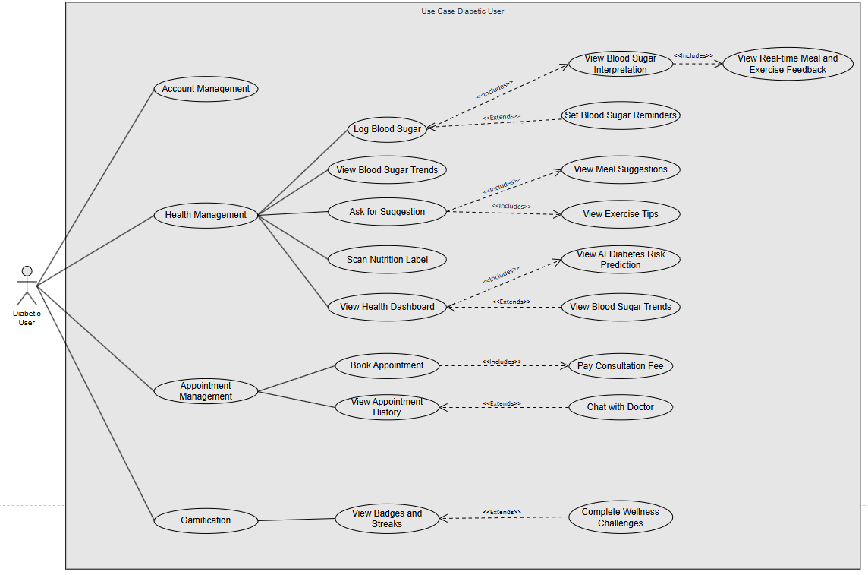
Figure 14: Diabetic User Use Case Diagram
This diagram illustrates how users interact with the Diabeatis360 mobile application. Users can manage their accounts by creating, updating, and deleting their profiles. Under health management, users can log their blood sugar readings, which automatically triggers the blood sugar interpretation feature that classifies each reading as low, normal, high, or critical and always includes real-time meal and exercise feedback based on the result. Users can also optionally set blood sugar reminders from the logging feature and view their blood sugar trends over time. They can tap the Ask for Suggestion button to receive AI-generated personalized meal and exercise recommendations based on local food culture and scan food product nutrition labels for health ratings and alternative suggestions.
Users can view their health dashboard, which always includes their AI diabetes risk prediction, generating a personalized risk classification that reflects their risk of progressing to full diabetes if prediabetic, or their risk of poor glycemic control or complications if already diagnosed with Type 1 or Type 2, along with corresponding recommendations for prevention, correction, and maintenance. Under appointment management, users can book a consultation with an available doctor, which always requires payment of the consultation fee and optionally allows them to chat with the doctor once the appointment is confirmed. Users can also view their appointment history. The gamification module allows users to view their earned badges and streaks and complete wellness challenges, which sometimes extend to updating their badges and streaks when a milestone is reached.
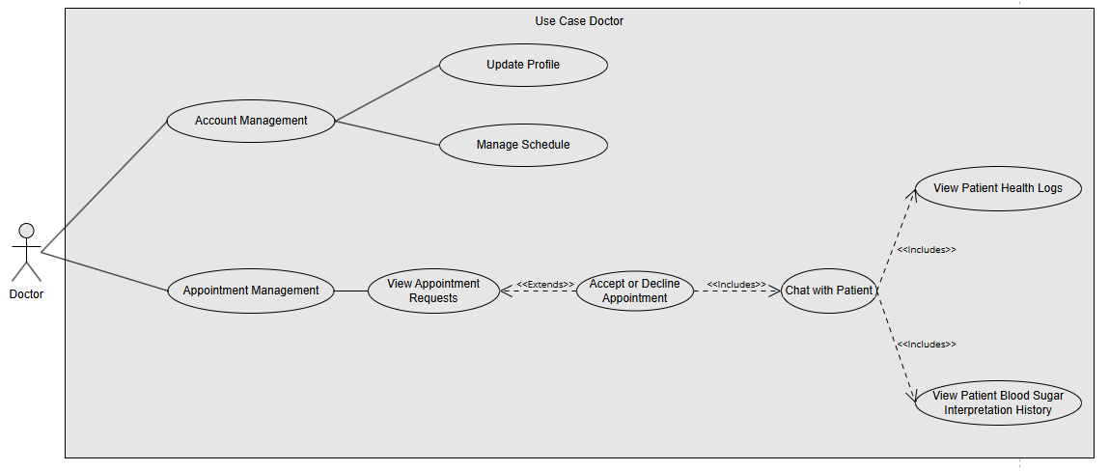
Figure 15: Doctor Use Case Diagram

This diagram illustrates how doctors interact with the Diabeatis360 mobile application. Doctors log in through a separate doctor account and are directed to their personal dashboard. From there, they can manage their profile and set their available consultation schedule. Doctors can view incoming appointment requests from users, which sometimes leads them to accept or decline them. Once an appointment is accepted, the doctor can always communicate with the patient through the in-app chat, which always includes access to the patient's health logs and blood sugar interpretation history to inform the consultation. Doctors can also view their consultation history, which always includes a summary of their earnings from completed appointments.
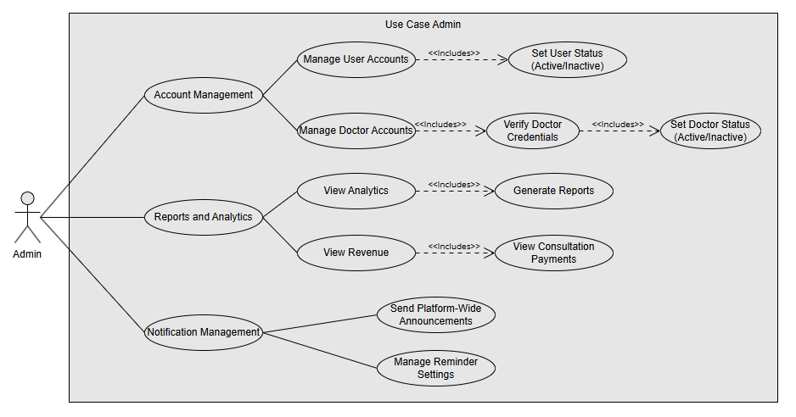
Figure 16: Admin Use Case Diagram
This diagram illustrates how the Admin interacts with the Diabeatis360 system through the web-based admin panel. The Admin does not use the mobile app and can only access the system through a web browser. Managing user accounts always includes the ability to set each account's status to active or inactive. Managing doctor accounts always includes verifying doctor credentials, which in turn sets the doctor's status to active or inactive. The Admin monitors platform activity through the analytics module, which always includes the ability to generate system reports. Revenue tracking always includes visibility into consultation payments. The Admin can also send platform-wide announcements and manage reminder settings for all users.
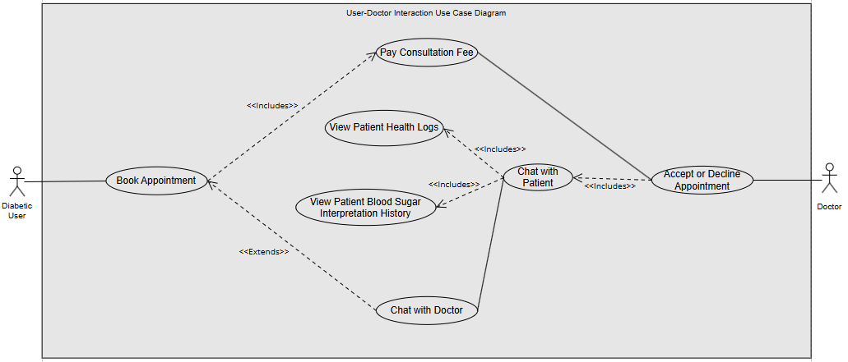
Figure 17: Diabetic User-Doctor Interaction Use Case Diagram
This diagram illustrates the shared interaction between the User and Doctor actors within the appointment and consultation flow of Diabeatis360. When a user books an appointment, the process always includes payment of the consultation fee, and optionally extends to chatting with the doctor once the appointment is confirmed. On the doctor's side, accepting or declining an appointment always includes the ability to chat with the patient, which in turn always grants access to the patient's health logs and blood sugar interpretation history to inform the consultation. The "Chat with Doctor" and "Chat with Patient" use cases represent the same in-app messaging feature viewed from each actor's perspective, showing that once an appointment is booked and accepted, both the user and the doctor converge into a single shared consultation channel.

Storyboard
A storyboard is a graphic organizer with illustrations or images that provides a visual sequence that illustrates how Diabeatis360 works from the user's perspective, giving them a clear overview of its operation in mobile view.

Figure 18: Welcome Page – User
The Welcome Page (User) is the first screen that a user sees when they download the mobile app. Simple typefaces and useful images illustrate the app's basic operation, so users can easily proceed.

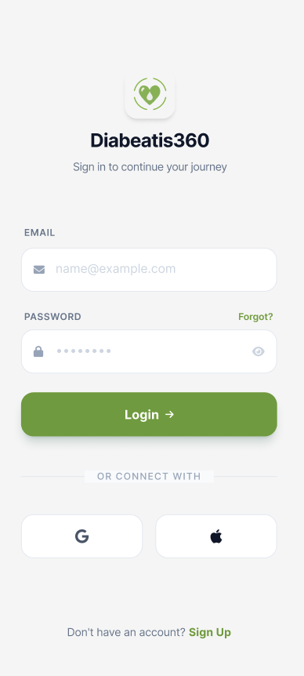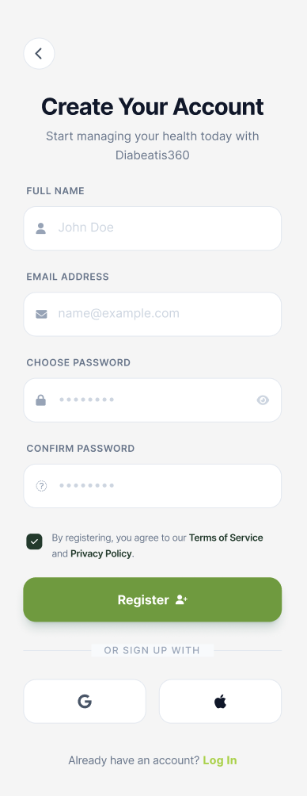
Figure 19: Login Page – Diabetic User Figure 20: Account Registration
These core screens handle authentication and access control for the application. The sign-in page allows existing users to log in with their email and password or use quick social login options. In contrast, the registration page enables new users to create an account by entering their name and credentials and agreeing to the platform's terms.

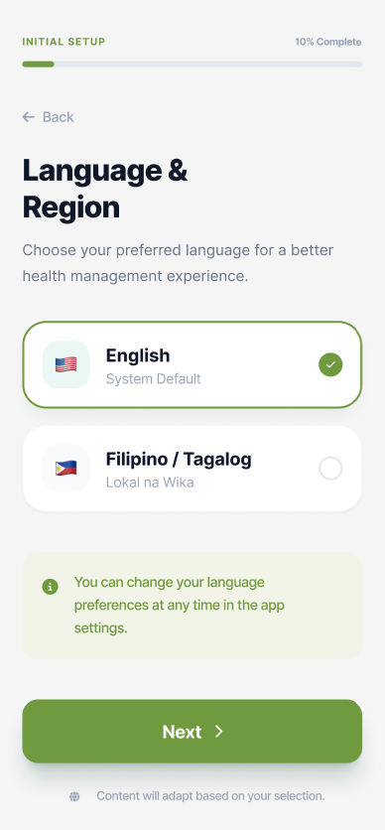
Figure 21: Language Preference

The Language Preference page allows users to select their preferred language for a localized app experience. It displays selectable language options, a helpful settings tip, and a 'Next' button to proceed with the initial setup.

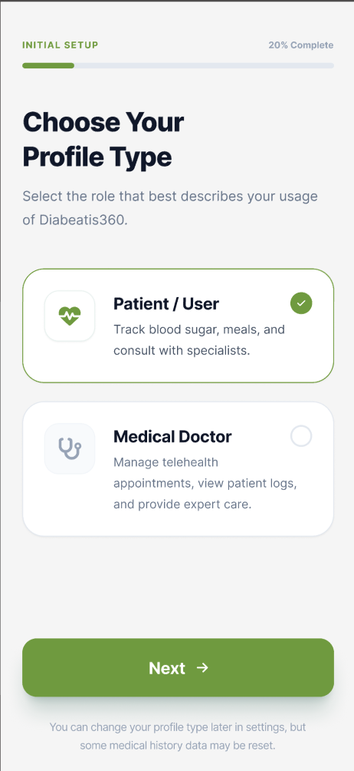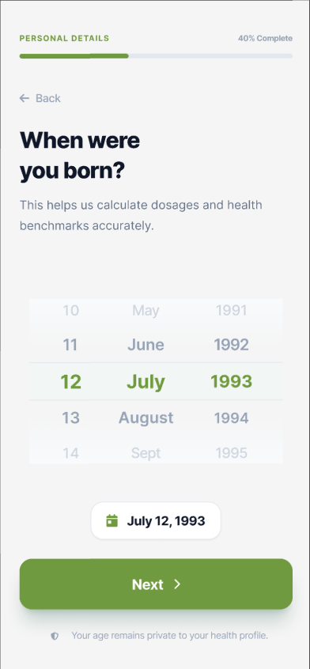
Figure 22: Role Selection Figure 23: Birthdate Selection
These screens represent the progression of the account configuration. The user selects their profile role on the first screen, choosing between a Patient or User account for personal health tracking and a Medical Doctor account for managing telehealth consultations and patient care. The user then enters their date of birth on the second screen, which the system uses to calculate age-appropriate health benchmarks and activate personalized tracking features tailored to the user's profile.

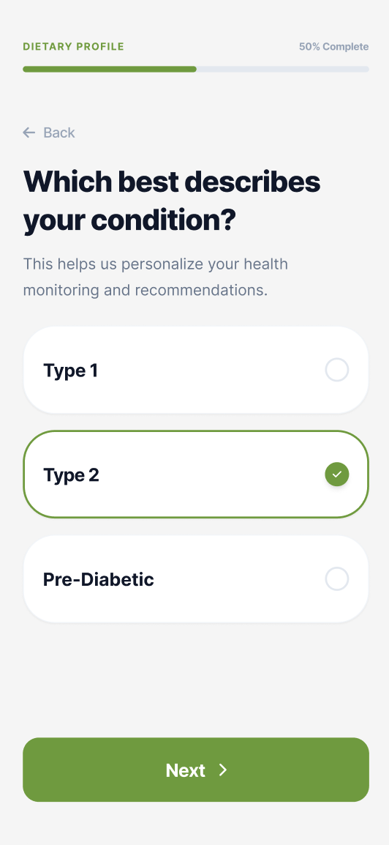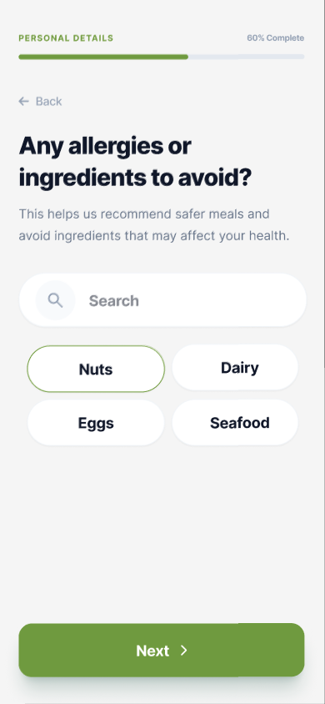
Figure 24: Dietary Profile Setup Figure 25: Medical Condition Profiling

These onboarding steps help customize the overall application environment. The first screen lets the user tap or search for specific food ingredients they need to avoid, which automatically moves them to the next screen, where they select their current diabetes diagnosis to ensure all health-tracking metrics fit their body perfectly.
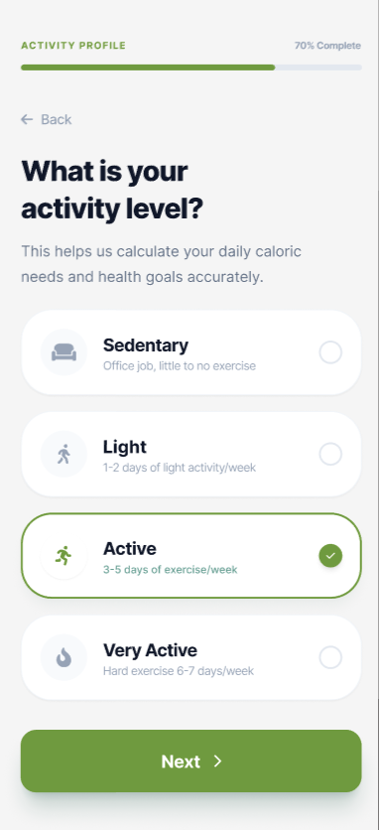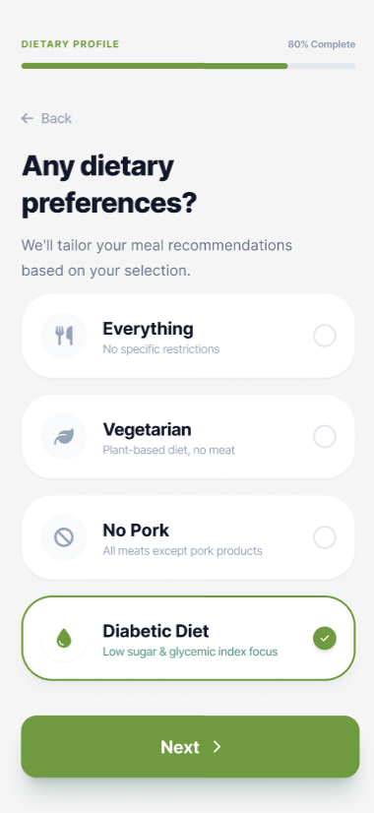

Figure 26: Activity Level Assessment Figure 27: Nutritional Preference Selection
These setup screens establish the user's daily habits to customize their ongoing health targets. The first page determines the user's physical activity level to calculate accurate daily caloric needs. In contrast, the second page captures specific lifestyle or dietary regimens to ensure all automated meal recommendations align safely with their health goals before advancing further into the configuration flow.

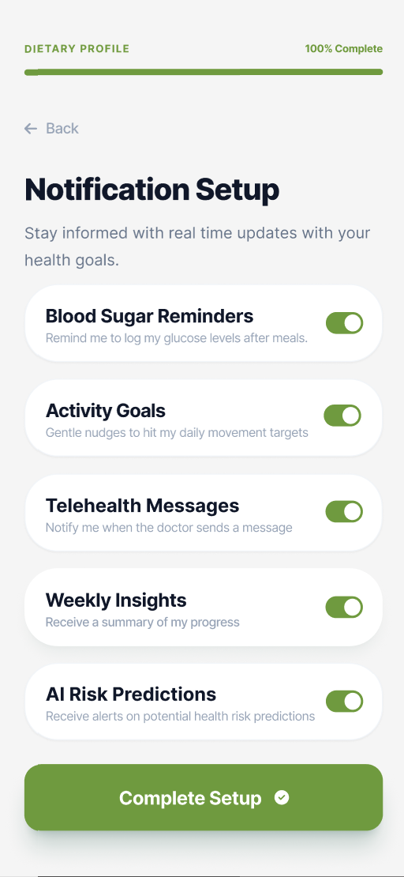

Figure 28: Notification Setup
The user first finalizes their nutritional track by choosing a dietary preference, and then transitions to the final setup page where they can toggle specific real-time alerts, like glucose logging reminders, telehealth message alerts, and risk predictions to reach 100% completion.
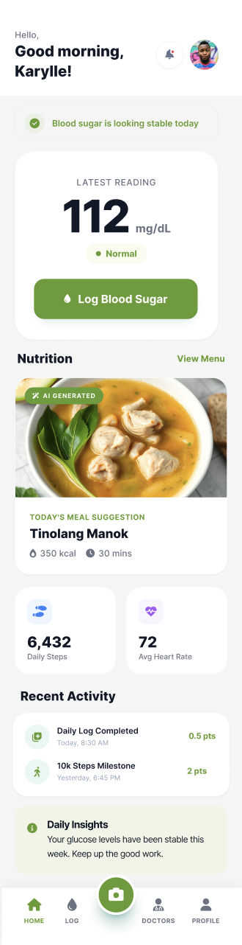
Figure 29: User Health Dashboard
This central interface acts as the core hub for the user's daily health tracking. It summarizes real-time clinical parameters and metrics in a cohesive view, featuring a prominent card for the latest blood glucose measurement with immediate logging, a personalized daily nutrition block highlighting local meal suggestions, and active summaries of physical fitness components.
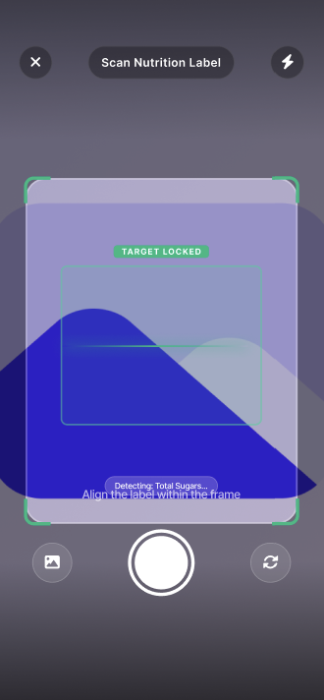
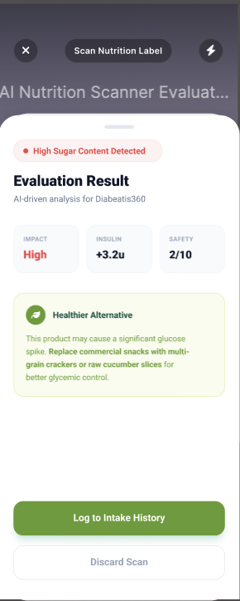
Figure 30: Smart Nutrition Scanner Figure 31: Scan Analysis and Evaluation
This camera-driven utility allows users to evaluate commercial food products in real time against their health profile. The scanning viewport uses the device's camera to target and process nutrition facts labels, which instantly generates a detailed dietary assessment sheet. Based on the scanned nutritional content, the system evaluates the product against the user's diabetes type, dietary preferences, and declared food allergies, and provides a health rating along with suggestions for healthier alternative food options.
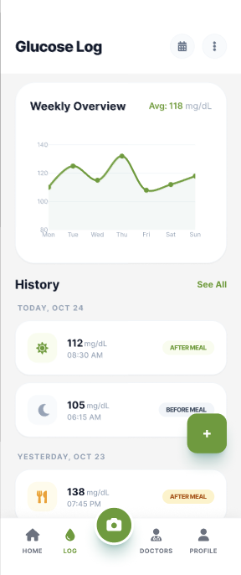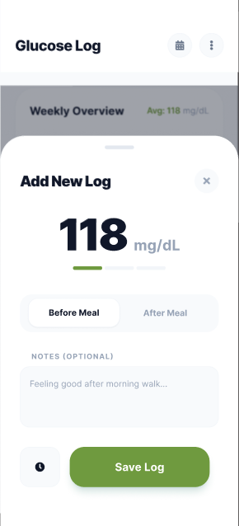
Figure 32: Glucose Logging History Figure 33: Manual Glucose Entry
These screens handle blood sugar tracking. The history view displays a "Weekly Overview" trend graph alongside a chronological feed of logged entries classified by meal status. Tapping the action button opens a modal sheet where users can enter numeric readings, toggle between "Before Meal" and "After Meal" states, add brief personal notes, and save the data instantly.
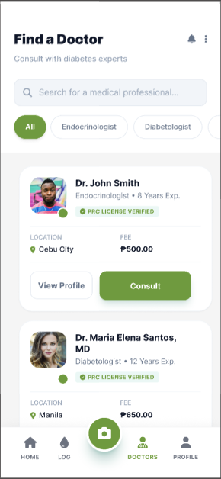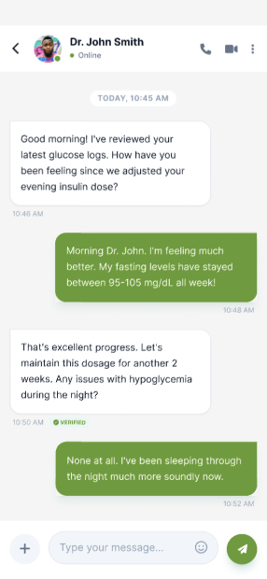

Figure 34: Healthcare Provider Directory Figure 35: Telehealth Consultation

The healthcare provider directory on the left allows patients to search for verified medical professionals using specialized filters such as endocrinologists or diabetologists. The directory displays critical credentials including verified PRC licenses, consultation fees, and local clinic regions. The telehealth interface on the right opens a real-time messaging window where patients and physicians can securely communicate about active blood glucose logs, follow up on medication updates, and manage clinical treatment strategies remotely.
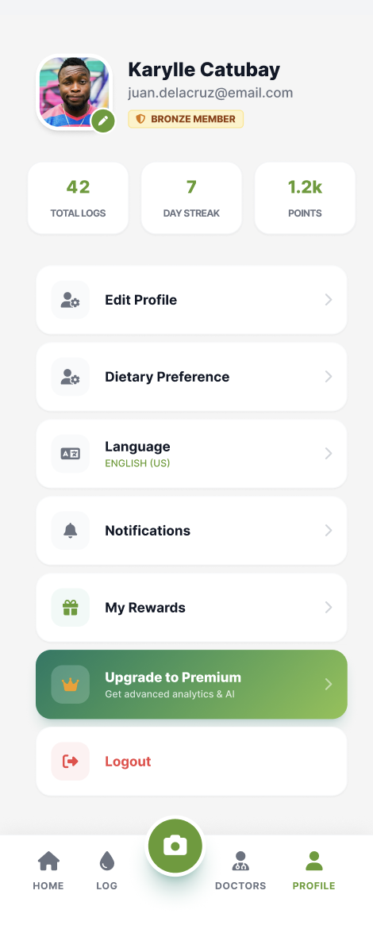

Figure 36: User Settings and Profile Management

The user settings screen centralizes personal account configurations, gamified engagement metrics, and localized application controls, including language preferences, notification toggles, dietary profile updates, and subscription management, in a single management hub.
Storyboard - Doctor

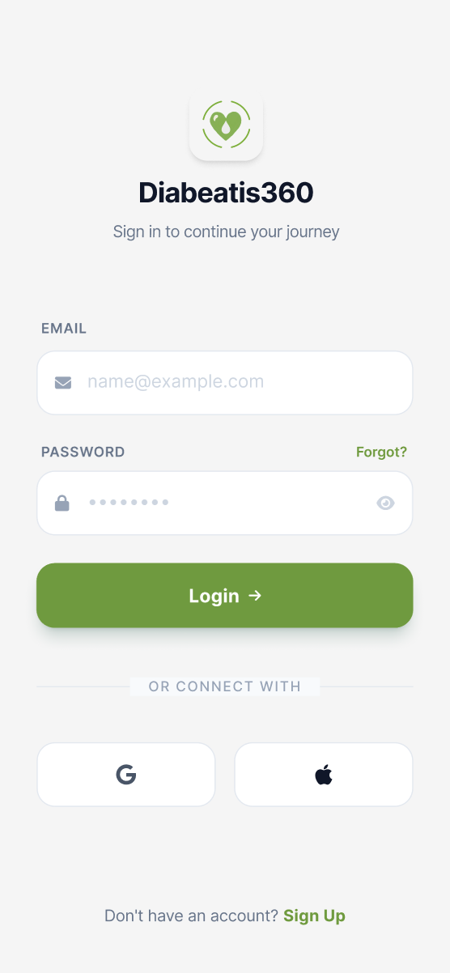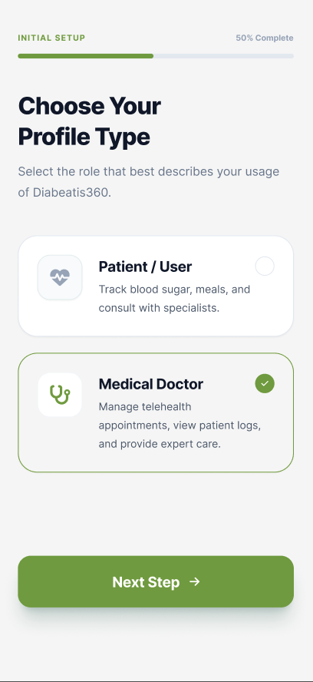

Figure 37: Login Page - Doctor Figure 38: Role Configuration

The login portal on the left securely verifies credentials and grants medical practitioners access to the system—the configuration interface on the right routes healthcare professionals to their respective specialized provider dashboards.
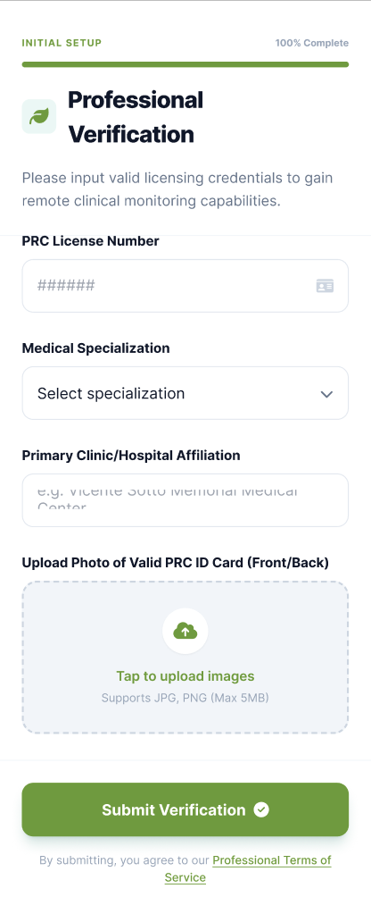

Figure 39: Professional Verification Portal

The credential verification screen securely validates a medical practitioner's professional licensing credentials before granting administrative telehealth and clinical monitoring capabilities within the system.

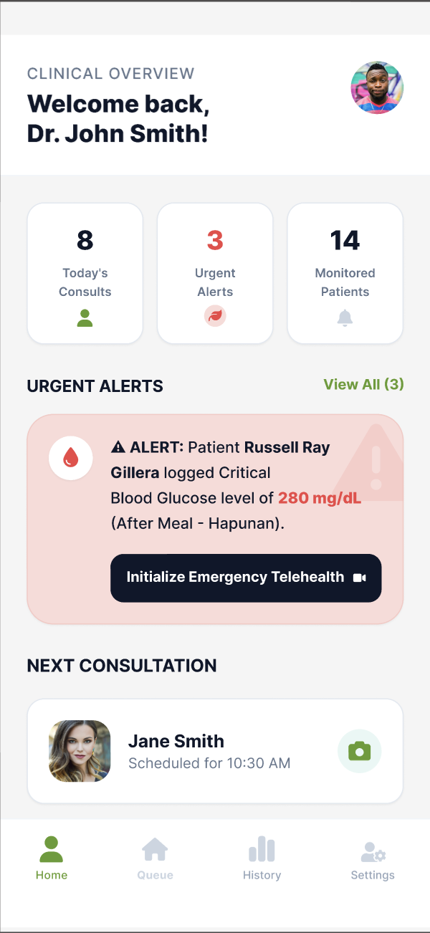

Figure 40: Clinical Overview Dashboard

The medical practitioner dashboard shown centralizes a doctor's daily consultation schedule and flags urgent patient health notifications.
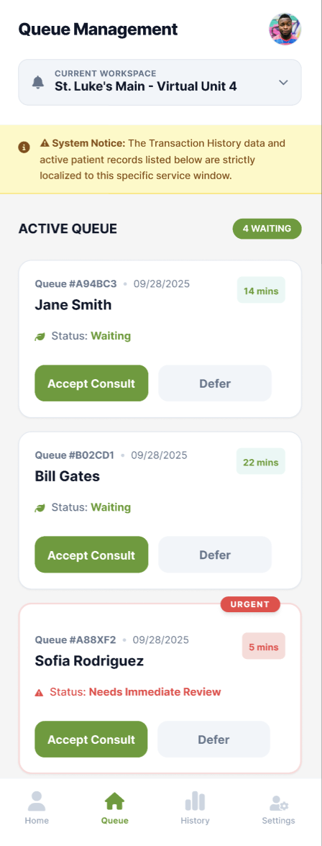

Figure 41: Queue Management

The clinical triage workspace monitors the incoming patient lineup, manages localized consultation requests, and prioritizes immediate clinical reviews. The interactive interface enables doctors to accept or defer incoming consultations while tracking patient wait times and emergency status alerts.
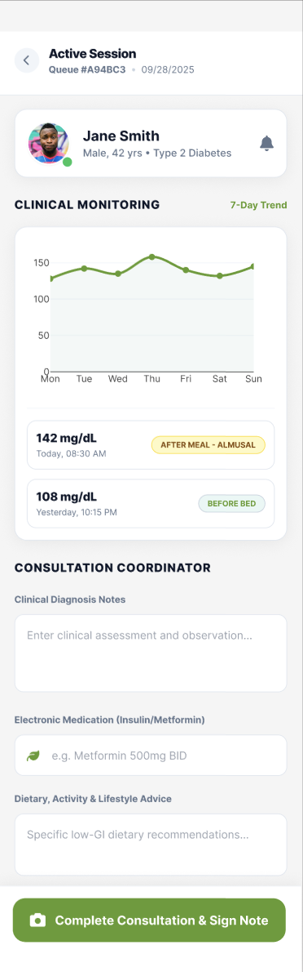
Figure 42: Clinical Monitoring & Consultation

The active session interface synthesizes a patient's ongoing physiological health trends with direct clinical documentation tools during a live appointment. The dashboard tracks multi-day blood glucose logs to give physicians a clear view of metabolic trends, while providing integrated entry fields for recording diagnosis notes, electronic prescriptions, and personalized lifestyle advice.
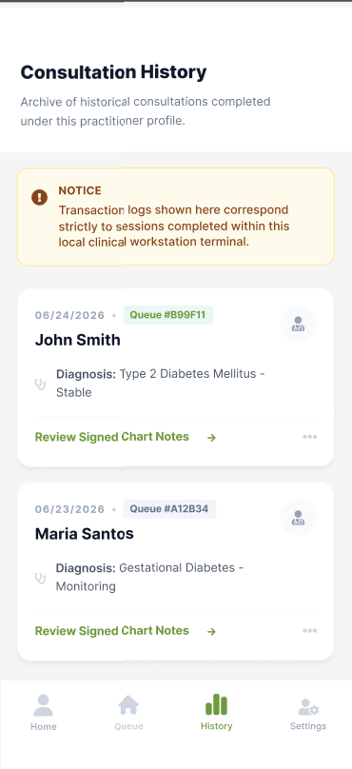
Figure 43: Consultation History

The consultation history interface aggregates past diagnostic records and medical interactions completed exclusively under the active practitioner's profile. The centralized archive serves as a secure audit log allowing physicians to revisit clinical diagnoses and review previously signed chart notes for individual localized sessions.
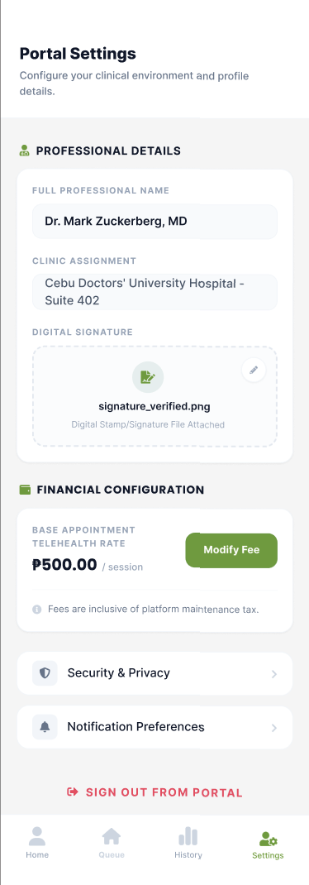

Figure 44: Doctor Settings

The clinical settings interface manages a medical practitioner's professional profile details, workplace assignments, and electronic authentication assets in a centralized dashboard.

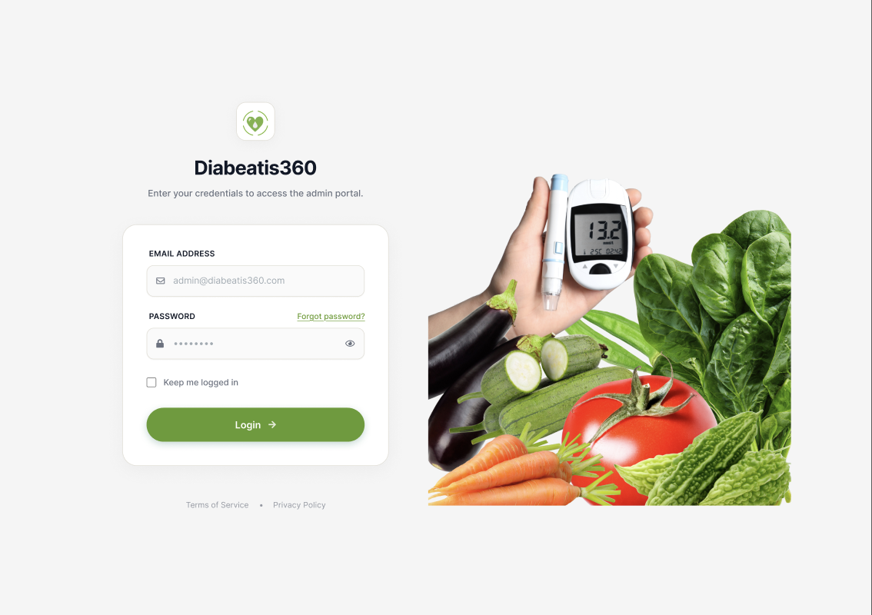
Figure 45: Admin Login Page

The authentication form features dedicated text fields for an administrative email address and password, paired with a secure "Login" action button to process account credentials.
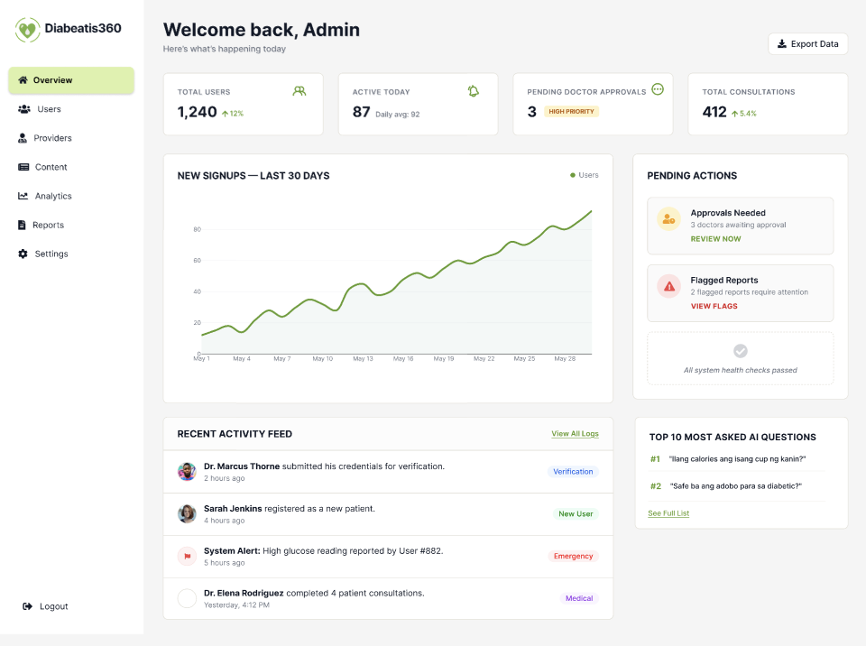

Figure 46: Administrator Dashboard
The administrator dashboard provides system managers with a centralized, real-time overview of user growth metrics, critical operational alerts, and platform activity logs.

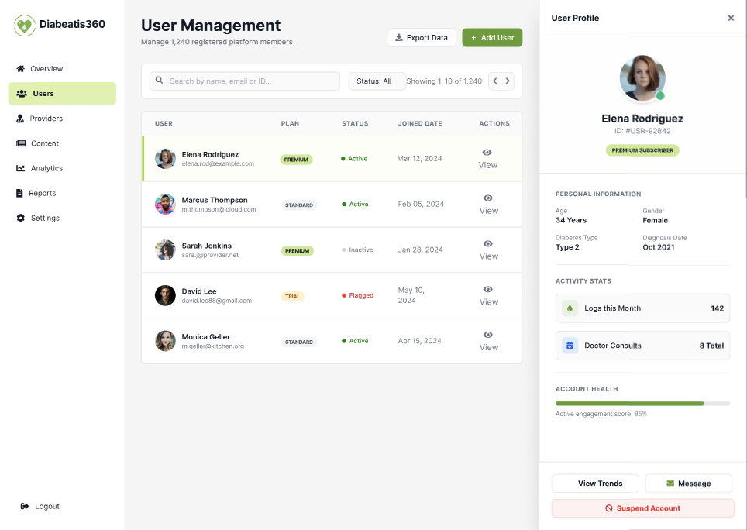

Figure 47: User Management

The user management interface provides administrators with a searchable directory for monitoring registered members' metrics and managing individual account profiles. Administrators can view each user's personal health details, subscription status, activity logs, and consultation history, as well as set individual account statuses to active or inactive as needed. This centralized directory ensures that the platform remains organized, secure, and responsive to any account-related concerns that may arise during system operation.

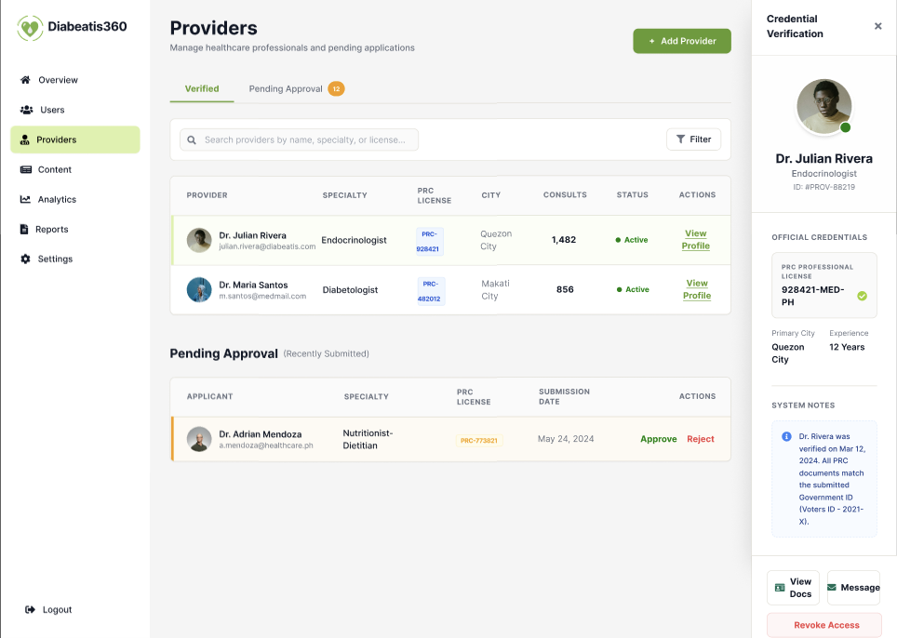
Figure 48: Provider Directory and Verification

The provider management interface oversees healthcare specialists by verifying official medical credentials and reviewing pending practitioner applications.
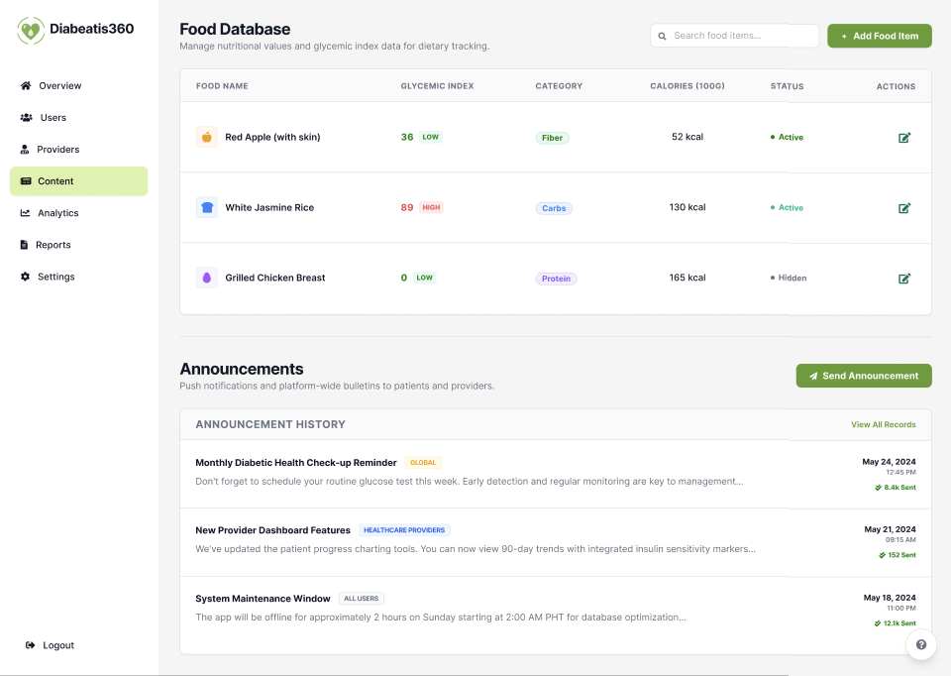
Figure 49: Content and Announcement Management
The content management interface manages the nutritional food database and broadcasts platform-wide bulletins to users.

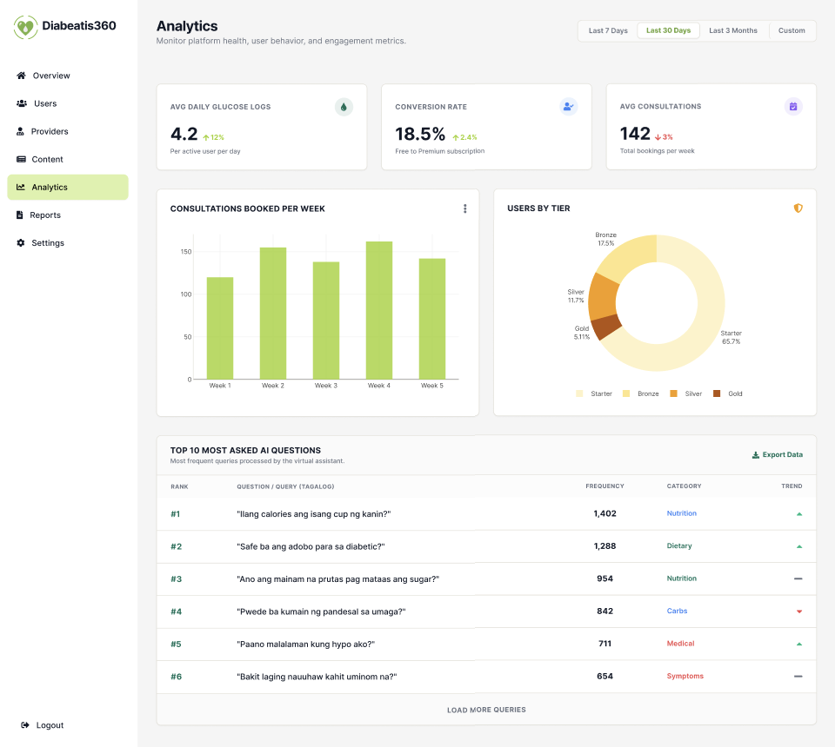

Figure 50: Platform Analytics
The analytics dashboard tracks system performance metrics, consultation trends, and user behavior.
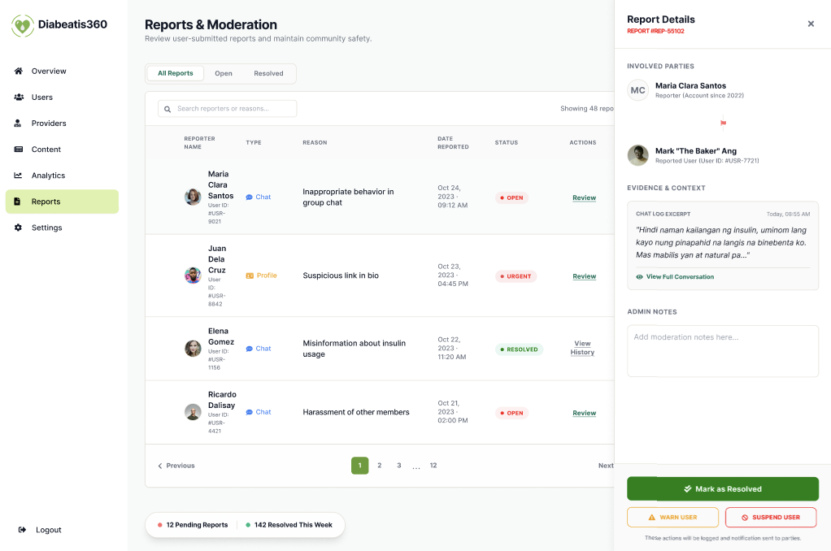
Figure 51: Reports
The reports and moderation interface handles user-submitted complaints and maintains community safety guidelines. Administrators can access detailed report records including the nature of the complaint, the involved parties, and the current resolution status, ensuring that all reported issues are addressed promptly and transparently. This interface serves as the primary tool for maintaining a safe, respectful, and trustworthy environment for all Diabeatis360 users and healthcare providers.

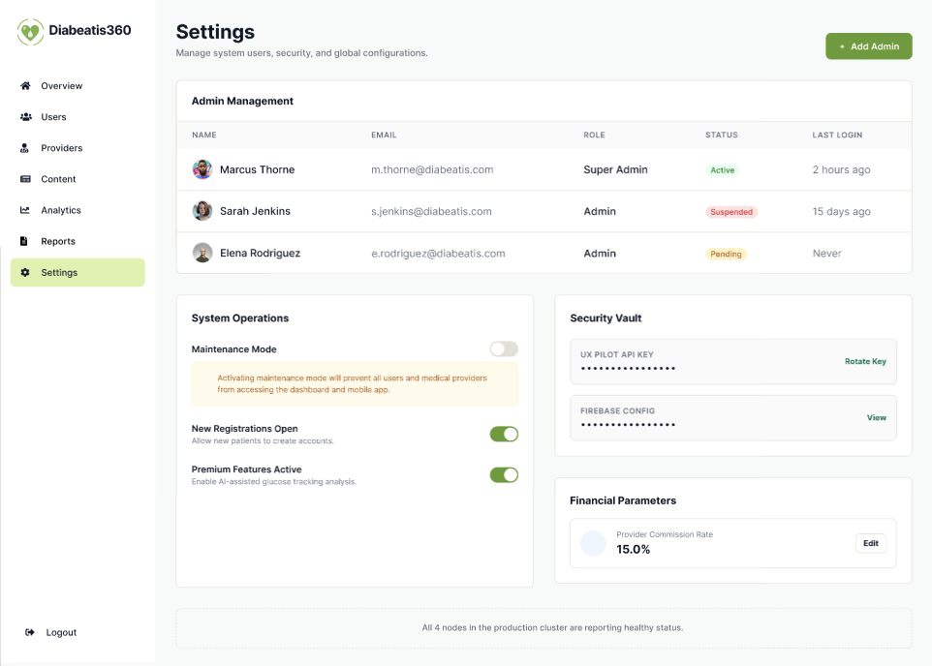

Figure 52: Admin Settings
The global settings dashboard manages administrator accounts, security settings, and overall system operations.

Database Design
Database design is the process of organizing and structuring data to ensure efficient storage, retrieval, integrity, and consistency within a database management system. A well-designed database minimizes redundancy, improves data quality, and supports the overall functionality and scalability of an information system (Al-Fedaghi, 2021). An Entity-Relationship Diagram (ERD) is a conceptual modeling technique used to visualize the structure of a database by identifying entities, attributes, and the relationships between them. Entities represent real-world objects or concepts about which data is stored, while attributes describe the characteristics or properties of each entity.
Relationships in an ERD illustrate how entities interact with one another and are commonly classified as one-to-one (1:1), one-to-many (1:M), or many-to-many (M:N). By establishing primary and foreign keys, the ERD enforces referential integrity, reduces data redundancy, and maintains consistency across related tables. As a result, it serves as a foundation for creating a logical and efficient database structure that supports reliable data management.
In the development of Diabeatis360, the Entity-Relationship Diagram serves as the blueprint for designing the system's database architecture. It illustrates the relationships among key entities such as users, doctors, administrators, blood sugar records, meal logs, exercise records, consultation bookings, notifications, gamification data, and AI-generated recommendations. By defining these entities and their interactions, the ERD ensures that health information is securely organized, efficiently retrieved, and accurately managed.

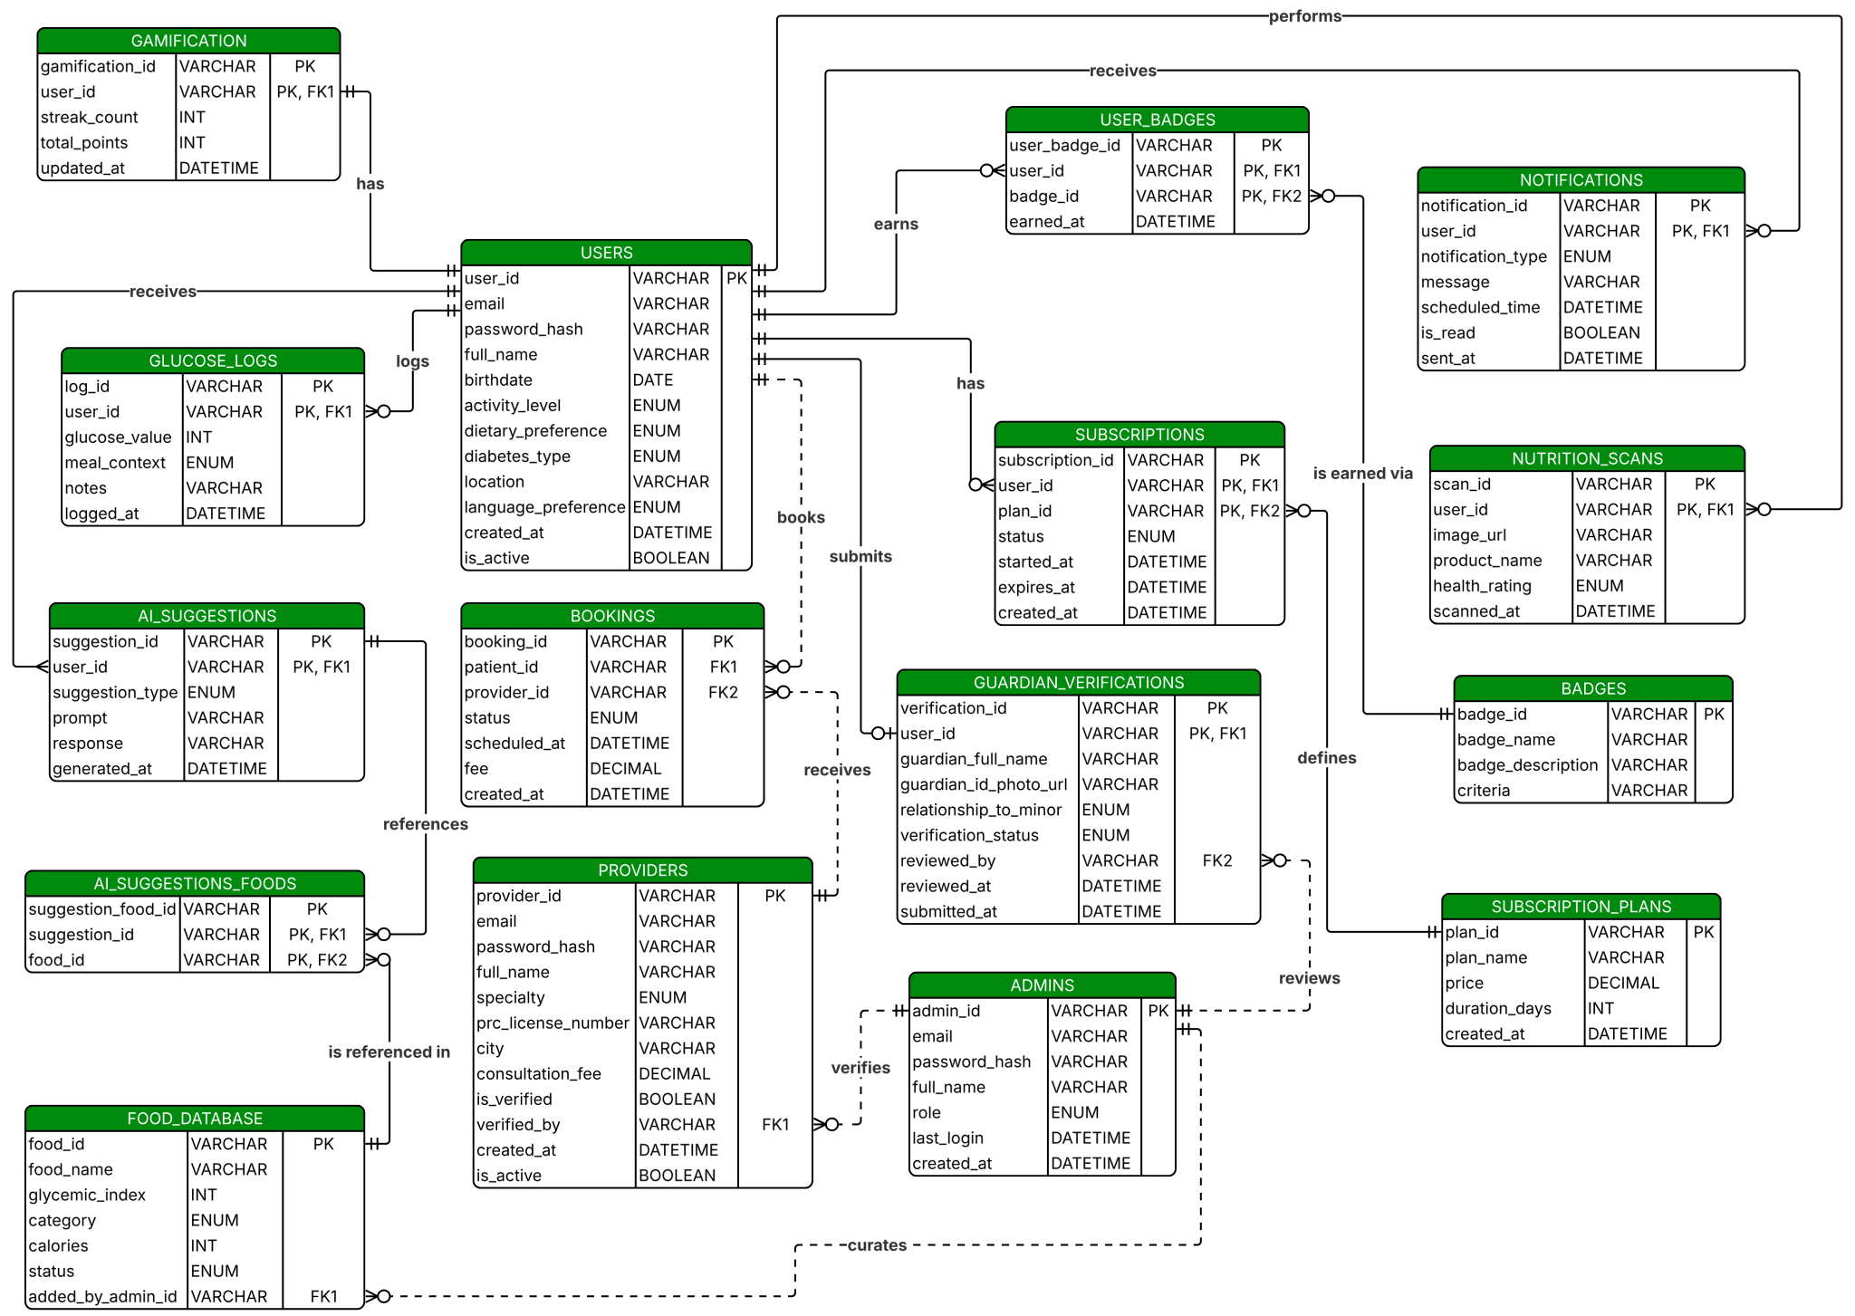
Entity-Relationship Diagram

Figure 53: Entity-Relationship Diagram

Data Dictionary
A data dictionary serves as a reference describing the structure, content, and organization of a database, as well as how its different parts relate to one another. It provides detailed information about each data element, including its field name, data type, size, constraints, and purpose within the system. As a result, it promotes consistency in database design and serves as a guide for developers during system implementation and maintenance.
The tables that follow outline the database design of Diabeatis360, covering each field, its data type, and the relationships between tables used throughout the system. They define how data is stored, organized, and connected to support the application's core functionalities. This documentation also serves as a valuable reference for future system enhancements, troubleshooting, and database management, ensuring the integrity and reliability of the system's data.
The data dictionary also supports effective communication among researchers, developers, and other stakeholders by providing a common understanding of the database structure and terminology. By documenting the attributes and relationships of each table, it minimizes inconsistencies in data handling and ensures that the database is implemented according to the system's design specifications. This contributes to the overall efficiency, accuracy, and maintainability of Diabeatis360 throughout its development and future enhancements. It also facilitates data validation by ensuring that each data field follows its defined format and constraints. Moreover, the data dictionary supports system scalability by providing a well-documented database structure that can be efficiently modified or expanded as new features are introduced.
Table 6
Users
Diabeatis360 Entities | Attribute Name | Contents | Type | Format | Range | Required | PK or FK | FK Reference Table
USERS | user_id | User ID Number | VARCHAR | XXXX | 255 | Yes | PK
USERS | email | User Email Address | VARCHAR | XXXX | 255 | Yes
USERS | password_hash | Encrypted Password | VARCHAR | XXXX | 255 | Yes
USERS | full_name | User's Full Name | VARCHAR | XXXX | 255 | Yes
USERS | birthdate | Date of Birth | DATE | YYYY-MM-DD |  | Yes
USERS | activity_level | Sedentary/Light/Moderate/Active | ENUM |  |  | Yes
USERS | dietary_preference | Dietary Restriction Type | ENUM |  |  | Yes
USERS | diabetes_type | Type1/Type2/Prediabetes/None | ENUM |  |  | Yes
USERS | location | City/Region | VARCHAR | XXXX | 255 | Yes
USERS | language_preference | English/Filipino | ENUM |  |  | Yes
USERS | created_at | Account Creation Date | DATETIME | YYYY-MM-DD HH:MM:SS |  | Yes
USERS | is_active | Account Status | BOOLEAN | TRUE/FALSE |  | Yes
Table 7
Guardian_verifications

Diabeatis360 Entities | Attribute Name | Contents | Type | Format | Range | Required | PK or FK | FK Reference Table
GUARDIAN_VERIFICATIONS | verification_id | Verification ID Number | VARCHAR | XXXX | 255 | Yes | PK
GUARDIAN_VERIFICATIONS | user_id | Minor's Own User ID | VARCHAR | XXXX | 255 | Yes | FK | USERS
GUARDIAN_VERIFICATIONS | guardian_full_name | Guardian's Full Name | VARCHAR | XXXX | 255 | Yes
GUARDIAN_VERIFICATIONS | guardian_id_photo_url | Uploaded Guardian ID Link | VARCHAR | XXXX | 500 | Yes
GUARDIAN_VERIFICATIONS | relationship_to_minor | Parent/Legal Guardian/Other | ENUM |  |  | Yes
GUARDIAN_VERIFICATIONS | verification_status | Pending/Approved/Rejected | ENUM |  |  | Yes
GUARDIAN_VERIFICATIONS | reviewed_by | Admin Who Reviewed | VARCHAR | XXXX | 255 | No | FK | ADMINS
GUARDIAN_VERIFICATIONS | submitted_at | Submission Date/Time | DATETIME | YYYY-MM-DD HH:MM:SS |  | Yes
Table 8
Providers
Diabeatis360 Entities | Attribute Name | Contents | Type | Format | Range | Required | PK or FK | FK Reference Table
PROVIDERS | provider_id | Provider ID Number | VARCHAR | XXXX | 255 | Yes | PK
PROVIDERS | email | Provider Email Address | VARCHAR | XXXX | 255 | Yes
PROVIDERS | password_hash | Encrypted Password | VARCHAR | XXXX | 255 | Yes
PROVIDERS | full_name | Provider's Full Name | VARCHAR | XXXX | 255 | Yes
PROVIDERS | specialty | Doctor/Nutritionist Specialty | ENUM |  |  | Yes
PROVIDERS | prc_license_number | PRC License Number | VARCHAR | XXXX | 50 | Yes
PROVIDERS | city | Practice Location | VARCHAR | XXXX | 255 | Yes
PROVIDERS | consultation_fee | Consultation Fee (₱) | DECIMAL | 999.99 | 8,2 | Yes
PROVIDERS | is_verified | Verification Status | BOOLEAN | TRUE/FALSE |  | Yes
PROVIDERS | verified_by | Admin Who Verified | VARCHAR | XXXX | 255 | No | FK | ADMINS
PROVIDERS | created_at | Account Creation Date | DATETIME | YYYY-MM-DD HH:MM:SS |  | Yes
PROVIDERS | is_active | Account Status | BOOLEAN | TRUE/FALSE |  | Yes
Table 9
Admins
Diabeatis360 Entities | Attribute Name | Contents | Type | Format | Range | Required | PK or FK | FK Reference Table
ADMINS | admin_id | Admin ID Number | VARCHAR | XXXX | 255 | Yes | PK
ADMINS | email | Admin Email Address | VARCHAR | XXXX | 255 | Yes
ADMINS | password_hash | Encrypted Password | VARCHAR | XXXX | 255 | Yes
ADMINS | full_name | Admin's Full Name | VARCHAR | XXXX | 255 | Yes
ADMINS | role | Super Admin/Admin | ENUM |  |  | Yes
ADMINS | last_login | Last Login Date/Time | DATETIME | YYYY-MM-DD HH:MM:SS |  | No
ADMINS | created_at | Account Creation Date | DATETIME | YYYY-MM-DD HH:MM:SS |  | Yes

Table 10
Glucose_Logs
Diabeatis360 Entities | Attribute Name | Contents | Type | Format | Range | Required | PK or FK | FK Reference Table
GLUCOSE_LOGS | log_id | Glucose Log ID Number | VARCHAR | XXXX | 255 | Yes | PK
GLUCOSE_LOGS | user_id | Associated User ID | VARCHAR | XXXX | 255 | Yes | FK | USERS
GLUCOSE_LOGS | glucose_value | Blood Sugar Reading (mg/dL) | INT | 999 | 3 | Yes
GLUCOSE_LOGS | meal_context | Before or After Meal | ENUM |  |  | Yes
GLUCOSE_LOGS | notes | Additional Notes | VARCHAR | XXXX | 500 | No
GLUCOSE_LOGS | logged_at | Date and Time of Log Entry | DATETIME | YYYY-MM-DD HH:MM:SS |  | Yes

Table 11
Food_Database
Diabeatis360 Entities | Attribute Name | Contents | Type | Format | Range | Required | PK or FK | FK Reference Table
FOOD_DATABASE | food_id | Food ID Number | VARCHAR | XXXX | 255 | Yes | PK
FOOD_DATABASE | food_name | Filipino Dish/Food Name | VARCHAR | XXXX | 255 | Yes
FOOD_DATABASE | glycemic_index | Glycemic Index Value | INT | 999 | 3 | Yes
FOOD_DATABASE | category | Food Category | ENUM |  |  | Yes
FOOD_DATABASE | calories | Calories Per Serving | INT | 9999 | 4 | Yes
FOOD_DATABASE | status | Active/Hidden | ENUM |  |  | Yes
FOOD_DATABASE | added_by_admin_id | Admin Who Added Entry | VARCHAR | XXXX | 255 | No | FK | ADMINS

Table 12
AI_Suggestions
Diabeatis360 Entities | Attribute Name | Contents | Type | Format | Range | Required | PK or FK | FK Reference Table
AI_SUGGESTIONS | suggestion_id | Suggestion ID Number | VARCHAR | XXXX | 255 | Yes | PK
AI_SUGGESTIONS | user_id | Associated User ID | VARCHAR | XXXX | 255 | Yes | FK | USERS
AI_SUGGESTIONS | suggestion_type | Chat/Meal/Exercise | ENUM |  |  | Yes
AI_SUGGESTIONS | prompt | User Input/Question | VARCHAR | XXXX | 1000 | Yes
AI_SUGGESTIONS | response | AI-Generated Response | VARCHAR | XXXX | 2000 | Yes
AI_SUGGESTIONS | generated_at | Date/Time Generated | DATETIME | YYYY-MM-DD HH:MM:SS |  | Yes

Table 13
AI_Suggestions_Foods
Diabeatis360 Entities | Attribute Name | Contents | Type | Format | Range | Required | PK or FK | FK Reference Table
AI_SUGGESTIONS_FOODS | suggestion_food_id | Suggestion-Food Link ID | VARCHAR | XXXX | 255 | Yes | PK
AI_SUGGESTIONS_FOODS | suggestion_id | Associated Suggestion ID | VARCHAR | XXXX | 255 | Yes | FK | AI_SUGGESTIONS
AI_SUGGESTIONS_FOODS | food_id | Associated Food ID | VARCHAR | XXXX | 255 | Yes | FK | FOOD_DATABASE

Table 14
Nutrition_Scans
Diabeatis360 Entities | Attribute Name | Contents | Type | Format | Range | Required | PK or FK | FK Reference Table
NUTRITION_SCANS | scan_id | Scan ID Number | VARCHAR | XXXX | 255 | Yes | PK
NUTRITION_SCANS | user_id | Associated User ID | VARCHAR | XXXX | 255 | Yes | FK | USERS
NUTRITION_SCANS | image_url | Scanned Label Image Link | VARCHAR | XXXX | 500 | Yes
NUTRITION_SCANS | product_name | Product Name (from OCR) | VARCHAR | XXXX | 255 | No
NUTRITION_SCANS | health_rating | Suitable/Caution/Unsuitable | ENUM |  |  | Yes
NUTRITION_SCANS | scanned_at | Date/Time Scanned | DATETIME | YYYY-MM-DD HH:MM:SS |  | Yes

Table 15
Bookings
Diabeatis360 Entities | Attribute Name | Contents | Type | Format | Range | Required | PK or FK | FK Reference Table
BOOKINGS | booking_id | Booking ID Number | VARCHAR | XXXX | 255 | Yes | PK
BOOKINGS | patient_id | Patient's User ID | VARCHAR | XXXX | 255 | Yes | FK | USERS
BOOKINGS | provider_id | Provider's ID | VARCHAR | XXXX | 255 | Yes | FK | PROVIDERS
BOOKINGS | status | Pending/Confirmed/Completed/Cancelled | ENUM |  |  | Yes
BOOKINGS | scheduled_at | Scheduled Date/Time | DATETIME | YYYY-MM-DD HH:MM:SS |  | No
BOOKINGS | fee | Fee Charged at Booking (₱) | DECIMAL | 999.99 | 8,2 | Yes
BOOKINGS | created_at | Booking Creation Date | DATETIME | YYYY-MM-DD HH:MM:SS |  | Yes

Table 16
Gamification
Diabeatis360 Entities | Attribute Name | Contents | Type | Format | Range | Required | PK or FK | FK Reference Table
GAMIFICATION | gamification_id | Gamification Record ID | VARCHAR | XXXX | 255 | Yes | PK
GAMIFICATION | user_id | Associated User ID | VARCHAR | XXXX | 255 | Yes | FK | USERS
GAMIFICATION | streak_count | Current Logging Streak | INT | 999 | 3 | Yes
GAMIFICATION | total_points | Total Points Earned | INT | 9999 | 4 | Yes
GAMIFICATION | updated_at | Last Update Date/Time | DATETIME | YYYY-MM-DD HH:MM:SS |  | Yes

Table 17
Badges
Diabeatis360 Entities | Attribute Name | Contents | Type | Format | Range | Required | PK or FK | FK Reference Table
BADGES | badge_id | Badge ID Number | VARCHAR | XXXX | 255 | Yes | PK
BADGES | badge_name | Badge Title | VARCHAR | XXXX | 255 | Yes
BADGES | badge_description | Badge Description | VARCHAR | XXXX | 500 | Yes
BADGES | criteria | Earning Criteria (e.g. "7-day streak") | VARCHAR | XXXX | 255 | Yes

Table 18
User_Badges
Diabeatis360 Entities | Attribute Name | Contents | Type | Format | Range | Required | PK or FK | FK Reference Table
USER_BADGES | user_badge_id | User-Badge Link ID | VARCHAR | XXXX | 255 | Yes | PK
USER_BADGES | user_id | Associated User ID | VARCHAR | XXXX | 255 | Yes | FK | USERS
USER_BADGES | badge_id | Associated Badge ID | VARCHAR | XXXX | 255 | Yes | FK | BADGES
USER_BADGES | earned_at | Date/Time Earned | DATETIME | YYYY-MM-DD HH:MM:SS |  | Yes

Table 19
Notifications
Diabeatis360 Entities | Attribute Name | Contents | Type | Format | Range | Required | PK or FK | FK Reference Table
NOTIFICATIONS | notification_id | Notification ID Number | VARCHAR | XXXX | 255 | Yes | PK
NOTIFICATIONS | user_id | Associated User ID | VARCHAR | XXXX | 255 | Yes | FK | USERS
NOTIFICATIONS | notification_type | Glucose Check/Meal/Medication/Exercise/Hydration/Appointment | ENUM |  |  | Yes
NOTIFICATIONS | message | Notification Text | VARCHAR | XXXX | 500 | Yes
NOTIFICATIONS | scheduled_time | Scheduled Send Time | DATETIME | YYYY-MM-DD HH:MM:SS |  | Yes
NOTIFICATIONS | is_read | Read Status | BOOLEAN | TRUE/FALSE |  | Yes
NOTIFICATIONS | sent_at | Actual Sent Date/Time | DATETIME | YYYY-MM-DD HH:MM:SS |  | No

Table 20
Subscription_Plans
Diabeatis360 Entities | Attribute Name | Contents | Type | Format | Range | Required | PK or FK | FK Reference Table
SUBSCRIPTION_PLANS | plan_id | Plan ID Number | VARCHAR | XXXX | 255 | Yes | PK
SUBSCRIPTION_PLANS | plan_name | Free/Monthly/6-Month/Annual | VARCHAR | XXXX | 255 | Yes
SUBSCRIPTION_PLANS | price | Plan Price (₱) | DECIMAL | 999.99 | 8,2 | Yes
SUBSCRIPTION_PLANS | duration_days | Plan Duration in Days | INT | 999 | 3 | Yes
SUBSCRIPTION_PLANS | created_at | Plan Creation Date | DATETIME | YYYY-MM-DD HH:MM:SS |  | Yes

Table 21
Subscriptions
Diabeatis360 Entities | Attribute Name | Contents | Type | Format | Range | Required | PK or FK | FK Reference Table
SUBSCRIPTIONS | subscription_id | Subscription ID Number | VARCHAR | XXXX | 255 | Yes | PK
SUBSCRIPTIONS | user_id | Associated User ID | VARCHAR | XXXX | 255 | Yes | FK | USERS
SUBSCRIPTIONS | plan_id | Associated Plan ID | VARCHAR | XXXX | 255 | Yes | FK | SUBSCRIPTION_PLANS
SUBSCRIPTIONS | status | Trial/Active/Expired/Cancelled | ENUM |  |  | Yes
SUBSCRIPTIONS | started_at | Subscription Start Date | DATETIME | YYYY-MM-DD HH:MM:SS |  | Yes
SUBSCRIPTIONS | expires_at | Subscription End Date | DATETIME | YYYY-MM-DD HH:MM:SS |  | Yes
 | created_at | Record Creation Date | DATETIME | YYYY-MM-DD HH:MM:SS |  | Yes

Network Design
The network design describes the communication infrastructure that supports the deployment, operation, and maintenance of the proposed system. A well-designed network architecture ensures reliable data transmission, secure communication, high availability, and scalability, which are essential requirements for healthcare information systems that handle sensitive patient information (Kurose & Ross, 2021). An effective network design also enables seamless connectivity among various system components, including mobile applications, web-based administrative dashboards, cloud services, and database servers. It also facilitates real-time synchronization of user data, ensuring that health records, AI-generated recommendations, appointment information, and notifications remain accurate and accessible across all connected devices and system modules.
For the proposed system, the network architecture will facilitate secure communication between patients, healthcare professionals, and administrators through internet-enabled devices. The system will utilize cloud-based services to support user authentication, real-time database synchronization, secure data storage, and application hosting. Cloud computing enhances healthcare applications by providing scalability, accessibility, and efficient resource management while maintaining data availability across multiple platforms (Buyya et al., 2023). Furthermore, implementing secure communication protocols, authentication mechanisms, and encrypted data transmission helps protect confidential health information and supports compliance with modern healthcare security practices (NIST, 2020).

Network Model
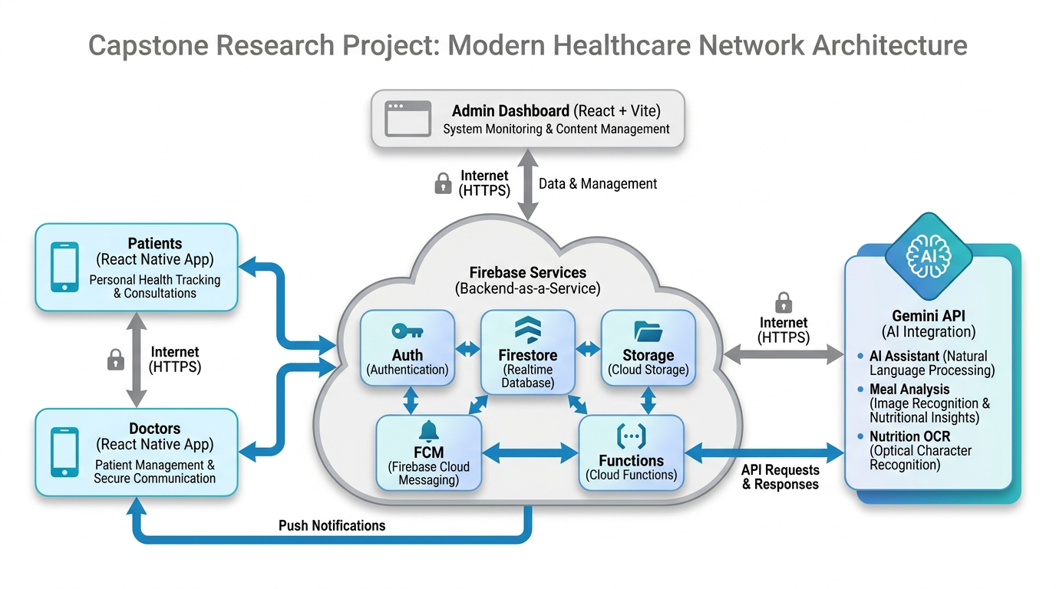
Figure 54: Diabeatis360 Network Model

The Diabeatis360 system adopts a cloud-based serverless architecture that utilizes Firebase as its Backend-as-a-Service (BaaS) platform. This architecture enables secure communication among patients, doctors, administrators, cloud services, and artificial intelligence without requiring a traditional dedicated application server. The network model is designed to provide scalability, reliability, and real-time synchronization while reducing infrastructure maintenance.
The AI Recommendation Engine in Diabeatis360 is powered by Google's Gemini API, a general-purpose generative AI model, which the system directs through structured prompt engineering rather than through model training. When a user requests a meal or exercise suggestion, the system does not query a proprietary diabetes model; instead, it constructs a prompt using the user's stored health profile (diabetes type, dietary preference, food allergies, activity level) together with entries from the Food_Database table, which contains glycemic index values and nutritional data for Filipino dishes sourced from published references such as the DOST-FNRI food composition tables. This prompt, along with the relevant grounding data, is sent to the Gemini API, which generates a response that is then formatted and returned to the user. In other words, the "localization" of the engine comes from the data supplied to Gemini at request time, not from Gemini itself being trained on Filipino data. This distinction matters for scope and limitations, since the accuracy of recommendations depends on both the quality of the underlying Food_Database and the general reasoning capability of the Gemini model.
The architecture consists of three primary layers: the Presentation Layer, Cloud Service Layer, and Artificial Intelligence Layer.
The Presentation Layer serves as the interface where users interact with the system. Patients and doctors access the platform via a mobile application built with React Native, Expo, and NativeWind. At the same time, administrators manage the system through a web-based dashboard built with React, Vite, and Tailwind CSS. Each user connects securely to cloud services via an encrypted HTTPS connection over the internet.
The Cloud Service Layer is powered entirely by Firebase. Firebase Authentication verifies the identity of patients, doctors, and administrators before granting access to the system. Cloud Firestore stores user profiles, blood glucose records, appointments, medication reminders, chat messages, and other application data in real time. Firebase Storage manages uploaded files such as profile pictures and nutrition label images. Firebase Cloud Functions execute backend processes including appointment processing, AI request handling, scheduled reminders, and other business logic without requiring a dedicated server. Firebase Cloud Messaging (FCM) delivers push notifications, including medication reminders, appointment confirmations, consultation updates, and important health alerts.
The Artificial Intelligence Layer integrates the Gemini API to provide intelligent healthcare assistance across four key functions: meal and exercise recommendations, nutrition label analysis, diabetes risk prediction, and AI chatbot interactions. When a user triggers any of these features, the mobile application does not communicate directly with the Gemini API. Instead, the request is routed to Firebase Cloud Functions, which act as a secure middleware layer. The Cloud Functions retrieve the user's health profile from Cloud Firestore, including their diabetes type, dietary preferences, food allergies, activity level, and logged blood sugar history, and use this data to construct a structured prompt. For meal and exercise recommendations, the prompt is further grounded with relevant entries from the Food_Database table, which contains glycemic index values and calorie data for Filipino dishes sourced from the DOST-FNRI food composition tables. This grounded prompt is then forwarded to the Gemini API over an encrypted HTTPS connection.
The Gemini API processes the prompt and returns a generated response, which the Cloud Functions format and send back to the mobile application for display. For nutrition label scanning, the user's captured image is first stored in Firebase Storage, after which the image URL is passed to the Cloud Functions along with the user's health profile to generate a health rating and alternative food suggestions. For diabetes risk prediction, accumulated blood sugar logs, dietary patterns, and activity data are compiled into a structured prompt that the Gemini API evaluates to produce a personalized risk classification with corresponding prevention and maintenance recommendations. This architecture ensures that Gemini API credentials are never exposed on the client side, all AI requests are centrally processed and logged in Cloud Firestore for audit purposes, and the system can handle multiple concurrent AI requests without performance degradation.
Network Topology
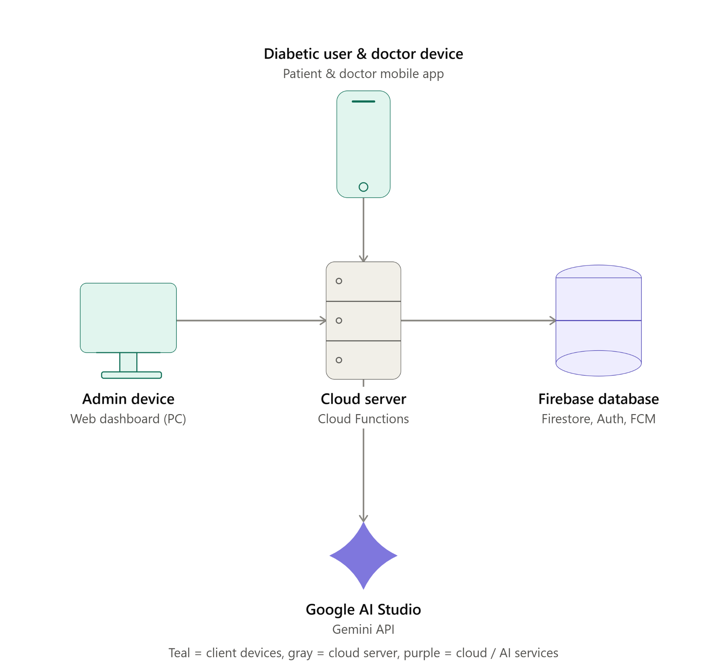

Figure 55: Diabeatis360 Network Topology

The figure illustrates the researchers' implementation of a star topology for Diabeatis360, which enables centralized control and management of the system's mobile and web components. This configuration allows the development team to monitor app activity, detect irregular usage patterns, and troubleshoot issues efficiently through a single backend server. In a star topology, client devices such as the patient's smartphone and the admin's desktop computer communicate directly with a central server over the internet, rather than connecting directly to external services. This setup ensures that requests from the mobile application and the admin dashboard are routed through a single controlled point before reaching the Firebase database or the Gemini API. As a result, this configuration isolates issues to specific devices, ensuring that a problem on one user's phone, such as a failed login attempt or a connectivity issue, does not affect the admin dashboard or other patients using the system simultaneously.

Development/Construction/Build Phase
This phase covers the actual tools and technologies the researchers used to bring Diabeatis360 from design into a working prototype, with each one chosen based on what the system specifically needed to do.

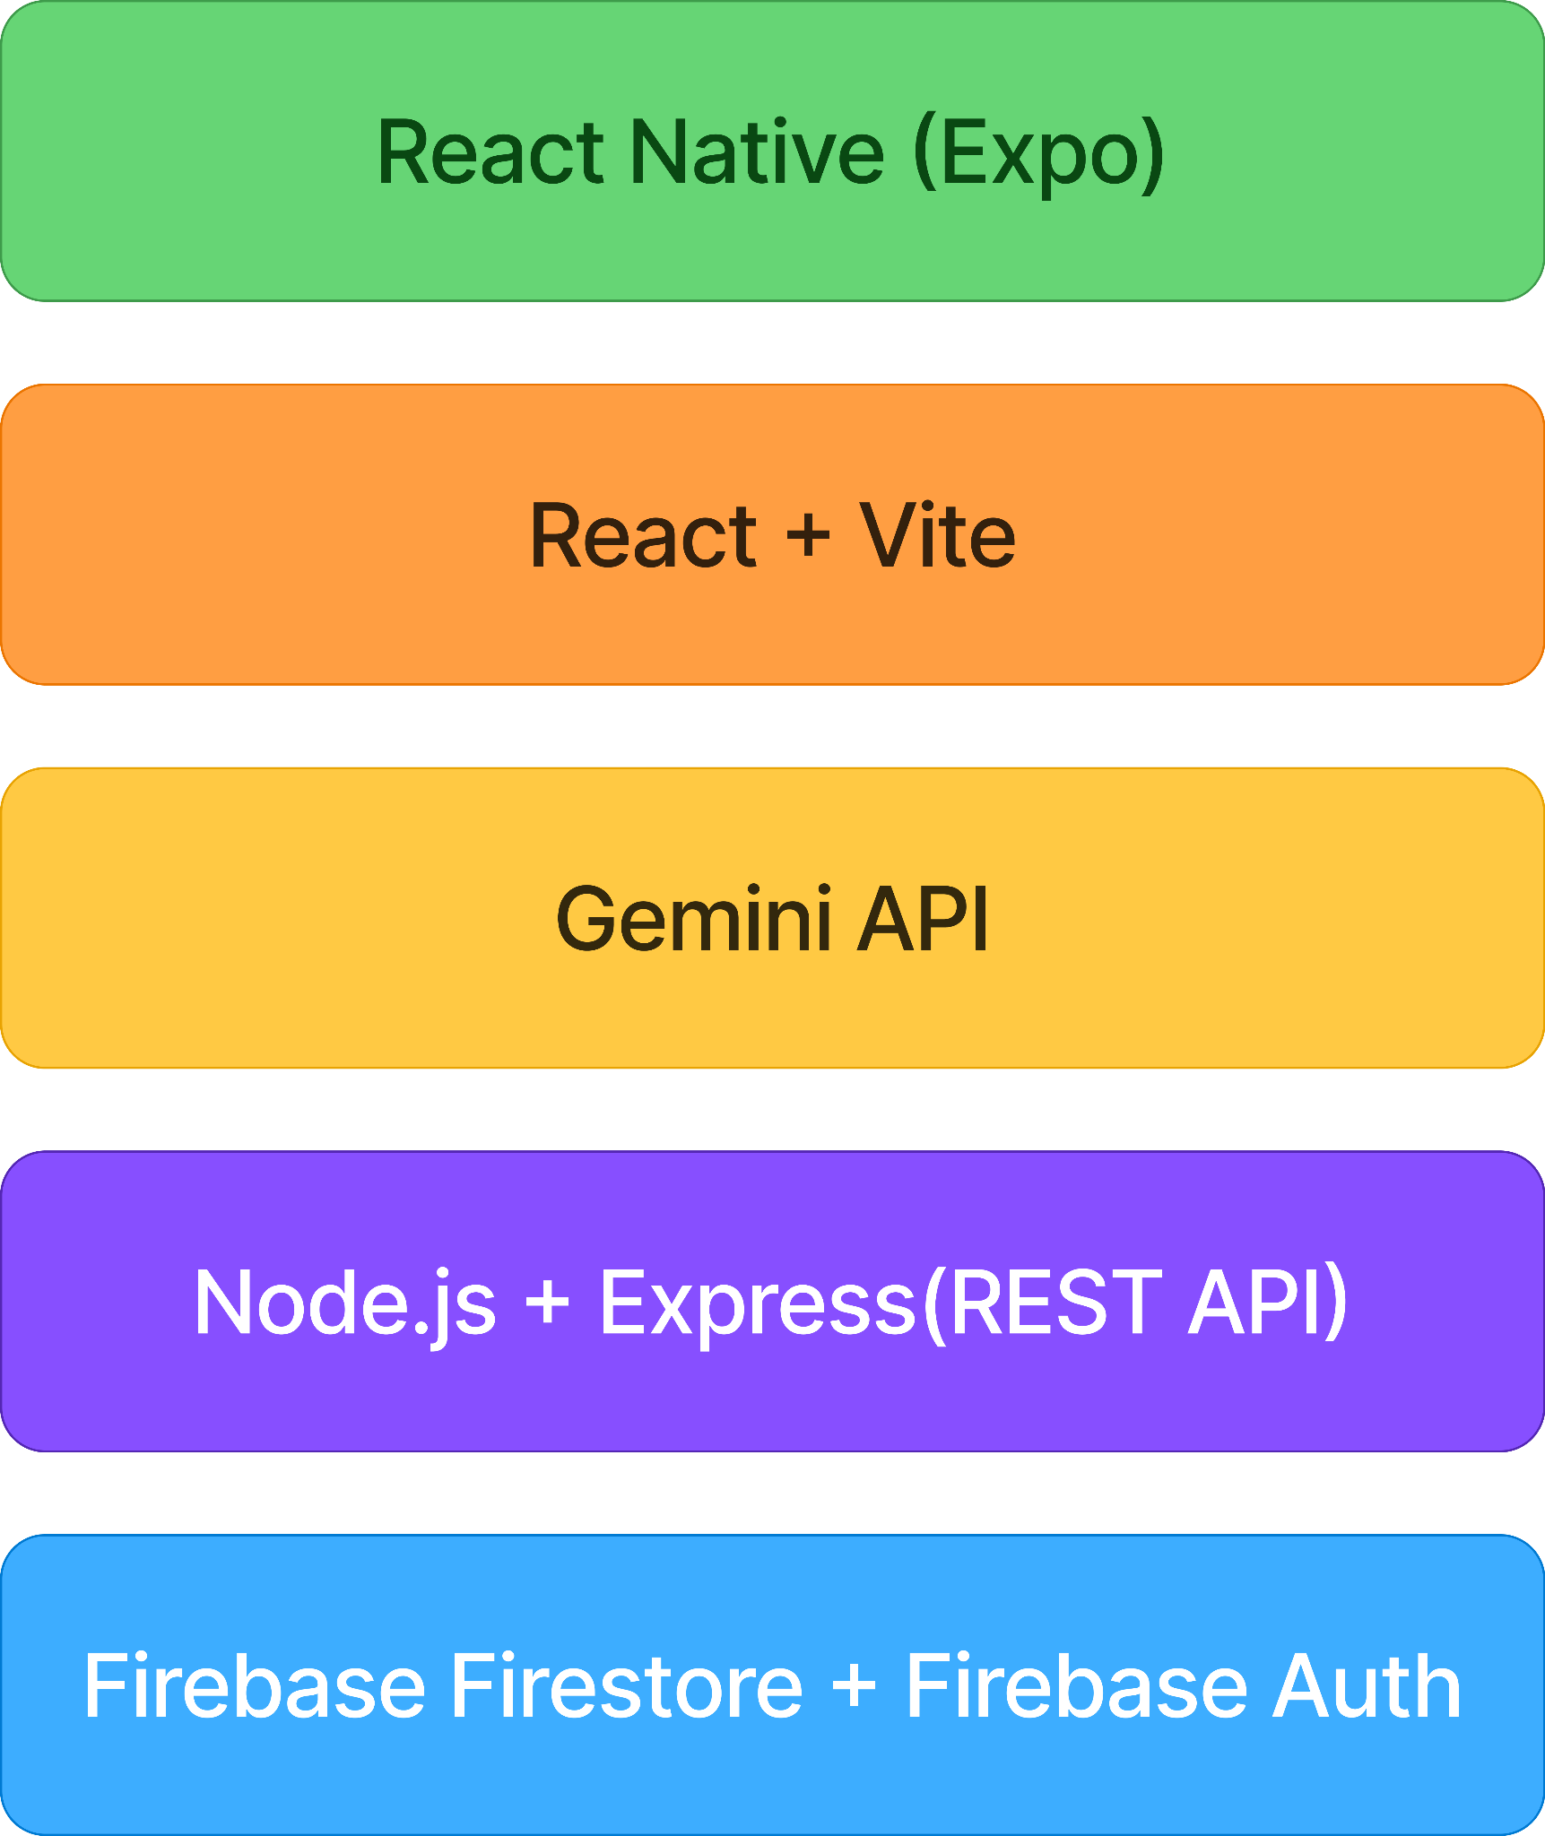
Technology Stack

Figure 56: Diabeatis360 Technology Stack
Selecting the right tools for both the frontend and back-end is essential to building the intended system. The diagram illustrates the particular technologies the researchers plan to utilize in developing Diabeatis360. For the mobile application, React Native with Expo will be used as the primary framework to support both Android and iOS platforms, styled with NativeWind for a consistent user interface. The back end will be built with Node.js and Express.js, which will process requests and securely communicate with the Gemini API for the AI chatbot and localized Filipino meal suggestions. Firebase will serve as the cloud infrastructure, covering the database through Firestore, user authentication, and push notifications via Firebase Cloud Messaging. The admin dashboard will be built using React with Vite, Tailwind CSS, and Recharts for data visualization. In contrast, Figma and Visual Studio Code will be used throughout the design and development process.

Software Specification
The software specification outlines the necessary software for the proposed system. This specification is essential for ensuring the system runs smoothly with minimal errors. The table below presents the software specifications that the researchers will utilize to achieve the objectives of the proposed system. Diabeatis360 will feature a mobile application for diabetic patients and guardians, as well as a web-based admin dashboard, enabling users, medical providers, and administrators to efficiently monitor and maintain the system.
Table 22
Software Specifications
OPERATING SYSTEM | Windows 11 / Windows 10
TOOLS | Figma
CODE EDITOR | Visual Studio Code
WEB BROWSER | Google Chrome, Opera GX, Etc.
DATABASE | Firebase Firestore

Hardware Specification
Hardware specifications refer to the physical components required for the system to run efficiently. Since Diabeatis360 is a lightweight mobile and web-based system, it
does not require high-end hardware to operate or develop. The following are the basic hardware recommendations for both the researchers' development environment and the user environment for patients and administrators accessing the system.
Table 23
Hardware Specifications
OPERATING SYSTEM | Android 10 or higher / iOS 14 or higher
PROCESSOR | Quad-core 1.8 GHz or higher
RAM | 3 GB
STORAGE | 100 MB free space
DISPLAY | 5.5 inches or larger, minimum 720p resolution
INTERNET CONNECTION | Wi-Fi or mobile data (3G/4G/5G/LTE)

Program Specification
The program specification is essential in guiding the researchers through the development of the proposed system. It defines the key functional components required to meet the system's primary goals. The table below provides a breakdown of these functions, including the modules allocated to each developer and the users who will interact with them.

List of Modules
Table 24
List of Modules
Programmer | Modules | Patient | Doctor | Admin
 | Account management
 | 1. Create Account | ✓ | ✓
 | 2. Login Account | ✓ | ✓ | ✓
 | 3. Update Account | ✓ | ✓ | ✓
 | 4. Reset Password | ✓ | ✓ | ✓
No. of Points(1 point per module per user) |  | 1 | 1 | 1
 | Health Profile
 | 1. Setup Health Profile | ✓
 | 2. Update Health Profile | ✓
 | 3. View Health Profile | ✓ | ✓
No. of Points(1 point per module per user) |  | 1 | 1 | 0
 | Blood Sugar Monitoring Management
 | 1. Add Blood Sugar Log | ✓
 | 2. Edit Blood Sugar Log | ✓
 | 3. View Blood Sugar History | ✓ | ✓
 | 4. View Blood Sugar Charts | ✓ | ✓
 | 5. Blood Sugar Interpretation | ✓
 | 6. View Interpretation Result | ✓
No. of Points(1 point per module per user) |  | 1 | 1 | 0
 | AI Health Assistant
 | 1. Generate Meal Recommendation | ✓
 | 2. Generate Exercise Recommendation | ✓
No. of Points(1 point per module per user) |  | 1 | 0 | 0
 | Nutrition Scanner
 | 1. Scan Nutrition Label | ✓
 | 2. View Nutrition Analysis | ✓
No. of Points(1 point per module per user) |  | 1 | 0 | 0
 | Appointment
 | 1. Book Appointment | ✓
 | 2. Accept or Decline Appointment |  | ✓
 | 3. Manage Schedule |  | ✓
 | 4. View Appointment History | ✓ | ✓ | ✓
No. of Points(1 point per module per user) |  | 1 | 1 | 1
 | Consultation Chat
 | 1. Send Messages | ✓ | ✓
 | 2. View Chat History | ✓ | ✓
 | 3. End Consultation | ✓ | ✓
 | 4. View Consultation Summary | ✓ | ✓
No. of Points(1 point per module per user) |  | 1 | 1 | 0
 | Notifications
 | 1. Receive Notifications | ✓ | ✓
 | 2. Send Announcements |  |  | ✓
No. of Points(1 point per module per user) |  | 1 | 1 | 1
 | Reports & Analytics
 | 1. View System Analytics |  |  | ✓
 | 2. Generate System Reports |  |  | ✓
No. of Points(1 point per module per user) |  | 0 | 0 | 1
 | Doctor Management
 | 1. Verify Doctor Credentials |  |  | ✓
 | 2. Activate or Deactivate Doctor |  |  | ✓
No. of Points(1 point per module per user) |  | 0 | 0 | 1
 | Gamification
 | 1. View Wellness Streak | ✓
 | 2. View Achievement Badge | ✓
 | 3. View Award Points |  |  | ✓
No. of Points(1 point per module per user) |  | 1 | 0 | 1
 | Subscription
 | 1. View Membership Plan | ✓
 | 2. Subscribe to Premium | ✓
 | 3. Manage Subscription | ✓
 | 4. View Subscription Status | ✓
 | 5. Manage Membership Plans |  |  | ✓
 | 6. View Premium Subscribers |  |  | ✓
No. of Points(1 point per module per user) |  | 1 | 0 | 1
Number of Modules per User |  | 10 | 6 | 7
Total Number of Modules |  | 23
Mr. Joaquin Patiño
Adviser

Testing Plan
The testing plan outlines the systematic verification strategy to ensure that all core modules of the Diabeatis360 platform function reliably, securely, and seamlessly for patients, providers, and administrators.

Unit Testing
The testing method involves testing individual components or parts of the software to verify that they work as expected. Application units are separately tested and checked for the specific functionalities, methods, and procedures, and their correctness is confirmed.
Table 25
Unit Testing for Mobile
Test Case ID | Unit Test | Description | Expected Result | Actual Result | Remarks
User Account and Modules
UT-001 | Create Account | Verify that a new user account can be created with valid input data. | User account is created successfully.
UT-002 | User Login | Validate that users can log in with correct credentials. | User logs in and is redirected to the dashboard.
UT-003 | Login with Blank Fields | Verify that the system prevents login when fields are left empty. | Prompt displayed: Please fill in all required fields.
UT-004 | Update Profile | Verify that a user can update their profile information. | Profile updated successfully.
UT-005 | Pediatric Account Setup | Verify that a pediatric profile can be created under parental supervision. | Pediatric profile created and linked to guardian account.
Blood Sugar Monitoring
UT-006 | Add Blood Sugar Log | Verify that a user can log a blood sugar reading. | Reading is logged and displayed in history.
UT-007 | View Trend Charts | Verify that trend charts reflect logged readings over time. | The chart displays historical readings correctly.
UT-008 | Set Blood Sugar Reminder | Verify that a user can set a scheduled reminder. | Push notification delivered at the scheduled time.
AI Recommendation
UT-009 | Generate Meal Suggestions | Verify that localized Filipino meal suggestions are generated based on the user's profile. | Personalized meal plan generated and displayed.
UT-010 | Generate Exercise Suggestions | Verify that exercise recommendations are generated based on the user's activity level. | Personalized exercise suggestions are generated and displayed.
Nutrition Label Scanning
UT-011 | Scan Nutrition Label | Verify that a nutrition label captured through the device camera is successfully scanned. | Label scanned and nutritional content displayed.
UT-012 | Evaluate Against Health Profile | Verify that scanned content is evaluated against the user's health profile. | Suitable or unsuitable assessment displayed.
Doctor Chat and Appointment
UT-013 | Send a message to the doctor | Verify that a user can send a message to a healthcare provider. | Message delivered and displayed in chat thread.
UT-014 | Book Appointment | Verify that a user can book a remote consultation. | Appointment confirmed and added to the schedule.
Notification
UT-015 | Push Notification Delivery | Verify that push notifications are delivered at scheduled times. | Notification received at the correct scheduled time.
Health Progress Dashboard
UT-016 | View Dashboard | Verify that the dashboard displays a summary of the user's overall wellness trends. | Dashboard displays accurate blood sugar, activity, and calorie summaries.
Gamification
UT-017 | Wellness Streak | Verify that the streak counter increments on consecutive blood sugar logs. | Streak counter updates correctly.
UT-018 | Achievement Badge | Verify that a badge is awarded when the user reaches a logging milestone. | Badge awarded and displayed on the user's profile.
Doctor Modules
UT-019 | Doctor Login | Validate that a doctor can log in with the correct credentials. | The doctor logs in and is redirected to the doctor dashboard.
UT-020 | View Patient Messages | Verify that a doctor can view messages sent by patients. | Patient messages are displayed correctly in the chat thread.
UT-021 | Respond to Patient | Verify that a doctor can reply to a patient's message. | Reply delivered and displayed in the chat thread.
UT-022 | Accept Appointment | Verify that a doctor can accept a consultation request. | Appointment confirmed and reflected in the doctor's schedule.
UT-023 | View Patient Health Data | Verify that a doctor can view a patient's blood sugar logs and health data. | Patient health data displayed correctly.

Table 26
Unit Testing for Web
Test Case ID | Unit Test | Description | Expected Result | Actual Result | Remarks
Admin Account Management
UT-A001 | Admin Login | Validate that the admin can log in with the correct credentials. | Admin logs in and is redirected to the dashboard.
UT-A002 | Admin Login with Blank Fields | Verify that the system prevents login when fields are left empty. | Prompt displayed: Please fill in all required fields.
User Management
UT-A003 | View All Users | Verify that the admin can view all registered users. | Complete list of registered users displayed.
UT-A004 | Deactivate User Account | Verify that the admin can deactivate a user account. | The selected user account is deactivated.
UT-A005 | Reactivate User Account | Verify that the admin can reactivate a deactivated account. | The selected user account is reactivated.
Doctor Management
UT-A006 | Add Doctor Profile | Verify that the admin can add a new healthcare provider profile. | New doctor profile saved and available in the directory.
UT-A007 | View All Appointments | Verify that the admin can view all scheduled appointments. | All appointments are displayed with correct details.
Food Database Management
UT-A008 | Add Food Item | Verify that the admin can add a new food item to the database. | New food item saved and available in the system.
UT-A009 | Edit Food Item | Verify that the admin can edit nutritional details of an existing food item. | Updated information was saved and reflected in the system.
UT-A010 | Delete Food Item | Verify that the admin can remove a food item from the database. | Selected food item deleted from the system.
Health Data Management
UT-A011 | View User Blood Sugar Logs | Verify that the admin can access users' submitted blood sugar logs. | Blood sugar logs displayed with correct details.
UT-A012 | Generate Health Trend Reports | Verify that the admin can generate health trend reports. | Health trend report generated and displayed accurately.

Integration Testing
This type of test refers to the testing done to reveal defects upon the correlation of integrated components.
Table 27
Integration Testing
Test Case ID | Module 1 | Integration Process | Module 2 | Pre–  condition | Result | Remarks
IT-001 | User Registration | Registered user data populates the personalized user profile. | User Profile Module | User has created an account successfully.
IT-002 | User Profile | Profile data is passed to the AI recommendation engine. | AI Recommendation Engine | User has completed profile setup.
IT-003 | Blood Sugar Logging | Logged reading is passed to the trend visualization module. | Health Progress Dashboard | User has submitted at least one blood sugar log.
IT-004 | Blood Sugar Log | Out-of-range reading triggers an alert to the notification system. | Notification System | Notifications are enabled, and an out-of-range reading is logged.
IT-005 | Nutrition Label Scanning | Scanned data is passed to the AI engine for evaluation. | AI Recommendation Engine | User profile is complete, and a label has been successfully scanned.
IT-006 | Doctor Chat Module | User message is delivered and displayed in the shared chat thread. | Healthcare Provider Interface | User is logged in and has selected a healthcare provider.
IT-007 | Appointment Scheduling | Confirmed appointment triggers a reminder notification to the user. | Notification System | User has a confirmed appointment, and notifications are enabled.
IT-008 | Blood Sugar Logging | Consecutive daily logs trigger the wellness streak counter to increment. | Gamification Module | The user has logged blood sugar on consecutive days.
IT-009 | AI Meal Recommendation | Generated meal plan data is reflected on the dashboard. | Health Progress Dashboard | A meal plan has been generated for the current day.
IT  -010 | User Authentication | An authenticated user is redirected to the health progress dashboard. | Health Progress Dashboard | User has logged in with valid credentials.

Alpha Testing
Alpha testing is the initial phase of validating whether a newly developed product will perform as expected before it is released to a wider audience.

Table 28
Alpha Testing
Test Criteria | Poor | Fair | Good | Very Good
Graphical User Interface (GUI)
Consistency (The interface maintains a uniform layout, icons, and color scheme throughout the entire application.)
Reusability (Common GUI components, such as buttons, input fields, and icons, are used consistently across all screens.)
Forgiveness and Tolerance (The system provides confirmation messages or undo options for critical actions, such as deleting a blood sugar log or canceling an appointment.)
Simplicity (The interface is clean, with minimal clutter and intuitive navigation suitable for users managing a chronic health condition.)
Readability (Font sizes, styles, and color contrast are readable and accessible to both adult and elderly diabetic users.)
Clarity (Error, success, and guidance messages are clearly worded and easy to understand for users with varying levels of digital literacy.)
User-Friendliness (The interface is easy to use and provides clear directions, especially for first-time users unfamiliar with health management applications.)
System Performance
Conformance to Requirements (The system meets its key features: secure user registration and profile building, blood sugar monitoring, AI-assisted recommendations, nutrition label scanning, and doctor chat module.)
Conformance to Objectives (All listed project objectives are implemented and fully functional within the application.)
Efficiency (AI recommendations, nutrition label scanning, blood sugar trend generation, and other processes are completed quickly with minimal delays.)
Security (User health data, including blood sugar records, personal profiles, and doctor communications, are securely handled and access-controlled.)
Integrity (The system protects personal health information, ensures data accuracy across all modules, and prevents unauthorized access or modification of user data.)
Overall Impression (The prototype is functional, relevant, and helpful in supporting diabetes self-management among Filipino diabetic patients.)

Acceptance Testing
This type of testing determines the degree to which an application meets end users' approval.
Table 29
Acceptance Testing Diabetic User
PROJECT IDENTIFICATION
Project Name | Date Created
Diabeatis360: An AI-Integrated Mobile Application for Diabetes Self-Management and Telehealth Consultation in the Philippines
Project Sponsors | Project Manager
Niño Dave Gulay  Russell Ray Gillera  Karylle Catubay | Niño Dave Gulay
Project Adviser | Dean
Mr. Joaquin Patiño | Mr. Neil A. Basabe

ACCEPTANCE CRITERIA TEST MATRIX
 |  | Critical |  | Test Results
Number | Acceptance Requirement | Yes | No | Accept | Reject | Comments
1 | Users can register successfully, log in, and update their profiles.
2 | Users can log blood sugar readings and view accurate history and trend charts.
3 | Push notifications for blood sugar, meals, exercise, hydration, and medication are delivered at the correct scheduled times.
4 | AI generates meal and exercise suggestions.
5 | Nutrition label scanner analyzes food products against the user's health profile.
6 | Users can message doctors and book consultations.
7 | Dashboard displays health progress summaries.
8 | Gamification tracks streaks and awards badges.
OTHER CONSIDERATIONS
Business Objectives - Did the software application/system meet the business objective?
Yes | No
Does the software application/system require any setups prior to installation? If so, please describe.
Yes | No
APPROVAL
Respondent |  | Signature |  |  | Date
Yes | No

Table 30
Acceptance Testing Doctor
PROJECT IDENTIFICATION
Project Name | Date Created
Diabeatis360: An AI-Integrated Mobile Application for Diabetes Self-Management and Telehealth Consultation in the Philippines
Project Sponsors | Project Manager
Niño Dave Gulay  Russell Ray Gillera  Karylle Catubay | Niño Dave Gulay
Project Adviser | Dean
Mr. Joaquin Patiño | Mr. Neil A. Basabe

ACCEPTANCE CRITERIA TEST MATRIX
 |  | Critical |  | Test Results
Number | Acceptance Requirement | Yes | No | Accept | Reject | Comments
1 | Doctors can log in successfully
2 | Doctors can view and respond to patient messages
3 | Doctors can accept or decline appointment requests
4 | Doctors can view patient blood sugar logs and health data
5 | Doctors can manage and update their availability schedule
6 | Doctors receive notifications for new messages and appointments
7 | Doctors can provide health recommendations to patients
8 | Doctors can view a summary of all their active patients.
OTHER CONSIDERATIONS
Business Objectives - Did the software application/system meet the business objective?
Yes | No
Does the software application/system require any setups prior to installation? If so, please describe.
Yes | No
APPROVAL
Respondent |  | Signature |  |  | Date
Yes | No

Table 31
Acceptance Testing Admin
PROJECT IDENTIFICATION
Project Name | Date Created
Diabeatis360: An AI-Integrated Mobile Application for Diabetes Self-Management and Telehealth Consultation in the Philippines
Project Sponsors | Project Manager
Niño Dave Gulay  Russell Ray Gillera  Karylle Catubay | Niño Dave Gulay
Project Adviser | Dean
Mr. Joaquin Patiño | Mr. Neil A. Basabe

ACCEPTANCE CRITERIA TEST MATRIX
 |  | Critical |  | Test Results
Number | Acceptance Requirement | Yes | No | Accept | Reject | Comments
1 | Admin can log in to the admin panel successfully
2 | Admin can view, approve, and deactivate user accounts (patients and doctors)
3 | Admin can monitor all registered doctors and verify their credentials
4 | Admin can view system-wide activity logs and usage reports
5 | Admin can manage and update app content (e.g., health tips, notifications)
6 | Admin can handle reported issues or flagged accounts
7 | Admin can view overall system performance and user engagement metrics
8 | Admin can generate and export reports on platform activity.
OTHER CONSIDERATIONS
Business Objectives - Did the software application/system meet the business objective?
Yes | No
Does the software application/system require any setups prior to installation? If so, please describe.
Yes | No
APPROVAL
Respondent |  | Signature |  |  | Date
Yes | No

REFERENCES
Alaslawi, H., Berrou, I., Al Hamid, A., Alhuwail, D., & Aslanpour, Z. (2022). Diabetes Self-management Apps: Systematic Review of Adoption Determinants and Future Research Agenda. JMIR Diabetes, 7(3), e28153. https://doi.org/10.2196/28153
Bayaga, C. L. T., Cabigas, C. K. C., Santos, I.-T. D., Pico, M. B., Andaya, E. M. M., Manaois, R. V., & Abilgos-Ramos, R. G. (2026). Determination of glycemic index and load of commercially available non-pigmented and pigmented rice varieties in the Philippines. Scientific Reports, 16(1), 20272. https://doi.org/10.1038/s41598-026-48966-6
Birhanu, T. E., Guracho, Y. D., Asmare, S. W., & Olana, D. D. (2024). A mobile health application use among diabetes mellitus patients: A systematic review and meta-analysis. Frontiers in Endocrinology, 15. https://doi.org/10.3389/fendo.2024.1481410
Cando, L. F. T., Quebral, E. P. B., Ong, E. P., Catral, C. D. M., Relador, R. J. L., Velasco, A. J. D., Alcazar, R. M. U., Reyes, N. A. L., Pilotin, E. J. B., Ornos, E. D. B., Paz-Pacheco, E., & Tantengco, O. A. G. (2024). Current status of diabetes mellitus care and management in the Philippines. Diabetes & Metabolic Syndrome: Clinical Research & Reviews, 18(2), 102951. https://doi.org/10.1016/j.dsx.2024.102951
Corsica, J. A., Kelly, M. C., Bradley, L. E., Konsor, M. M., Wilson, E. J., Quinones, I. C., W. Jeddi, R., & Markey, M. A. (2025). Mobile apps for diabetes self-management: An updated review of app features and effectiveness. Journal of Behavioral Medicine, 48(1), 137–148. https://doi.org/10.1007/s10865-024-00525-y
Elvira Arcellana, A., & Jimeno, C. (2020). Challenges and Opportunities for Diabetes Care in the Philippines in the Time of the COVID-19 Pandemic. Journal of the ASEAN Federation of Endocrine Societies, 35(1), 55–57. https://doi.org/10.15605/jafes.035.01.04
Geirhos, A., Stephan, M., Wehrle, M., Mack, C., Messner, E.-M., Schmitt, A., Baumeister, H., Terhorst, Y., & Sander, L. B. (2022). Standardized evaluation of the quality and persuasiveness of mobile health applications for diabetes management. Scientific Reports, 12(1), 3639. https://doi.org/10.1038/s41598-022-07544-2
Guan, Z., Li, H., Liu, R., Cai, C., Liu, Y., Li, J., Wang, X., Huang, S., Wu, L., Liu, D., Yu, S., Wang, Z., Shu, J., Hou, X., Yang, X., Jia, W., & Sheng, B. (2023). Artificial intelligence in diabetes management: Advancements, opportunities, and challenges. Cell Reports Medicine, 4(10), 101213. https://doi.org/10.1016/j.xcrm.2023.101213
Huang, X., Xiang, X., Liu, Y., Wang, Z., Jiang, Z., & Huang, L. (2023). The Use of Gamification in the Self-Management of Patients With Chronic Diseases: Scoping Review. JMIR Serious Games, 11(1), e39019. https://doi.org/10.2196/39019
International Diabetes Federation. (2024). Philippines—Diabetes Statistics and Trends. Diabetes Atlas. https://diabetesatlas.org/data-by-location/country/philippines/
Middelbeek, R. J. W., Bouchonville, M. F., Agarwal, S., & Romeo, G. R. (2023). Editorial: Application of telehealth to diabetes care delivery and medical training: challenges and opportunities. Frontiers in Endocrinology, 14. https://doi.org/10.3389/fendo.2023.1229706
National Privacy Commission. (2024). Artificial intelligence risk management framework: Generative artificial intelligence profile (Error: 600-1; p. error: 600-1). National Institute of Standards and Technology (U.S.). https://doi.org/10.6028/NIST.AI.600-1
Ong, A. K. S., Kurata, Y. B., Castro, S. A. D. G., De Leon, J. P. B., Dela Rosa, H. V., & Tomines, A. P. J. (2022). Factors influencing the acceptance of telemedicine in the Philippines. Technology in Society, 70, 102040. https://doi.org/10.1016/j.techsoc.2022.102040
Parshley, I. J. N. (2023). eHealth Use and Disease Control During COVID-19 among Diabetes Patients in China and the Philippines.
Philippine Statistics Authority. (2024). 2024 Causes of Death in the Philippines (Provisional as of 31 January 2025) | Philippine Statistics Authority. https://psa.gov.ph/content/2024-causes-death-philippines-provisional-31-january-2025
Sarmiento, R. F. R., Overgaard, S. M., Gai, C., Overgaard, J. D., & Ohde, J. W. (2025). Guiding responsible AI in healthcare in the Philippines. Npj Digital Medicine, 8(1), 338. https://doi.org/10.1038/s41746-025-01755-3
Stevens, S., Gallagher, S., Andrews, T., Ashall-Payne, L., Humphreys, L., & Leigh, S. (2022). The effectiveness of digital health technologies for patients with diabetes mellitus: A systematic review. Frontiers in Clinical Diabetes and Healthcare, 3, 936752. https://doi.org/10.3389/fcdhc.2022.936752
World Health Organization. (2024). Diabetes. https://www.who.int/news-room/fact-sheets/detail/diabetes
Xin, M., Yao, Y., Huang, P., & Li, Q. (2026). Application study of an artificial intelligence and big data-based personalized chronic disease management model for diabetes patients. Frontiers in Public Health, 14. https://doi.org/10.3389/fpubh.2026.1735295

CURRICULUM VITAE

PERSONAL PROFILE
Name: Karylle C. Catubay
Phone Number: 09666173159
Email Address: karyllecatubigcatubay@gmail.com
Address: MH Aznar St, Cebu City, Cebu 6000

EDUCATIONAL BACKGROUND
College: University of Cebu - Main Campus
Sanciangko St, Cebu City, 6000
(2023-Present)
Senior High: San Sebastian National High School
San Sebastian, Samboan, Cebu, 6027
(2021-2023)
Junior High: San Sebastian National High School
San Sebastian, Samboan, Cebu, 6027
2017-2021
Elementary: Colase Elementary School
Colase, Samboan, Cebu, 6027
(2011-2017)

PERSONAL PROFILE
Name: Russell Ray Y. Gillera
Phone Number: 09943720514
Email Address: russell.gillera@gmail.com
Address: R.Duterte St. Banawa, Cebu City 6000

EDUCATIONAL BACKGROUND
College: University of Cebu - Main Campus
Sanciangko St, Cebu City, 6000
(2023-Present)
Senior High: Bantayan National High School - Senior High School
Ticad, Bantayan, Cebu 6052
(2021-2023)
Junior High: Bantayan National High School
Village, Ticad, Bantayan, Cebu 6052
2017-2021
Elementary: Bantayan Central Elementary School
Ticad, Bantayan, Cebu 6052
(2011-2017)


PERSONAL PROFILE
Name: Niño Dave M. Gulay
Phone Number: 09912349901
Email Address: davegulay747@gmail.com
Address: Pakigne, Minglanilla, Cebu

EDUCATIONAL BACKGROUND
College: University of Cebu - Main Campus
Sanciangko St, Cebu City, 6000
(2023-Present)
Senior High: Asian College of Technology
Cebu South Road in Poblacion, Talisay City, Cebu, Philippines 6045
(2017-2019)
Junior High: Lipata National High School
Cebu South Rd., Sandayong, Minglanilla, 6046 Cebu
(2013-2017)
Elementary: Lipata Elementary School
Cebu South Rd., Sandayong, Minglanilla, 6046 Cebu
(2006-2013)

APPENDICES

Appendix A: Oath of Confirmation
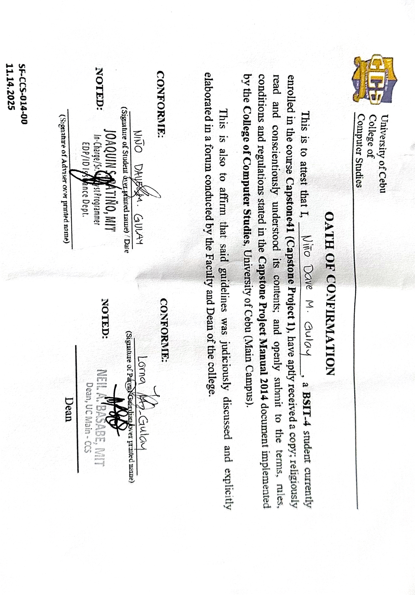
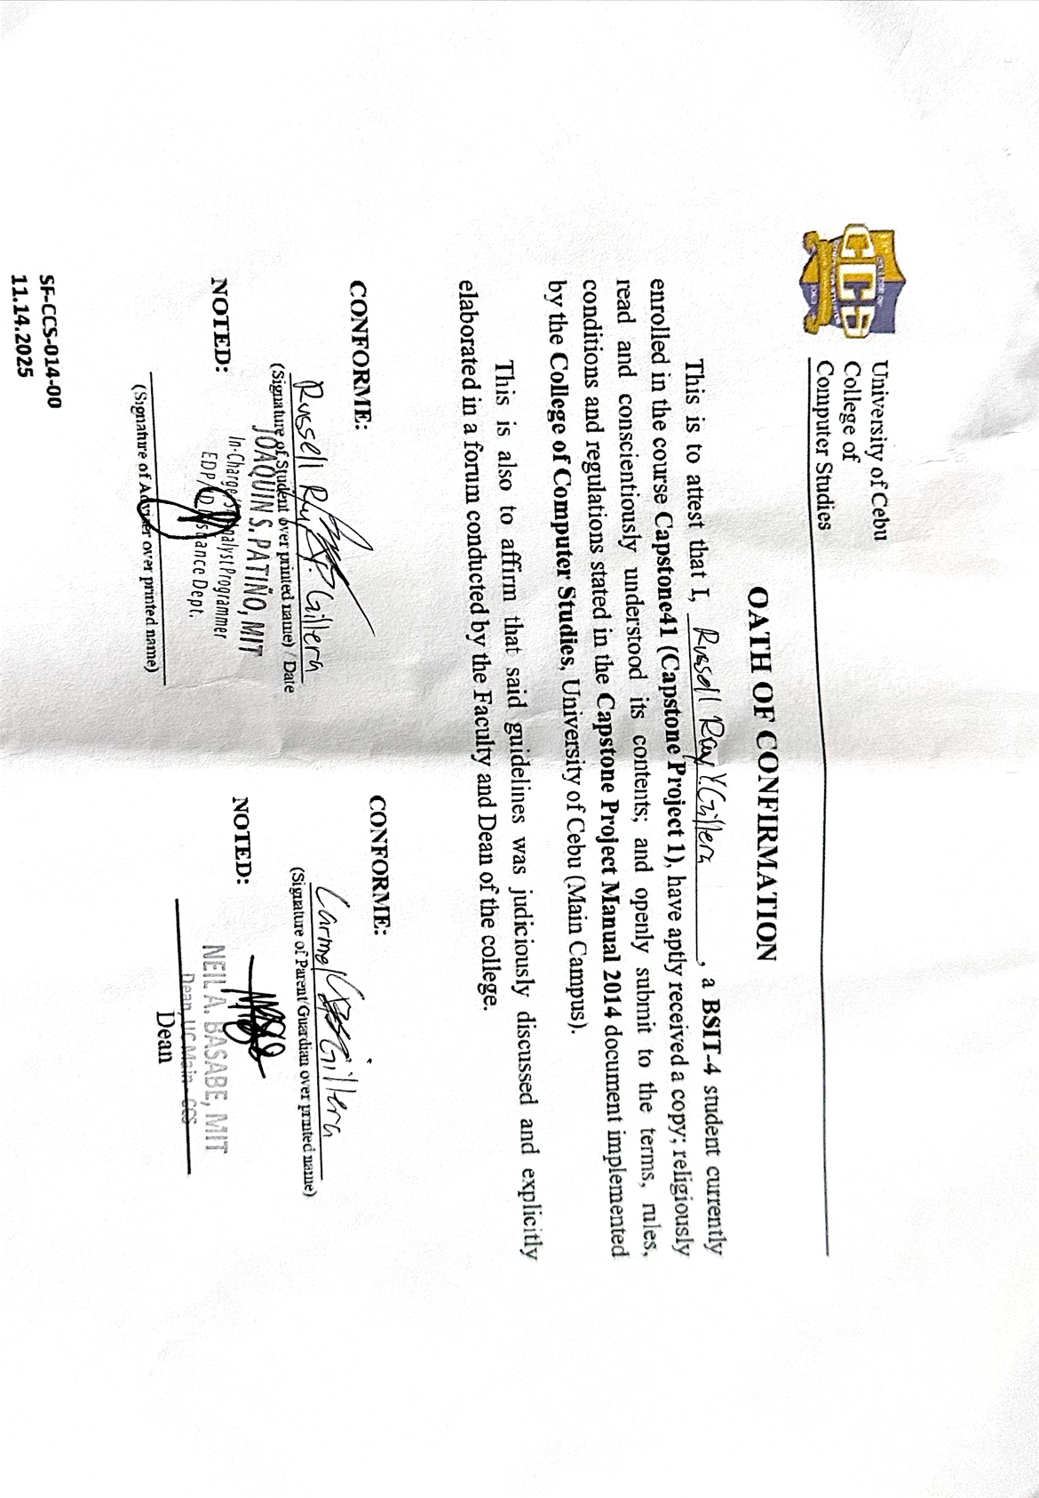

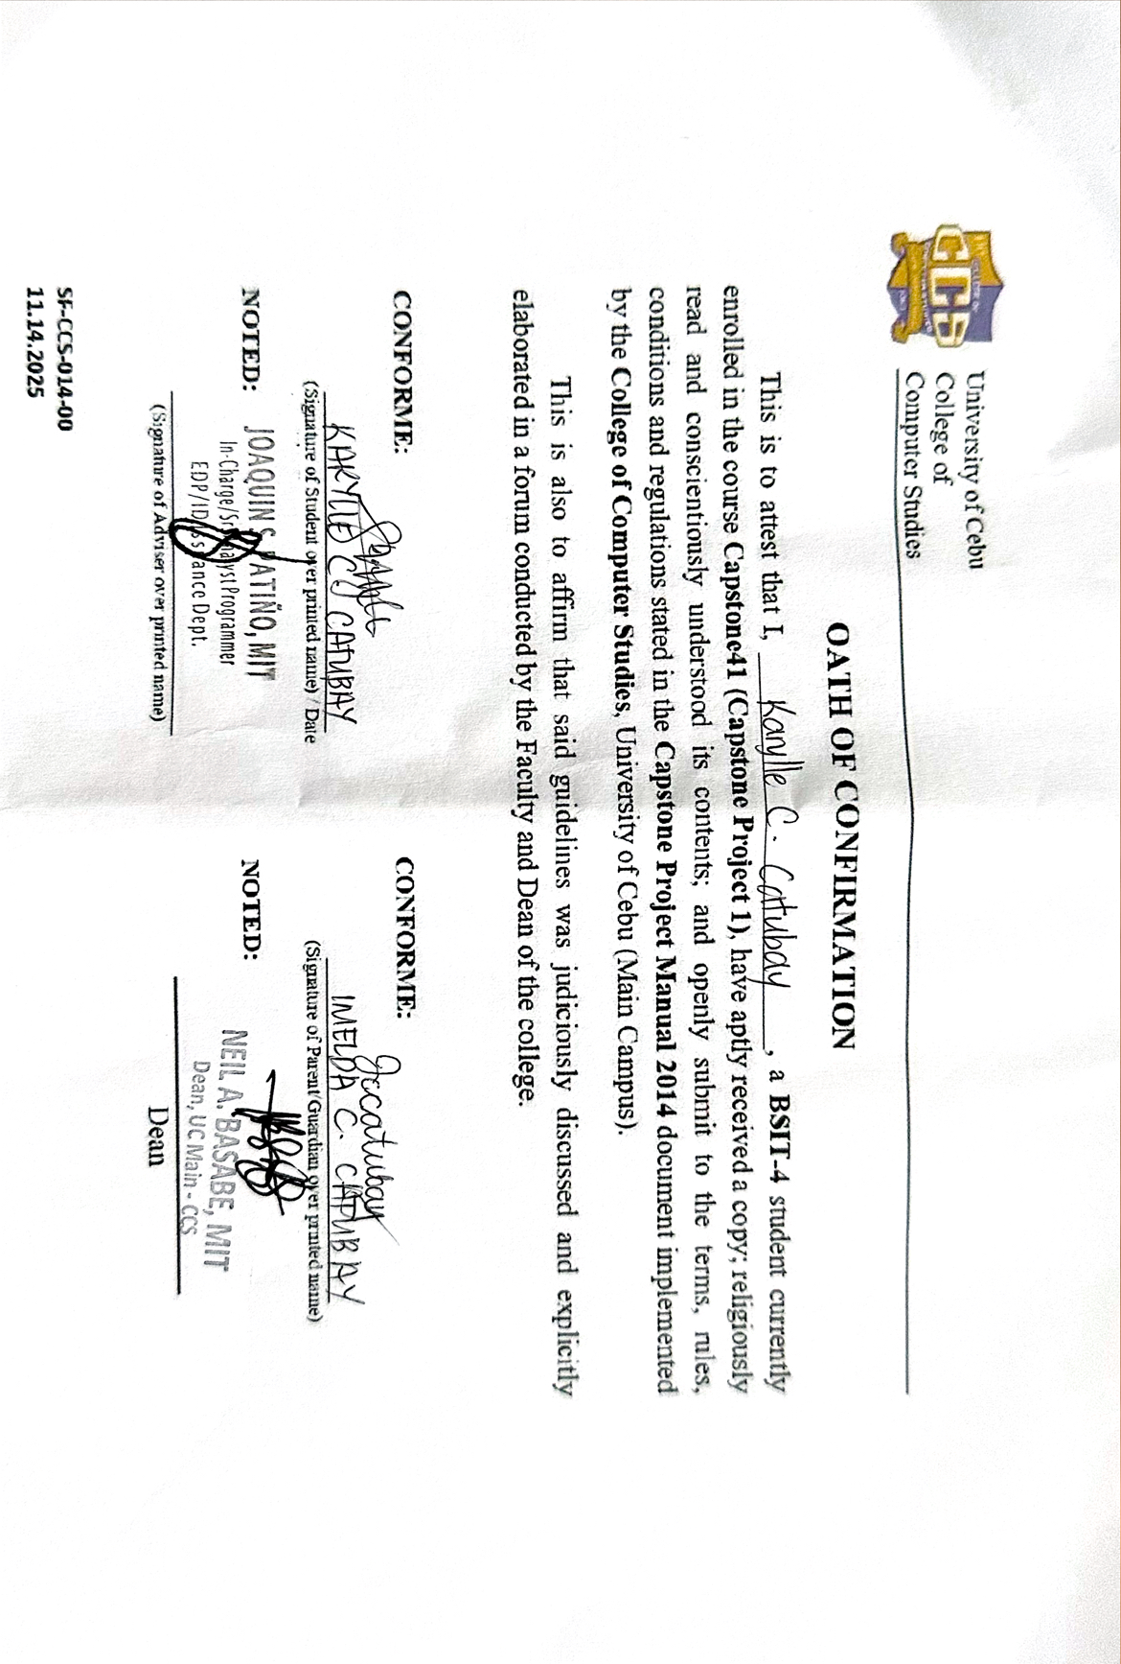

Appendix AA: Standard Form for the Grammar and Plagiarism Tests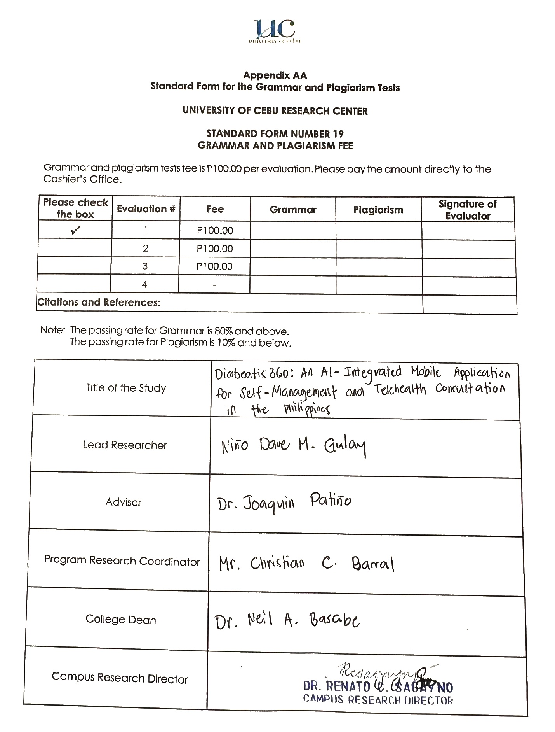

Appendix AA: Grammar and Plagiarism Form and Result

Appendix B: Capstone Project Team Composition Form



Appendix BB: Standard Form for the Research Topic Endorsement
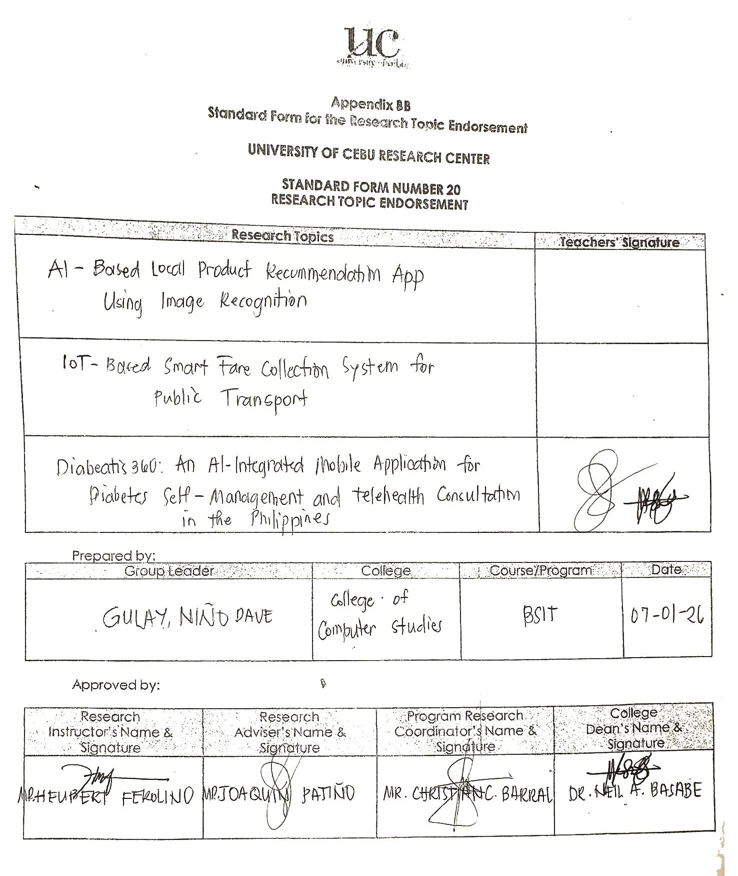

Appendix E: Capstone Project Working Title Form

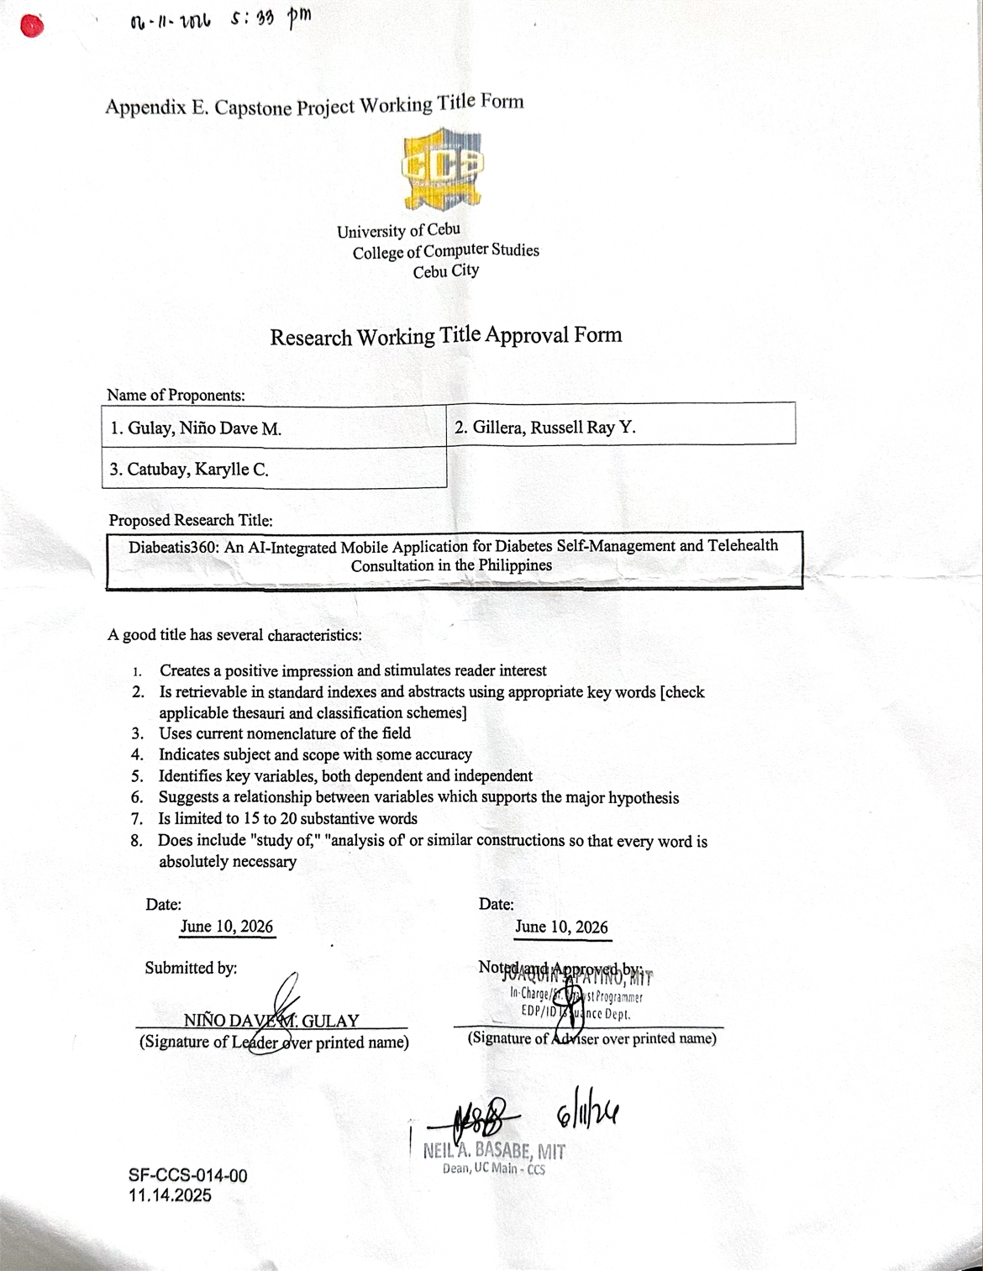

Appendix G: Consultation Logs

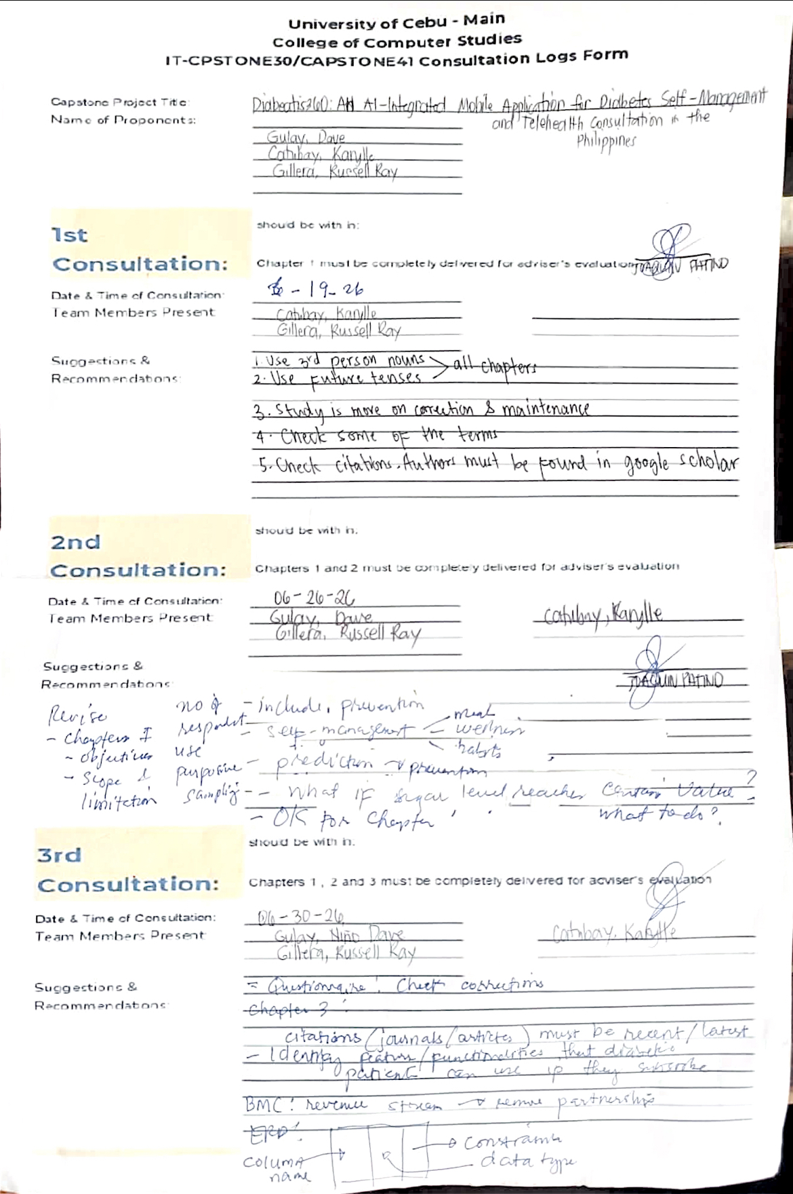

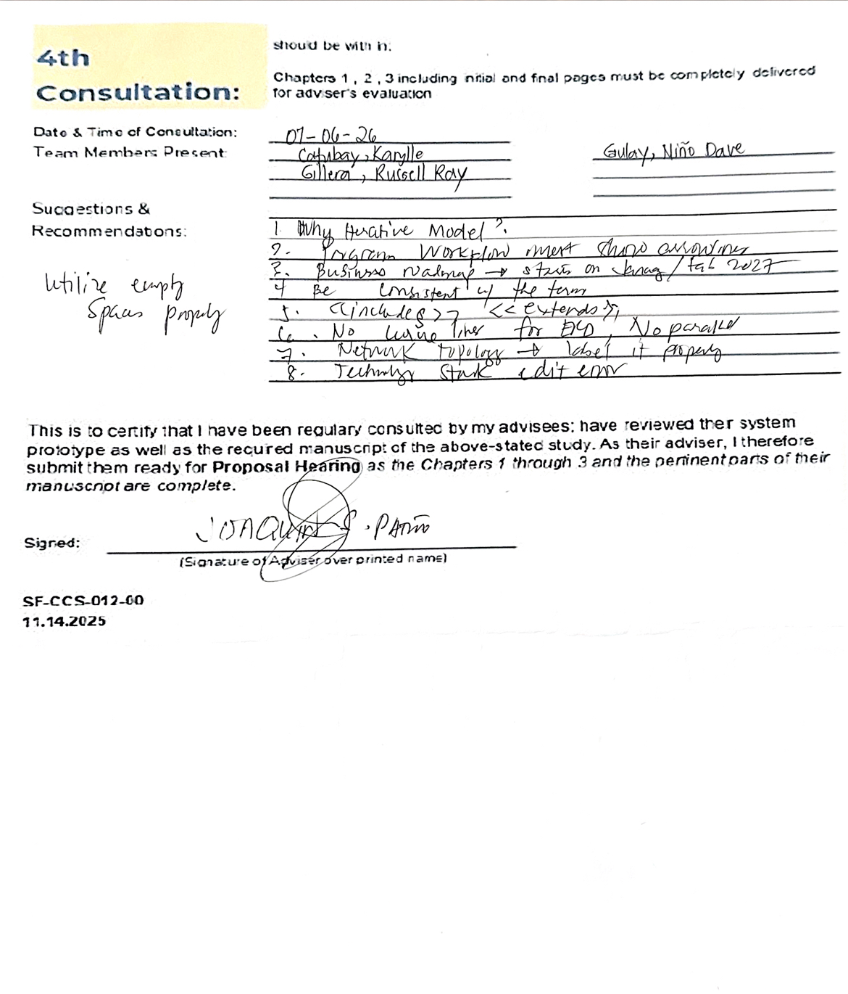

Appendix H: Transmittal Letter

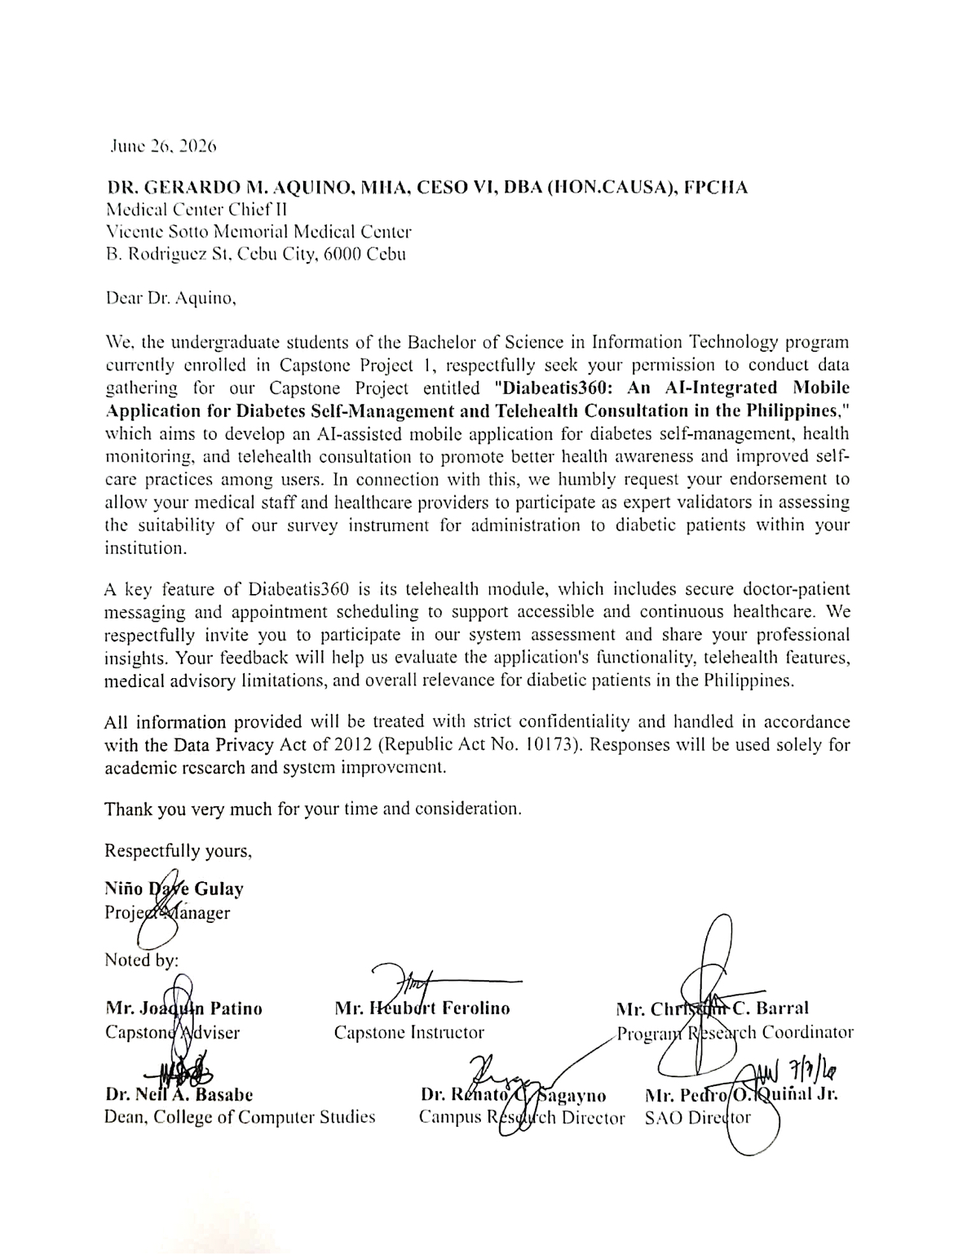

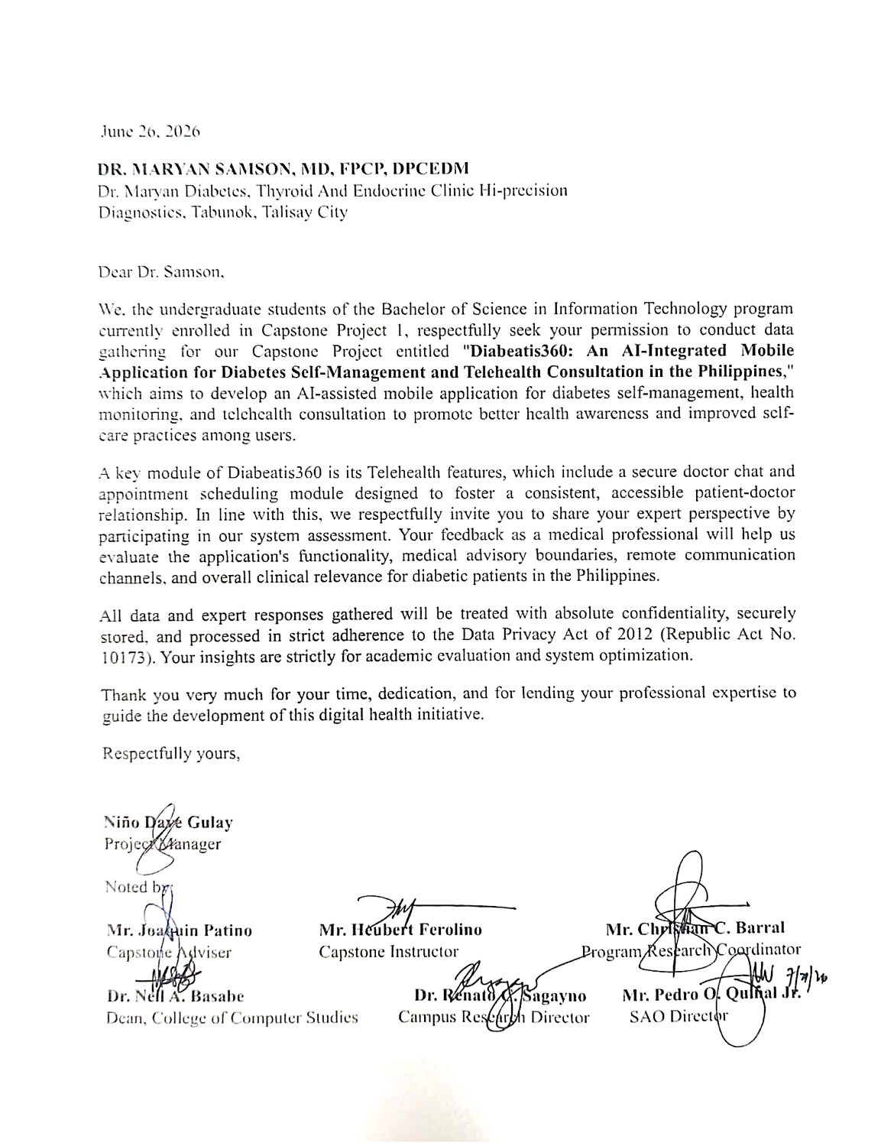

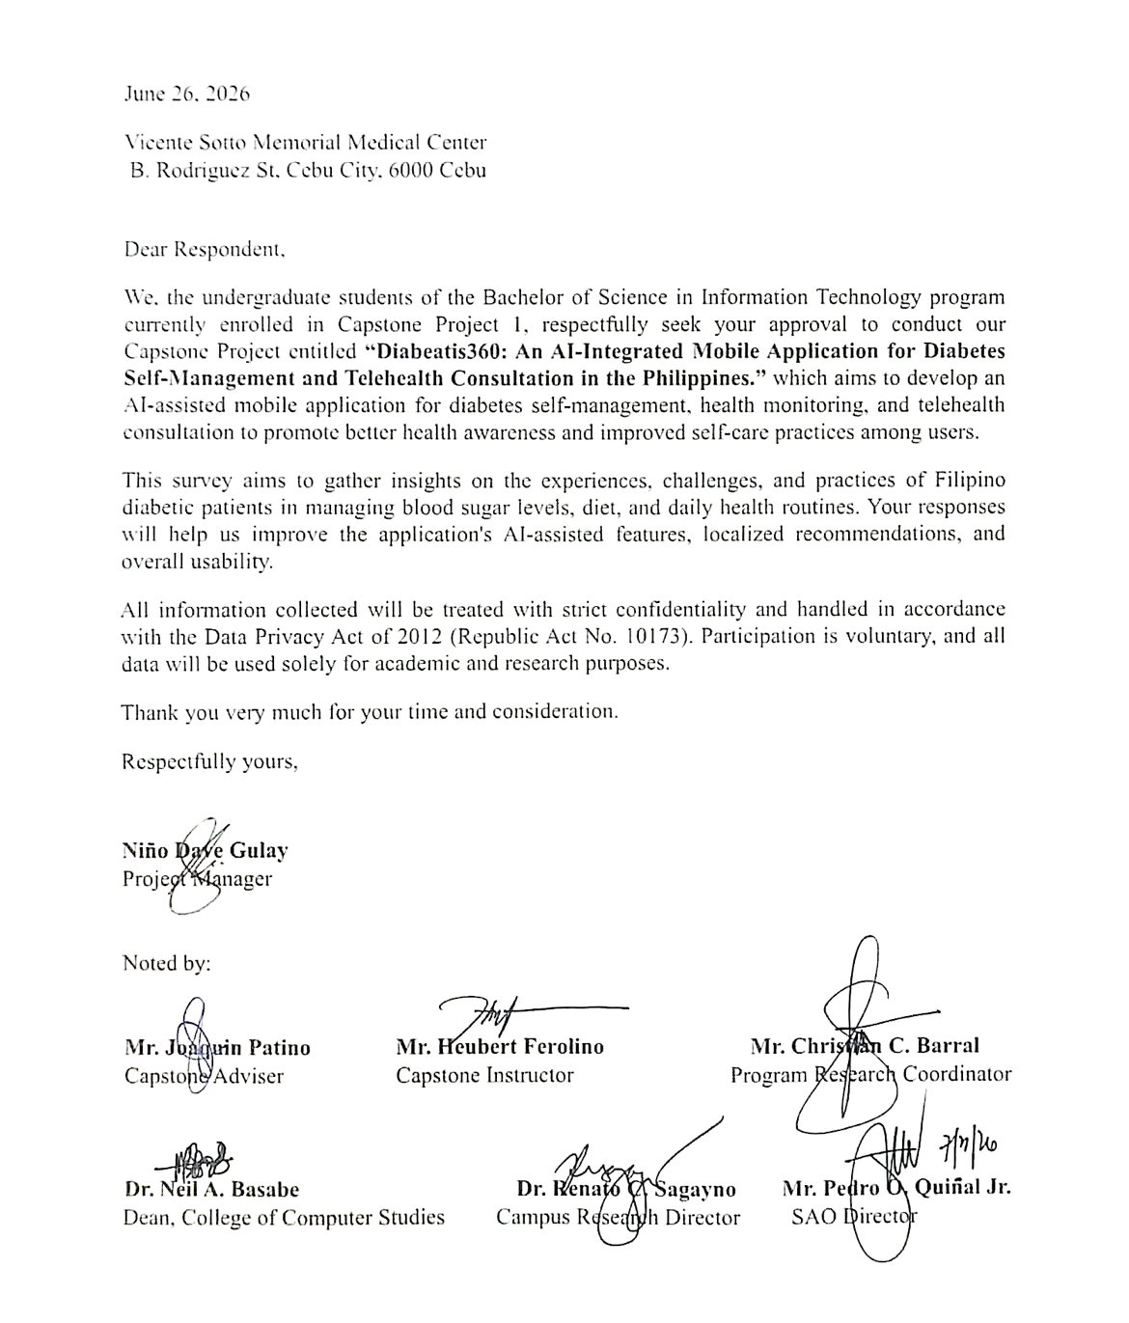

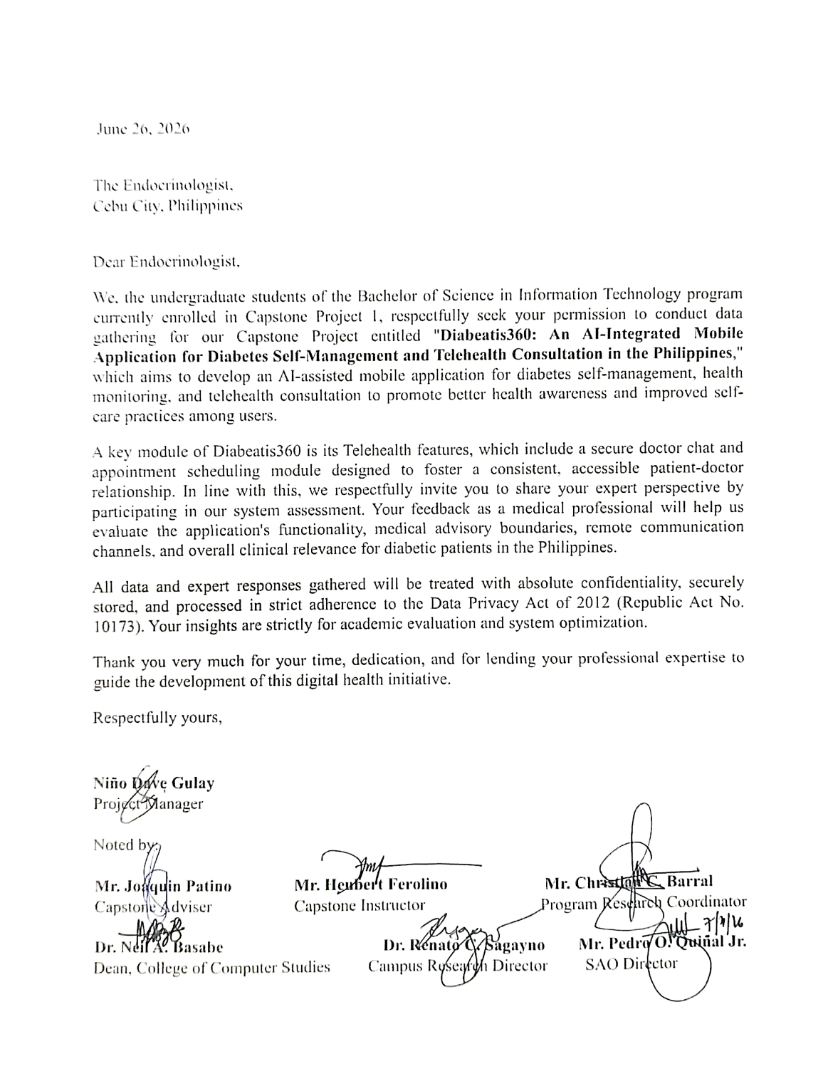

Appendix I: Diabetic Adults – Survey Questionnaire

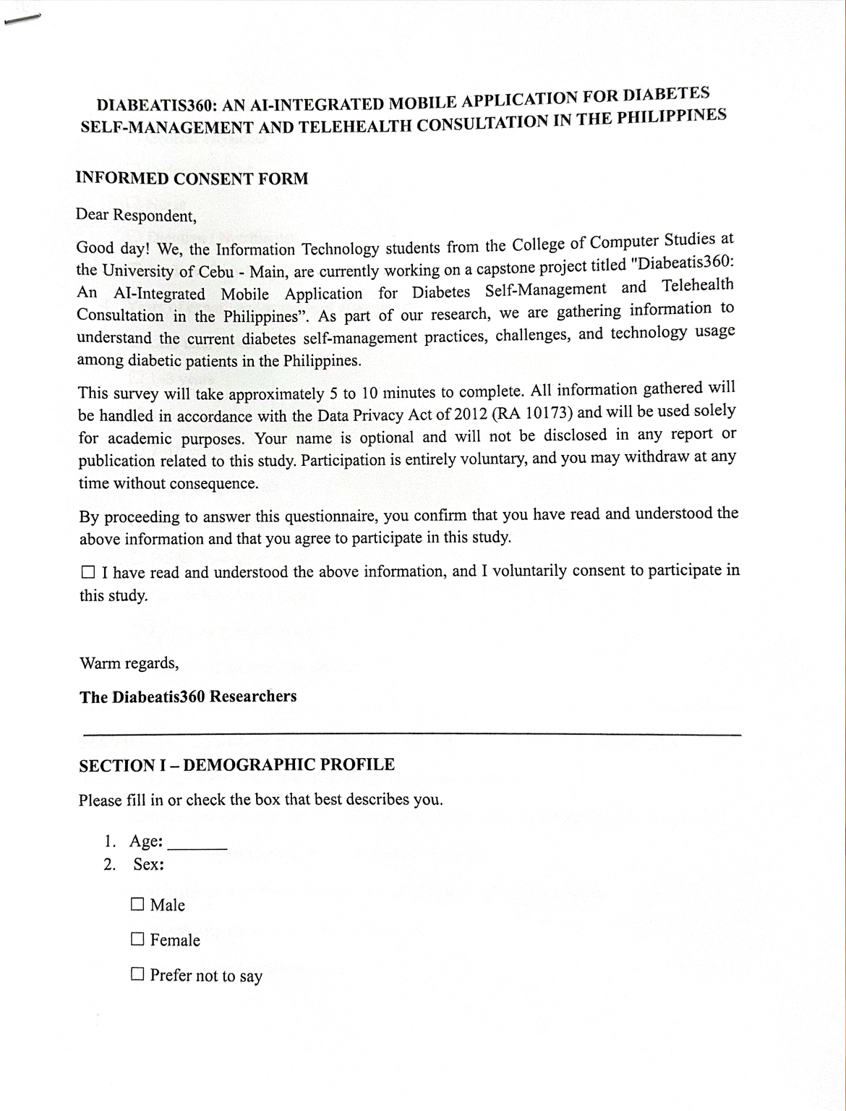

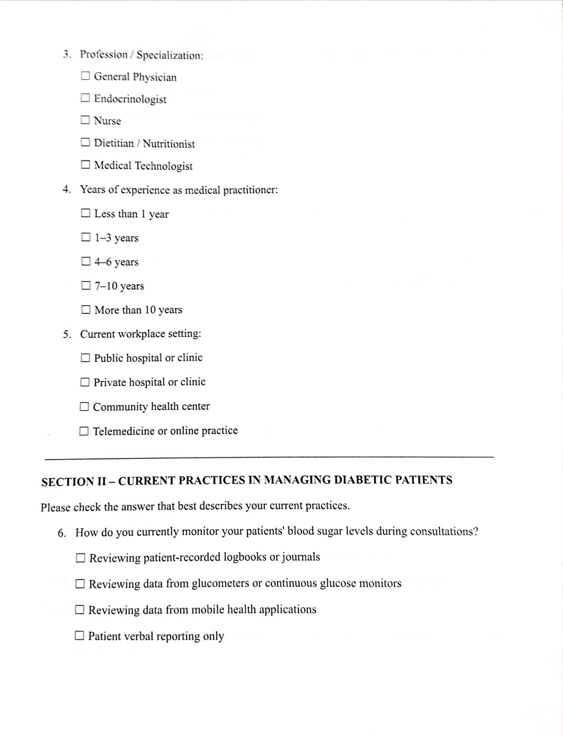

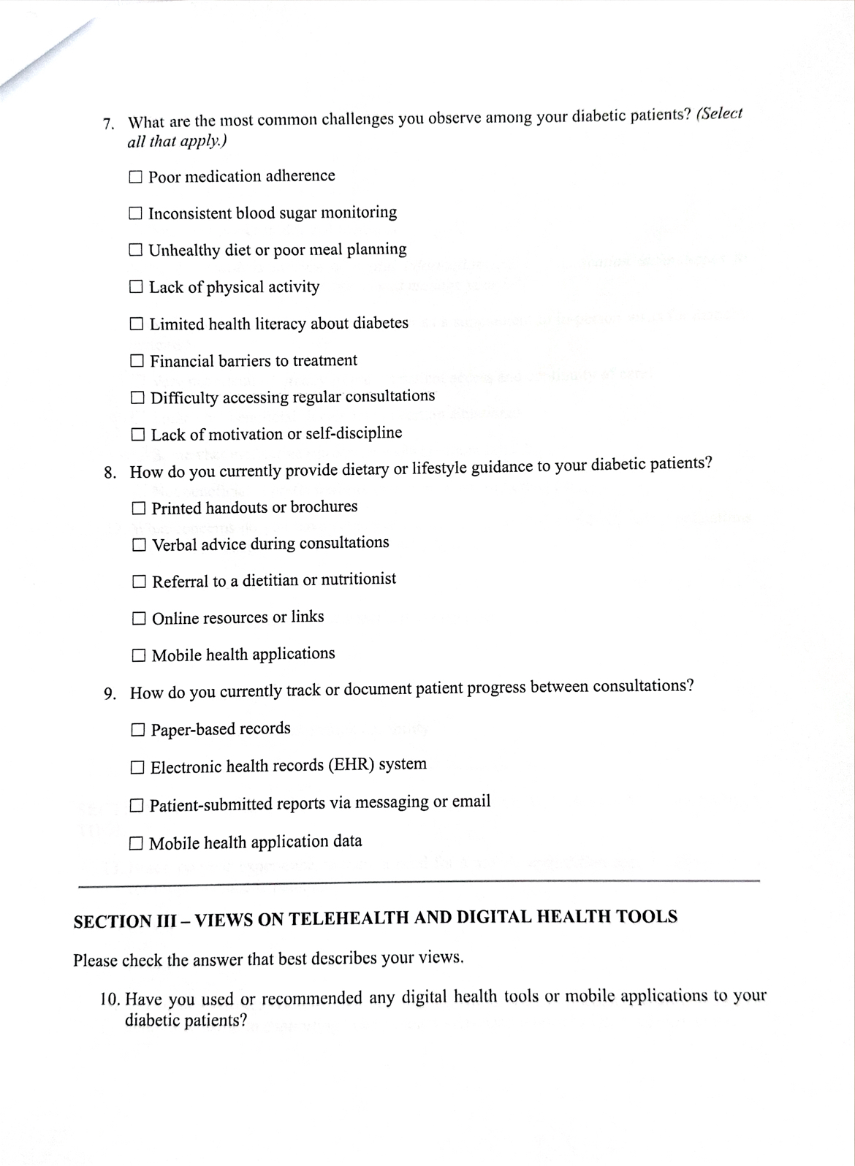

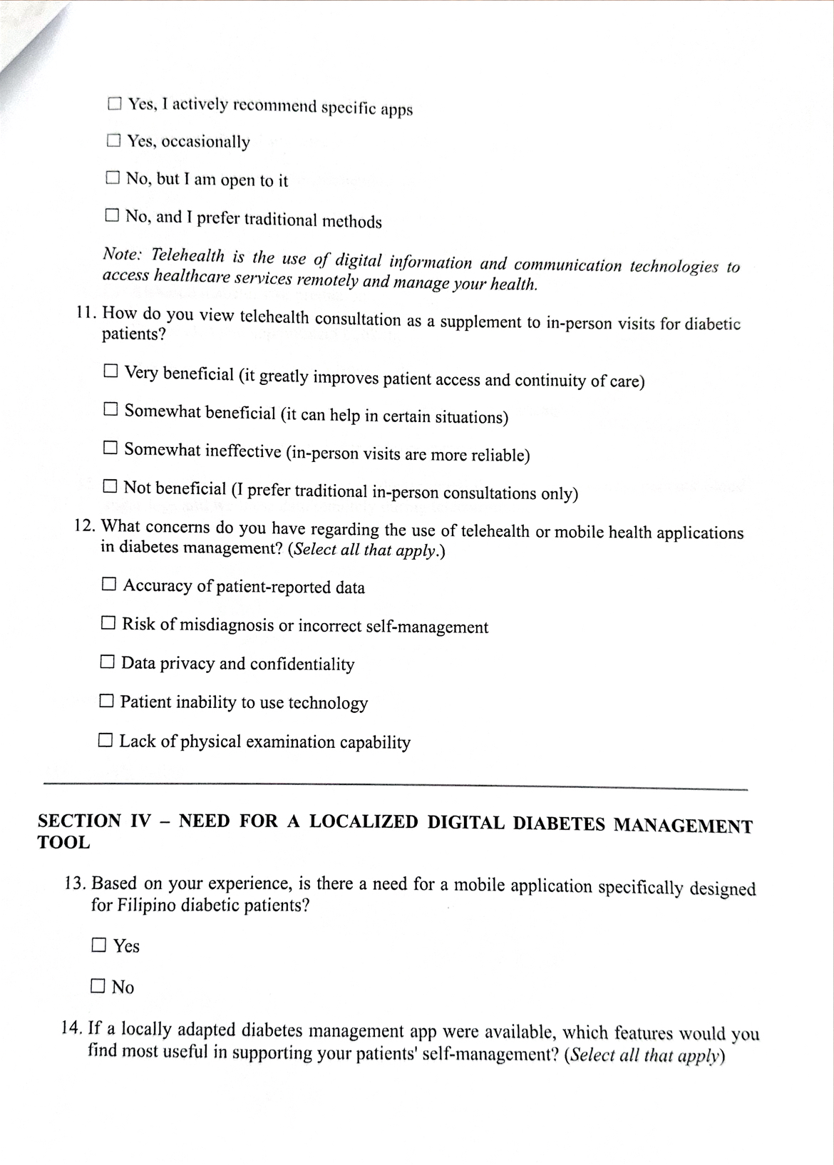

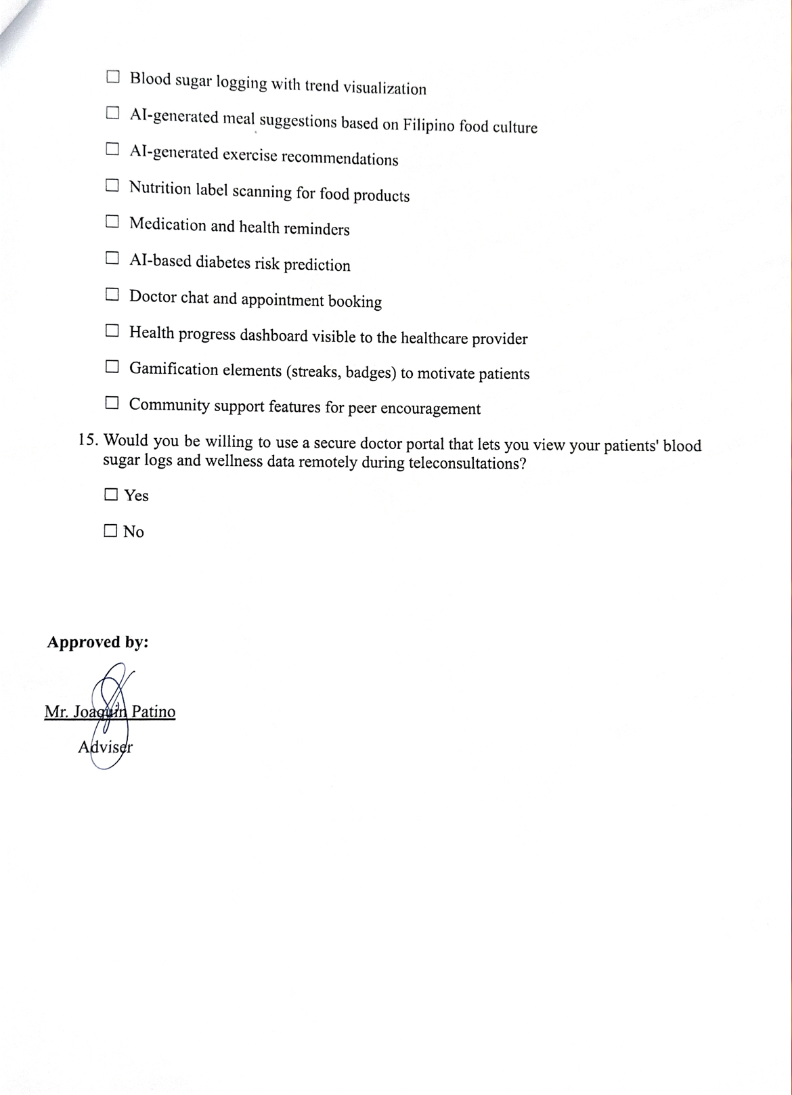

Appendix J: Doctor – Survey Questionnaire
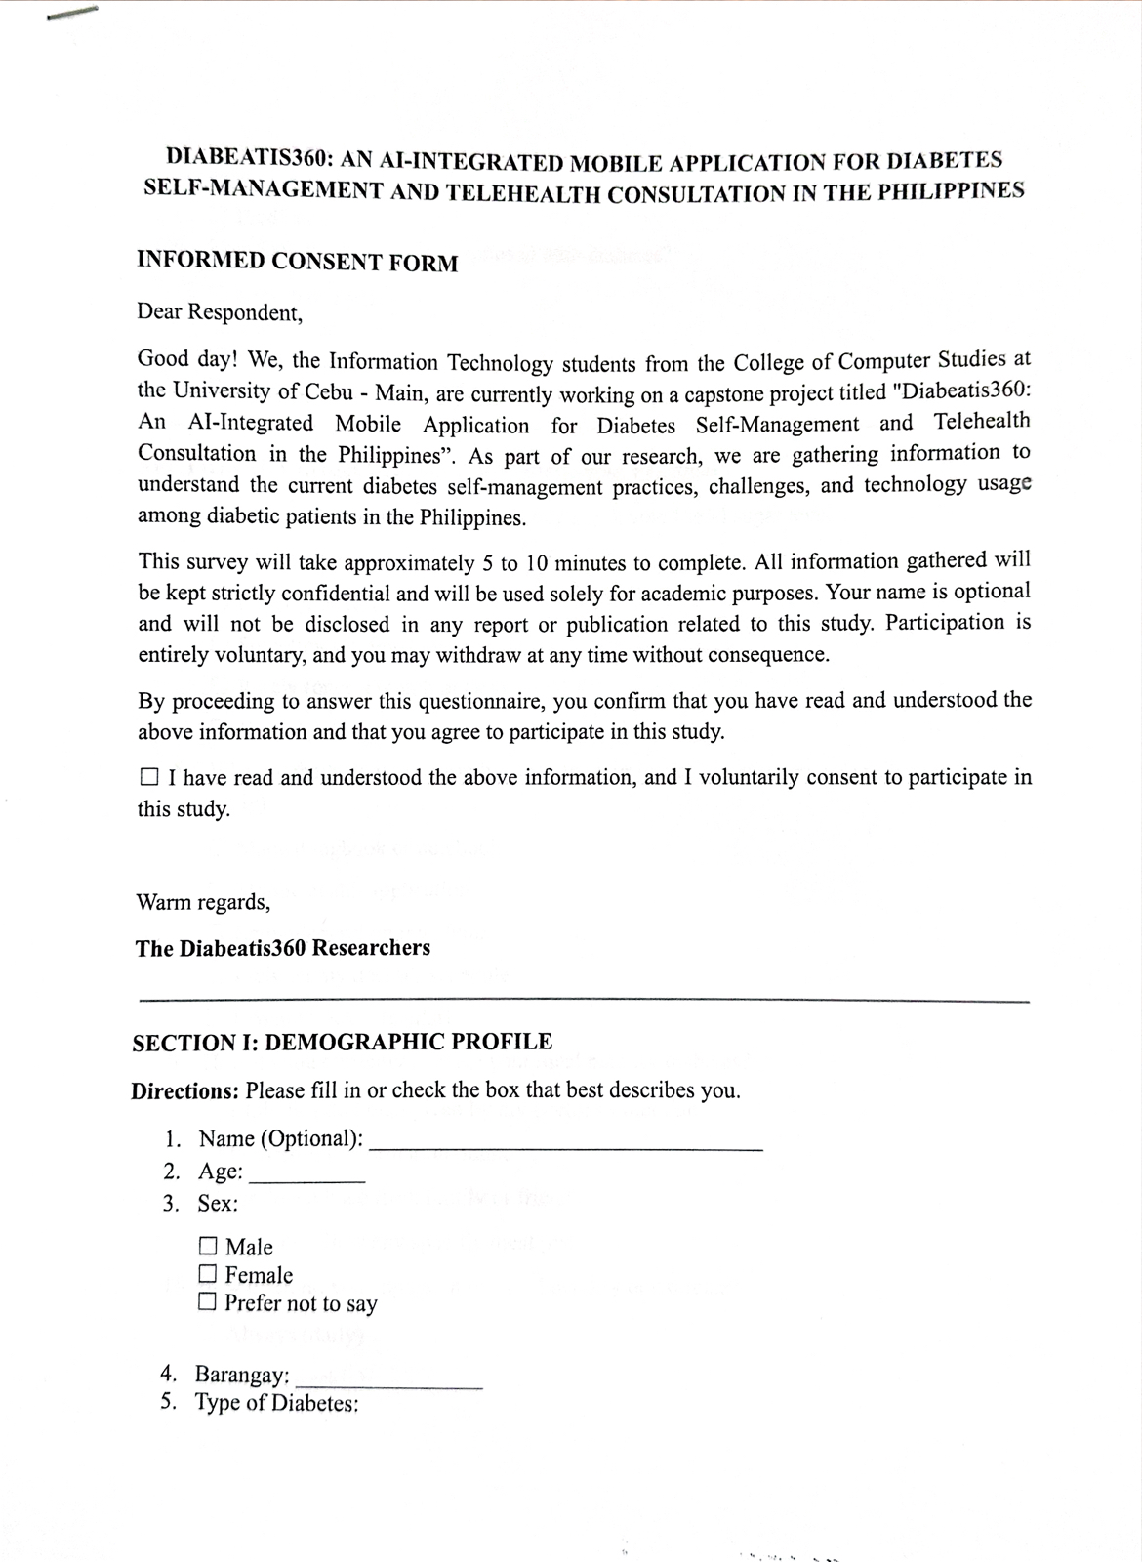
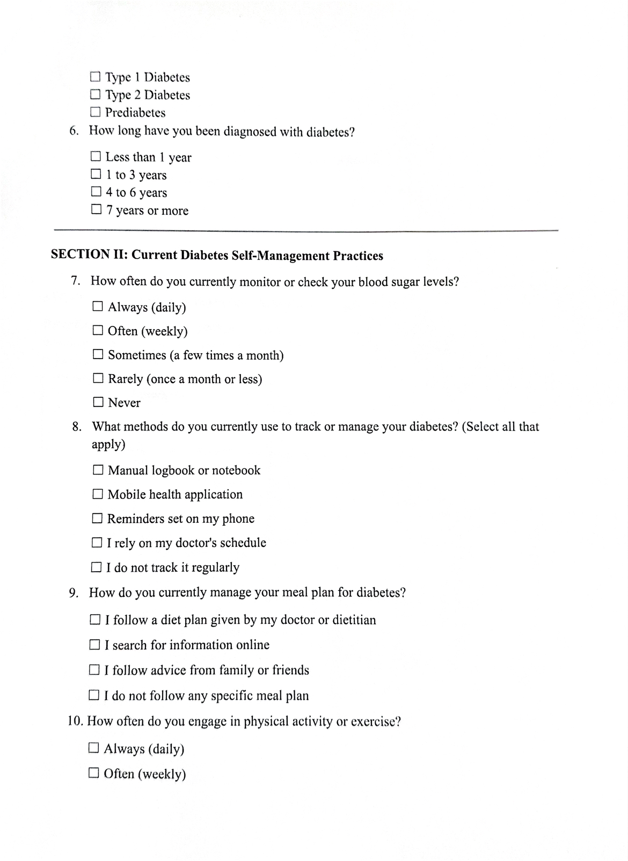

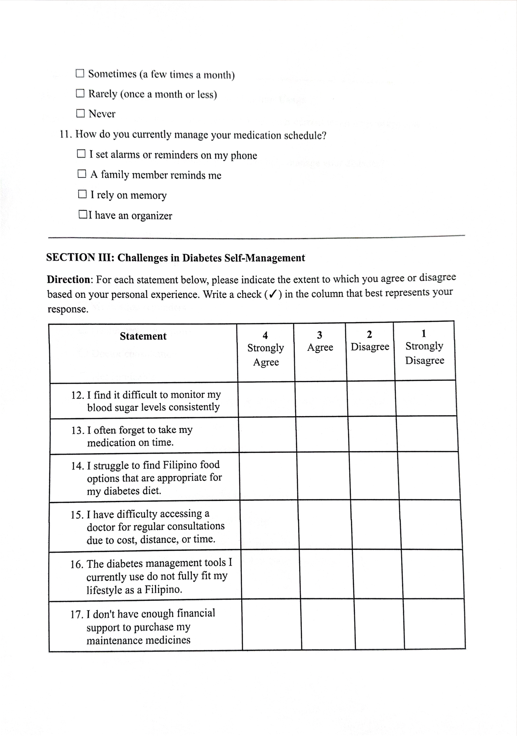

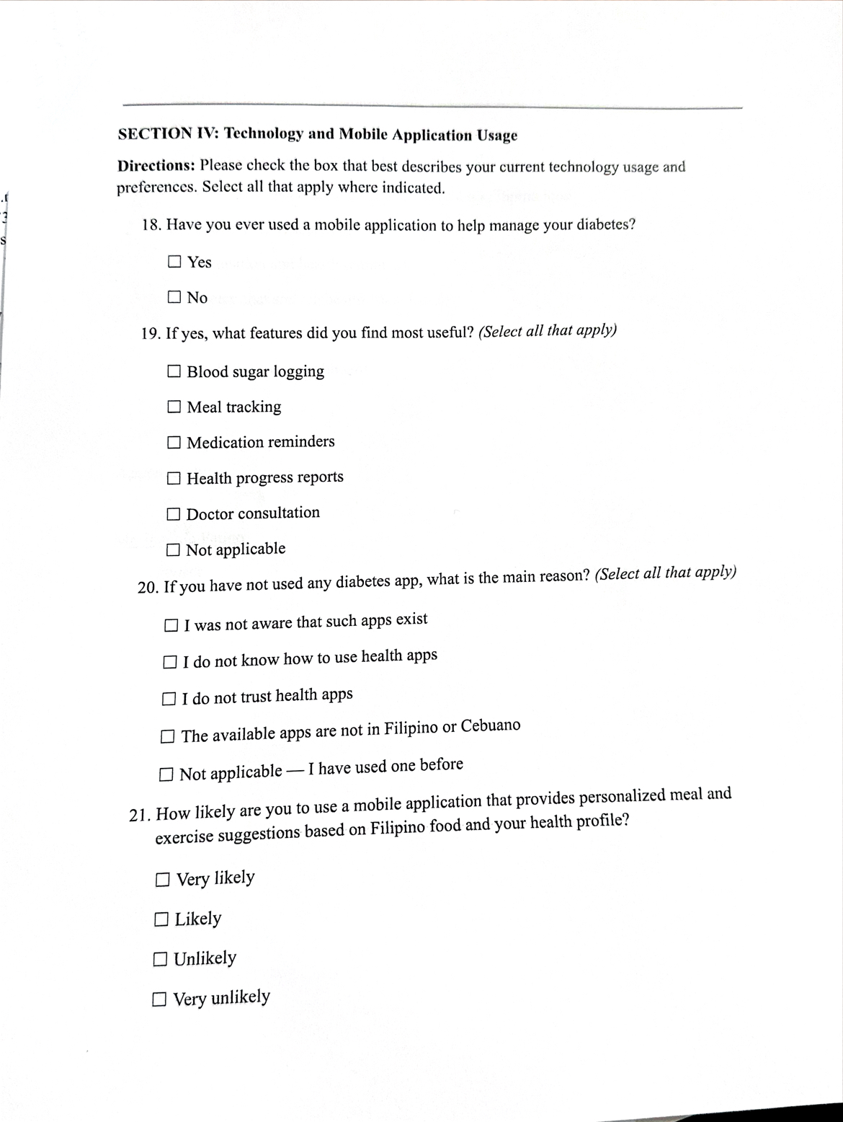

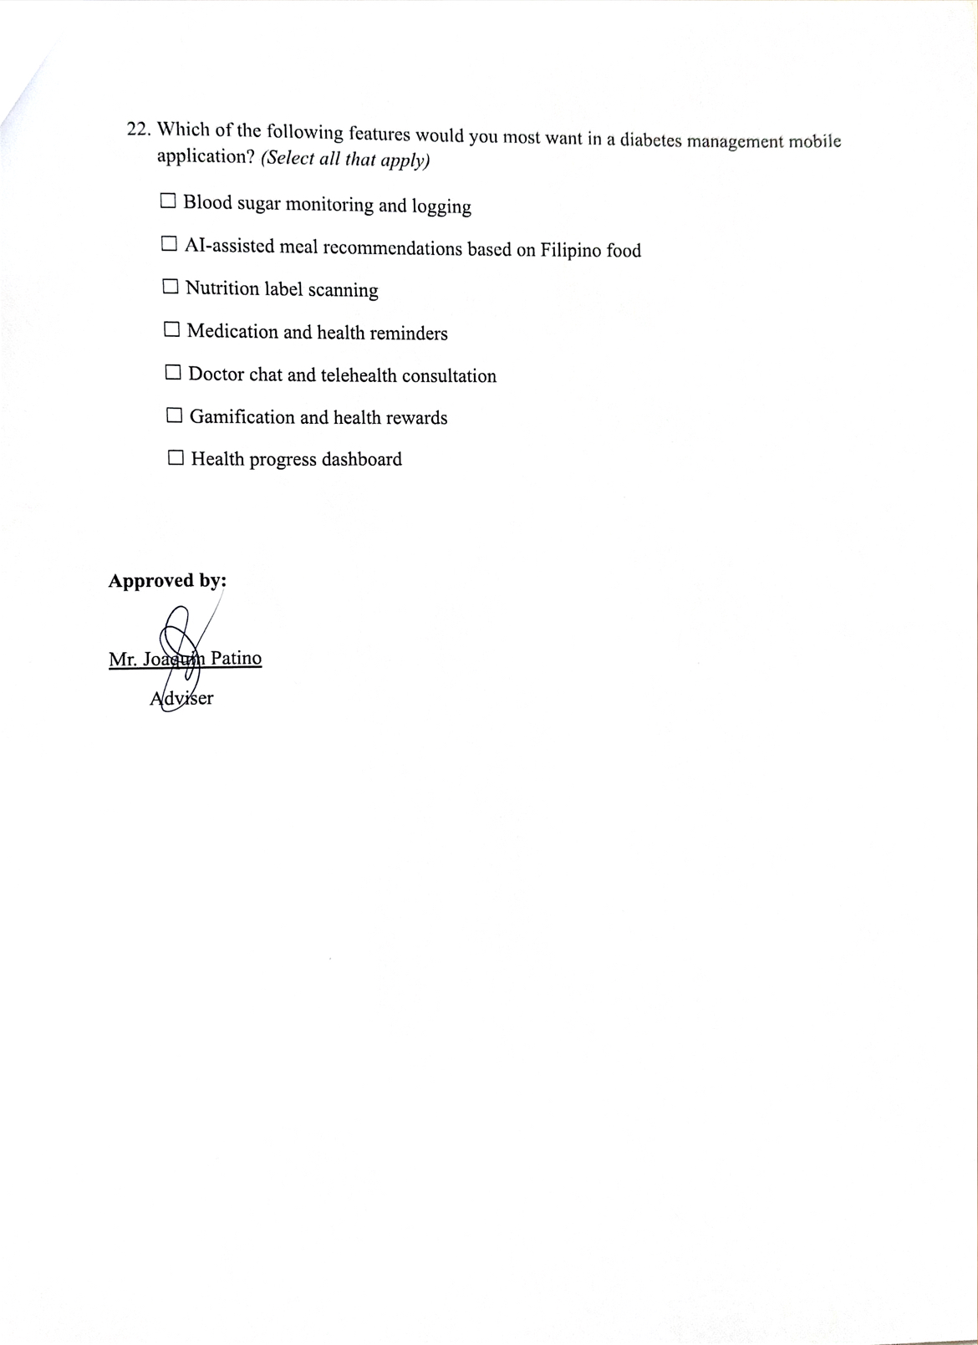

Appendix K: Capstone Project Minutes of the Proceedings
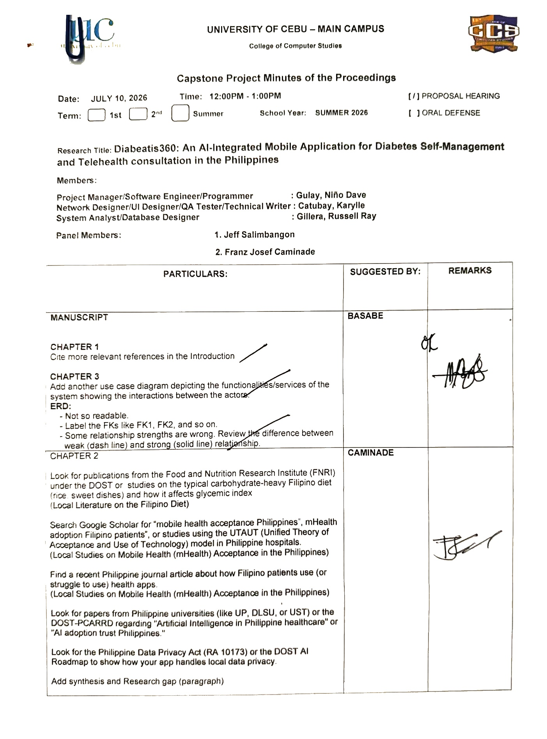

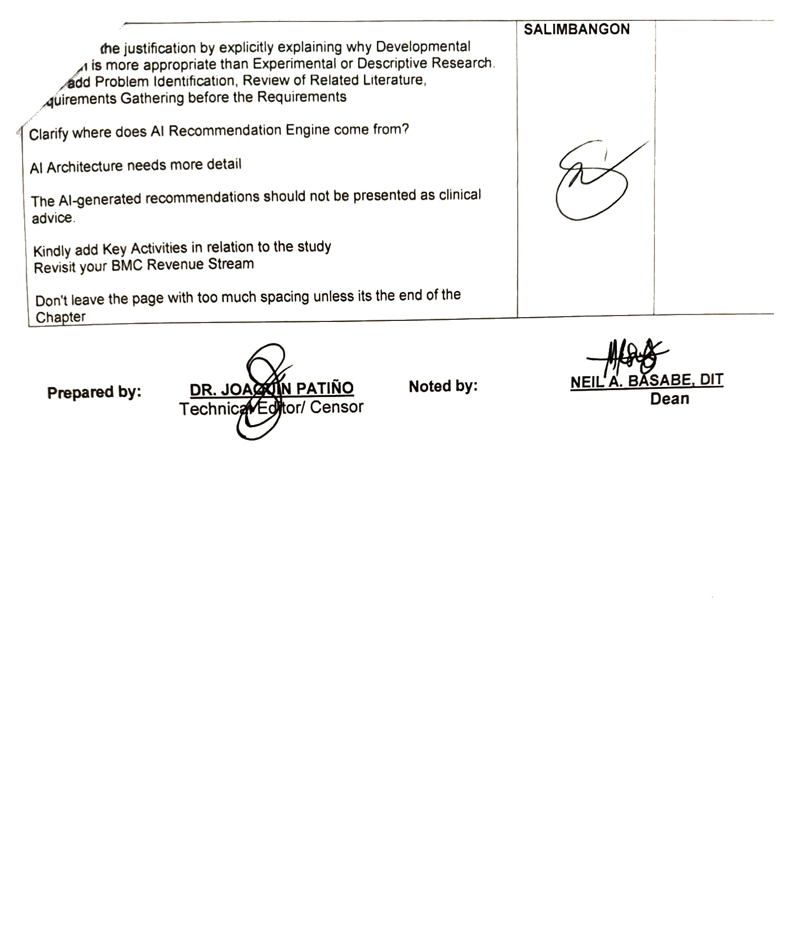

Appendix L: Capstone Project Hearing Notice


Appendix R: Capstone Project Panel Honoraria (Form 10)

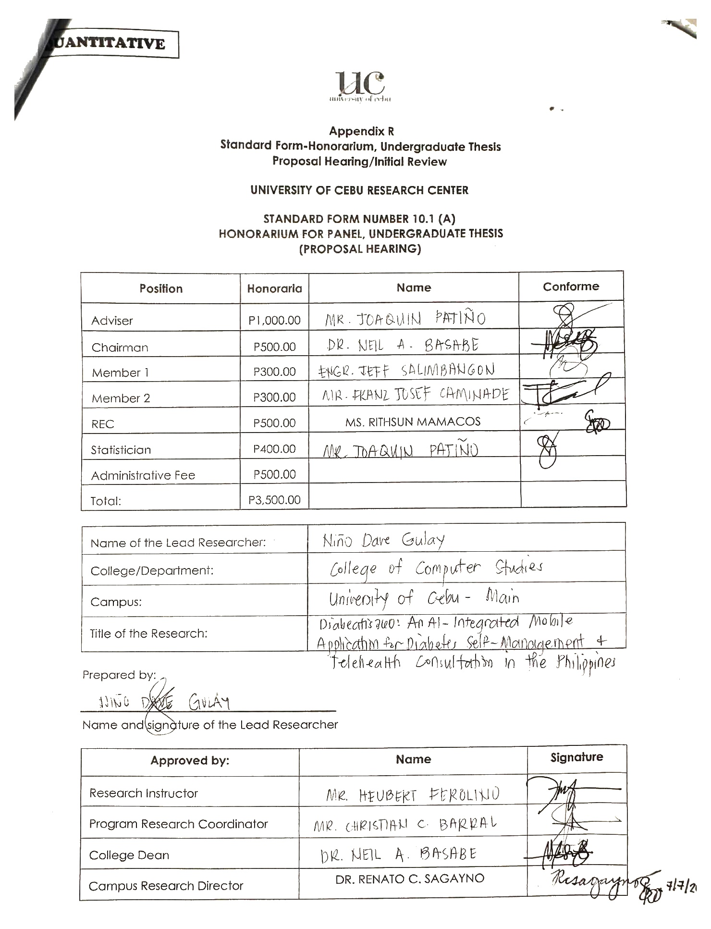

Appendix W: Standard Form for Proposal Hearing Endorsement
